Sexual and Reproductive Health Commissioning Intentions: Consultation Report

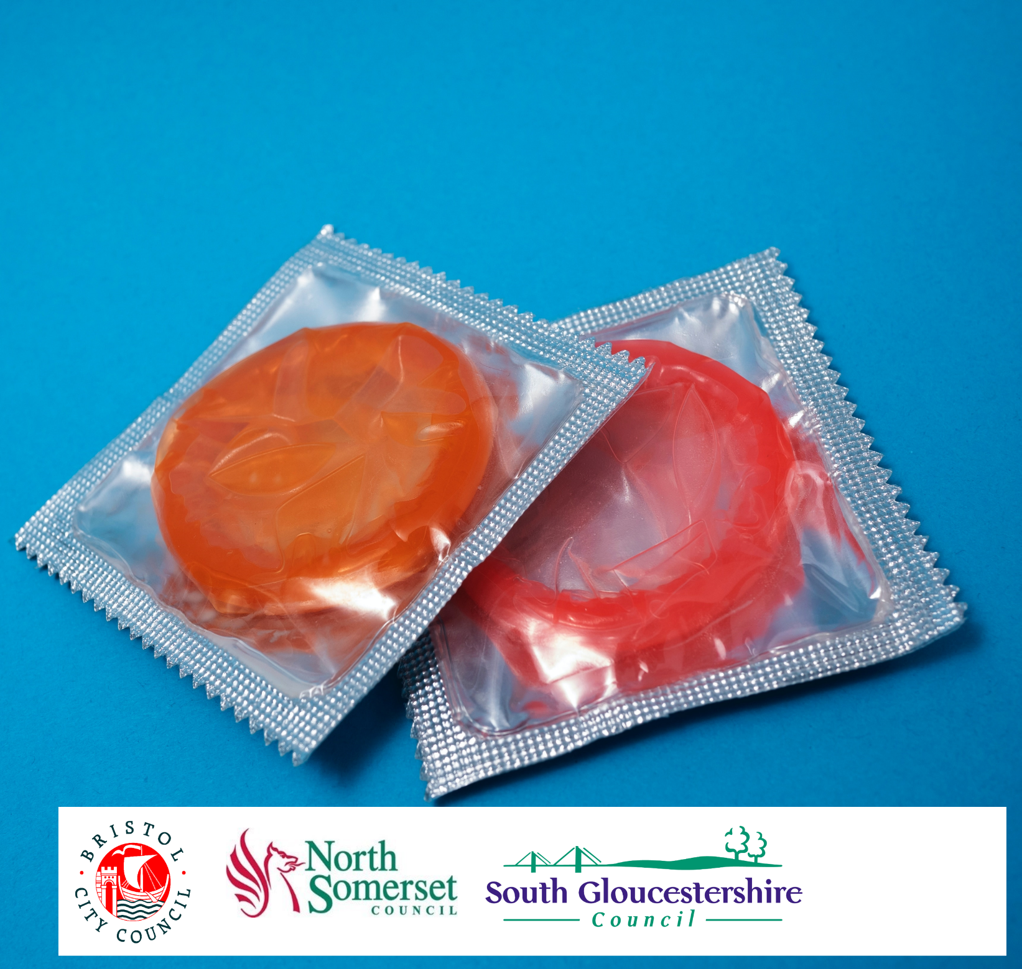
Contents
1 Introduction 4
1.1 Background 4
1.2 Sexual and Reproductive Health Commissioning Intentions consultation 4
1.3 Scope of this report 4
2 Methodology 5
2.1 Survey 5
2.1.1 Online survey 5
2.1.2 Alternative formats 6
2.2 Publicity and briefings 6
2.2.1 Objective 6
2.2.2 Internal communications 6
2.2.3 BNSSG partners and voluntary sector organisations 6
2.2.4 Social media – posts, outreach, and advertising 8
3 Survey response rate and respondent characteristics 9
3.1 Response rate to the survey 9
3.2 Geographic distribution of responses 9
3.3 Response rate from areas of high and low deprivation 13
3.4 Characteristics of respondents 17
3.4.1 Overview 17
3.4.2 Age 18
3.4.3 Disability 19
3.4.4 Ethnicity 20
3.4.5 Religion/faith 21
3.4.6 Sex 22
3.4.7 Gender reassignment 23
3.4.8 Sexual orientation 24
3.4.9 Pregnancy and maternity, carer status and and refugee/asylum status 24
4 Survey results 27
4.1 Views on the vision 27
4.1.1 All respondents 27
4.1.2 Views on the vision by sex 28
4.1.3 Views on the vision by ethnicity 29
4.1.4 Views on the vision by Disability 30
4.1.5 Views on the vision by age 31
4.1.6 Views on the vision by sexual orientation 32
4.1.7 Free text responses 33
4.2 Views on the proposal for access to sexual and reproductive health services 35
4.2.1 All respondents 35
4.2.2 Views on access to sexual and reproductive health services by sex 35
4.2.3 Views on access to sexual and reproductive health services by ethnicity 37
4.2.4 Views on access to sexual and reproductive health services by Disability 38
4.2.5 Views on access to sexual and reproductive health services by age 39
4.2.6 Views on access to sexual and reproductive health services by sexual orientation 40
4.2.7 Free text responses 41
4.3 Views on the proposal for in-person clinics 43
4.3.1 All respondents 43
4.3.2 Views on in-person clinics by sex 45
4.3.3 Views on in-person clinics by ethnicity 46
4.3.4 Views on in-person clinics by Disability 47
4.3.5 Views on in-person clinics by age 48
4.3.6 Views on in-person clinics by sexual orientation 49
4.3.7 Free text responses 50
4.4 Prevention activities 52
4.4.1 All respondents 52
4.4.2 Views on prevention activities by sex 53
4.4.3 Views on prevention activities by ethnicity 54
4.4.4 Views on prevention activities by Disability 55
4.4.5 Views on prevention activities by age 56
4.4.6 Views on prevention activities by sexual orientation 57
4.4.7 Free text responses 58
4.5 Q7 Do you have any additional comments on the draft plans? 60
5 Impact of the proposals because of protected characteristics 64
5.1 Scale of effects 64
5.2 Reasons why the proposals would affect people because of protected characteristics 65
6 How will this report be used? 66

Introduction

Background
Local councils have a duty to provide integrated sexual health services (ISHS) for their local population. In Bristol, North Somerset, and South Gloucestershire (BNSSG) this includes free and confidential services such as contraception, condom distribution, testing and treatment of sexually transmitted infections (STIs) such as chlamydia and gonorrhoea, HIV prevention and testing.
ISHS are co-commissioned by the three BNSSG local authorities, Bath and North East Somerset Council, who jointly commission chlamydia screening services, and the Integrated Care Board (ICB), who jointly commission abortion services, with Bristol City Council taking the lead. University Hospitals Bristol and Weston Trust (UHBW) is currently contracted to provide these services, which they deliver through Unity – a partnership of several subcontracted providers including the British Pregnancy Advisory Service (BPAS), MSI Reproductive Choices, Brook, Terrence Higgins Trust (THT) and North Bristol NHS Trust (NBT). We plan to commission new services from April 2025. These will no longer include abortion services, which will be commissioned separately by the ICB.
We have previously undertaken work to listen to and understand people’s experiences of current sexual and reproductive health services. This has helped us develop our plans for improved services for the future. During winter 2023/2024, we consulted on those plans.

Sexual and Reproductive Health Commissioning Intentions consultation
From 4 December 2023 to 28 January 2024, we consulted on the Draft BNSSG Sexual and Reproductive Health Commissioning Intentions to find out from the public and partners if they agree with our proposals, and to help identify and address problems or gaps in our plans.
The consultation asked respondents for their feedback on four key elements of the draft commissioning intentions:
- Our proposed vision
- Our proposal to improve how people can access services via online (digital) routes
- Our proposals around provision of in-person clinics in the community
- Our proposals for prevention activities that encourage healthy behaviours and prevent sexually transmitted infections and unplanned pregnancies.
Further details of the consultation topics and methodology is described in Chapter 2.

Scope of this report
This consultation report describes the consultation methodology and the feedback received, which will be considered by the BNSSG Sexual Health Recommissioning Board.
Chapter 2 of this report describes the consultation methodology. The consultation survey can be viewed online.
Chapter 3 presents the survey response rate and respondent characteristics.
Chapter 4 summarises respondents’ views on the four key elements of the draft commissioning intentions.
Chapter 5 sets out the effects that respondents said the proposals would have on them because of their protected characteristics.
Chapter 6 describes how this report will be used and how to keep updated on the
decision-making process.

Methodology

Survey

Online survey
The Sexual and Reproductive Health Commissioning Intentions consultation was available on the council’s Consultation and Engagement Hub (www.ask.bristol.gov.uk) from
4 December 2023 to 28 January 2024.
A link to an online Easy Read version of the consultation was also available on the Consultation and Engagement Hub.
Consultation subject
The consultation asked respondents how they rate the following elements of the draft commissioning intentions on a scale from strongly agree to strongly disagree:
- Our proposed vision to procure comprehensive and integrated services that champion prevention, inclusivity, and equitable access. They will place service users at the heart of care, empowering them to make informed choices about their sexual and reproductive health. Services will provide seamless pathways of care and will be in an ongoing conversation with communities to ensure local voices are being heard and responded to.
- Our proposal to improve how people can access sexual and reproductive health services via online (digital) routes. This would include being able to access a wide range of services and advice online (digitally), such as ordering self-sampling kits for common sexually transmitted infections or booking a clinic appointment.
- Our proposal to provide in-person clinics in the community that are welcoming to everyone regardless of age, ethnicity, or background in addition to digital services. These would provide alternative access for those that are unable to use online services and will include walk-in and booked appointments.
- Prevention: our proposal for the new service to have a strong focus on activities that encourage healthy behaviours and prevent sexually transmitted infections and unplanned pregnancies, as well as providing treatment. Prevention activities may include campaigns and use of social media, training and education, and outreach to communities.
Respondents were invited to provide additional comments on each of the four key elements of the draft commissioning intentions.
About you questions
The ‘About you’ section requested information which helps the council to check if the responses are representative of people across BNSSG who may have different needs.
- Respondents’ postcode – this identifies if any parts of the BNSSG area are under-represented in responding to the consultation and it can show if people from more deprived areas have different views compared to people living in less deprived areas.

- Equalities monitoring information – this enables the BNSSG Integrated Care Board to know if people with specific protected characteristics under the Equality Act 2010 are under-represented in the responses, and it can also show if people with different protected characteristics have different views.
Respondents could choose to answer some or all questions in any order and save and return to the survey later.

Alternative formats
The consultation was available in Easy Read format on the Consultation and Engagement Hub. Paper copies and alternative formats (braille, large print, audio, British Sign Language (BSL) and translation to other languages) were available on request.

Publicity and briefings

Objective
The following programme of activity was carried out to publicise and explain the Sexual and Reproductive Health Commissioning Intentions consultation. The primary objective was to engage residents, communities, and stakeholders across the city in helping to inform decisions on the proposed options, and the consultation was open to the whole BNSSG population.
To achieve this, information was shared across a wide range of channels, reaching as broad a range of audiences as possible across BNSSG to maximise response rates. Views from identified at-risk and underserved groups were proactively sought including:
- Children and young people (Aged 13-25)
- Looked after children
- Older people (Aged 65 and over)
- Gypsy, Roma & Traveller
- People in contact with the health and justice system
- Asylum seekers and refugees
- LGBTQIA+ people
- GBMSM
- People living with HIV
- Minorities religious groups
- Minorities ethnic groups
- People living in areas of high deprivation
- People living with a disability (Including learning difficulties, memory deficits, sight and hearing deficits, mobility impairments and neurodivergent people.)
- Vulnerable women such as those at risk of domestic abuse or sexual violence
- Commercial sex workers
- Those in contact with substance use services
- Rough sleepers / people who are homeless

The views of service providers who have contact with at-risk and underserved groups were also sought:
- Family Nurse Partnership (Specialist Health Visiting service for teenage parents)
- Education settings e.g. schools, public health nursing, higher education & universities
- Looked after children services
- Youth service providers
- Supported housing providers
- Providers supporting people with learning difficulties
- Substance misuse services
- Providers supporting LGBTQIA+ people
- Primary care
- Secondary care
- Integrated sexual health providers

Internal communications
A link to the online consultation survey was shared internally across all three local authorities via a range of routes including internal comms newsletters. See Appendix 1 for further engagement plan details.

BNSSG partners and voluntary sector organisations
Details of the consultation were shared at the launch with representatives, voluntary sector organisations, public sector/city stakeholders, local health partners, equalities groups and community groups with a request for information to be circulated through their networks. This included sending publicity materials and electronic and printable posters. A list of partners and stakeholders contacted can be found in Appendix 1.

Social media – posts, outreach, and advertising
Regular posts on local authority social media channels (X, formerly Twitter, Facebook, Next Door, and Instagram) were made for the duration of the consultation.
These organic posts reached 1,830 people in Bristol. Posts on South Gloucestershire local authority social media channels were 857 impressions on X (formerly Twitter) and 1160 impressions on Facebook – 1160 impressions. (Impressions is the number of times content is displayed to users).

Survey response rate and respondent characteristics

Response rate to the survey
The Sexual and Reproductive Health Commissioning Intentions consultation survey received 551 responses, of which 547 were via the online survey and four used the paper survey. Of the 547 online responses, seven were completed via the online Easy Read version.

Geographic distribution of responses
Figure 1 shows the geographic distribution of respondents by local authority area. Figure 1 is based on the following information provided by survey respondents:
- Postcodes. Respondents were asked for their full postcode and, if they were responding on behalf of an organisation, for the postcode for the organisation’s premises
- Home location. Respondents were asked which of the three BNSSG local authorities they live in (Bristol, North Somerset, South Gloucestershire)
The answers to these two questions were cross-referenced and for respondents who did not provide a full postcode, the stated local authority area was used.
Of the 551 respondents to the survey, 546 were based in the three BNSSG authority areas:
- 241 (44%) responses were received from the Bristol City Council area
- 202 (37%) responses were from South Gloucestershire
- 103 (19%) responses were from North Somerset.
A further 3 (0.5%) were from locations beyond the four West of England local authorities.
2 (0.4%) respondents did not provide a postcode or state which local authority they live in.
Figure 1: Geographic distribution of responses
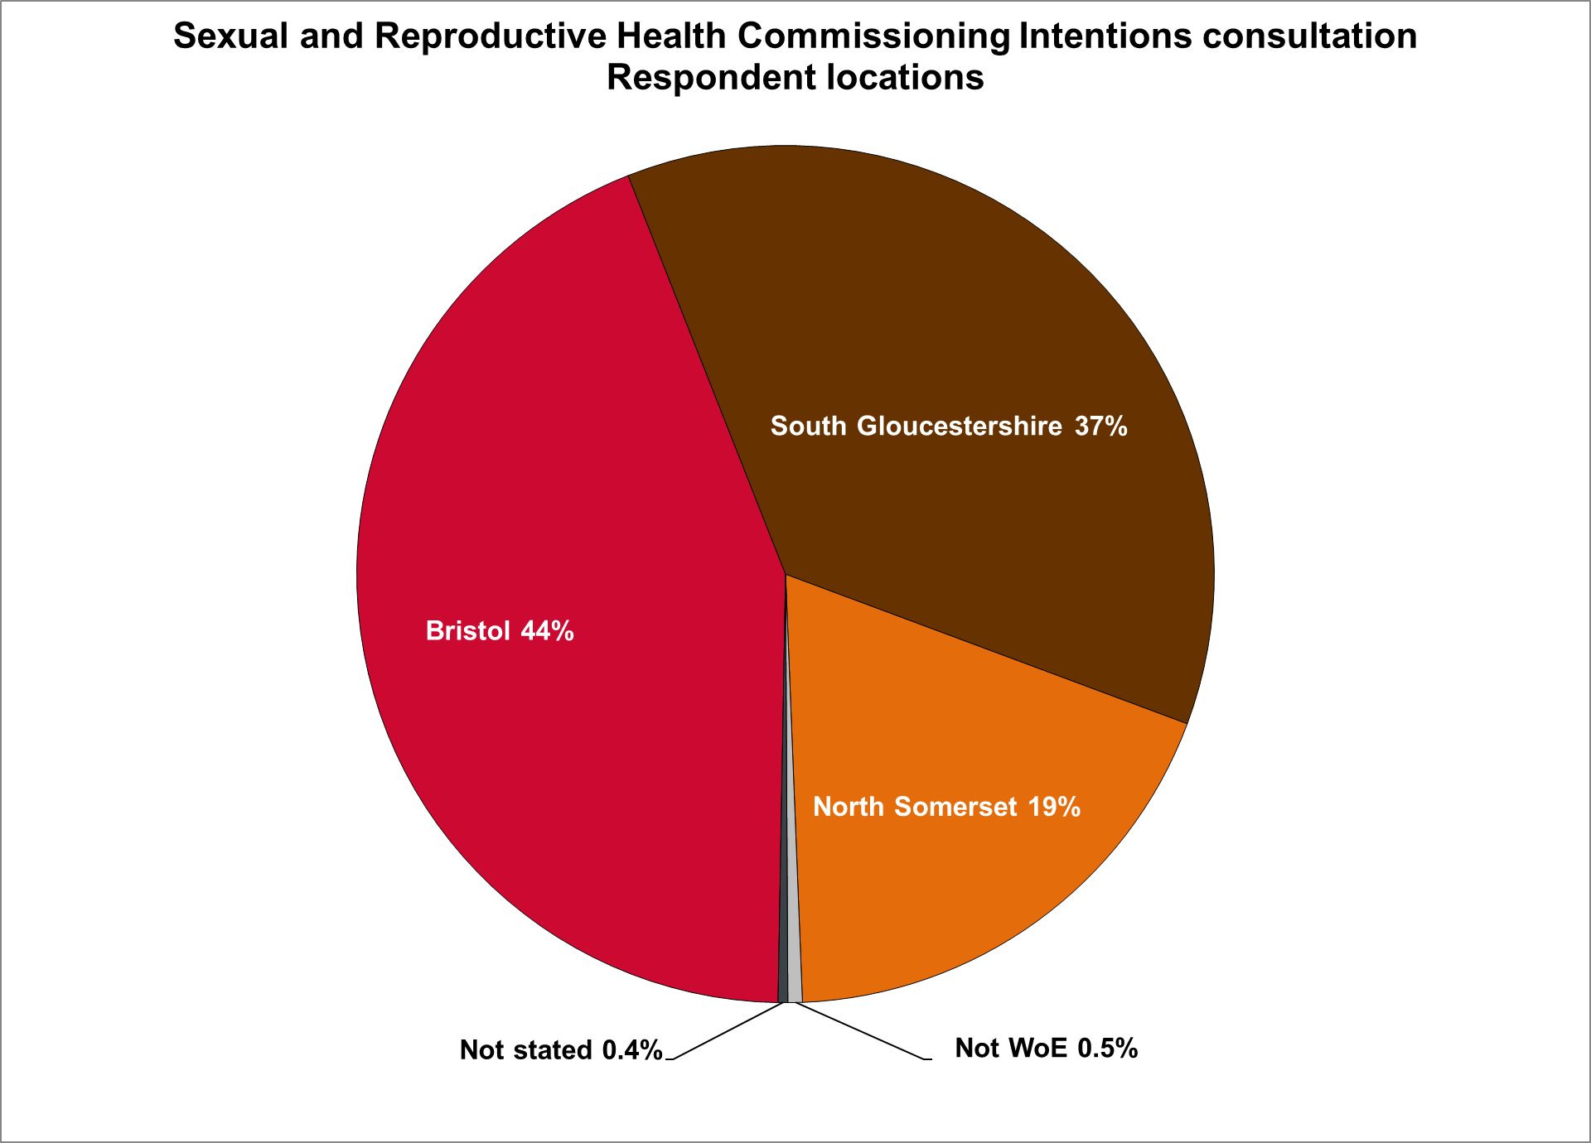
Of the 241 responses from within the Bristol City Council area, 156 provided full or partial postcodes from which the ward of origin could be identified (Figure 2).
Figure 2: Distribution of responses by wards in Bristol
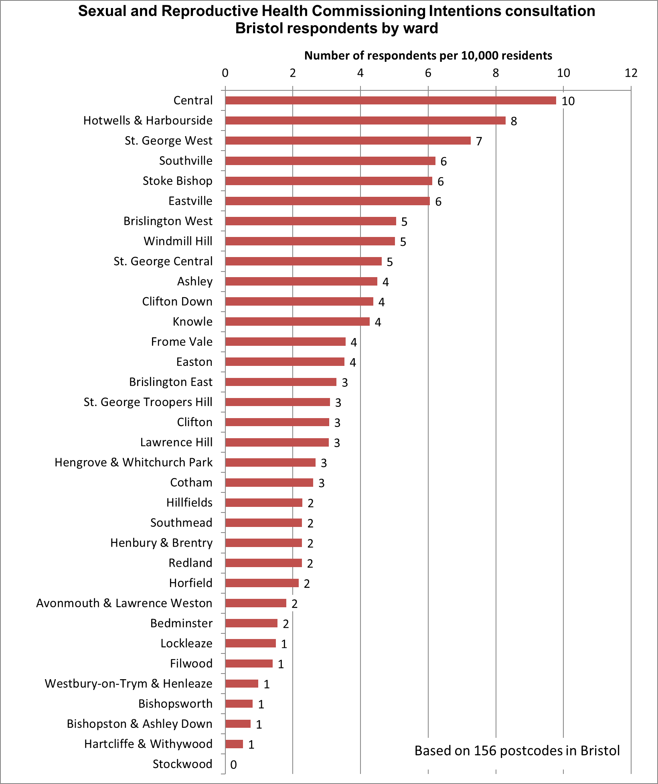

Of the 202 responses from within the South Gloucestershire Council area, 146 provided full or partial postcodes from which the ward of origin could be identified (Figure 3).
Figure 3: Distribution of responses by wards in South Gloucestershire
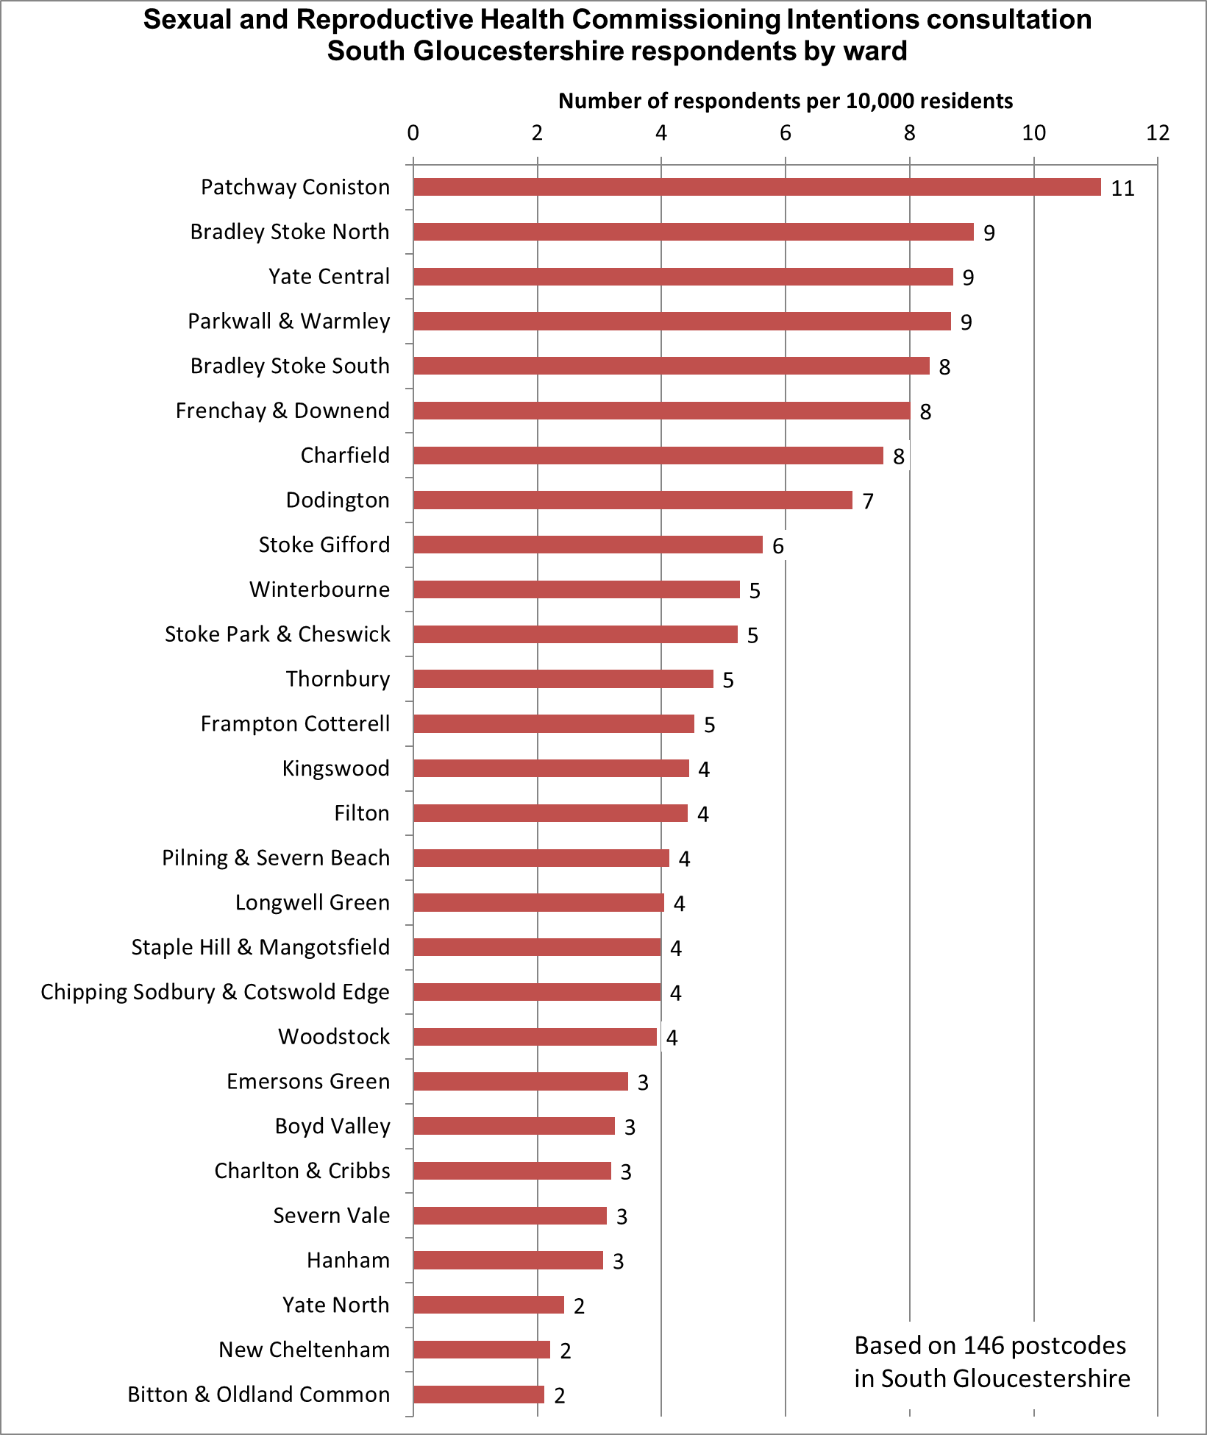

Of the 103 responses from within the North Somerset Council area, 54 provided full or partial postcodes from which the ward of origin could be identified (Figure 4).
Figure 4: Distribution of responses by wards in North Somerset
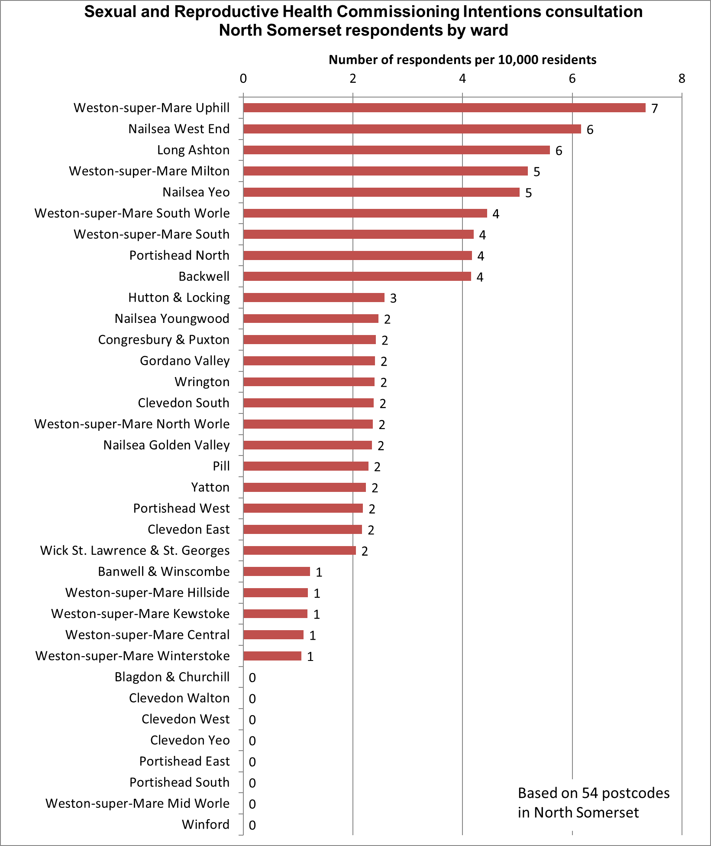

Response rate from areas of high and low deprivation
The home location of respondents in each local authority in the BNSSG area was compared with nationally published information on levels of deprivation across each local authority. This helps to understand if the respondents include a cross-section of people living in more deprived and less deprived areas. It can also show if the views of citizens in more deprived areas differ from people living in less deprived areas.
The comparison looked at levels of deprivation in 10 bands (known as ‘deciles’) from
decile 1 (most deprived) to decile 10 (least deprived). Figure 5 compares the percentage of Bristol respondents living in each of the deprivation deciles (red bars) to the percentage of all Bristol citizens who live in each decile (grey bars). Figure 6 and Figure 7 show equivalent data for South Gloucestershire and North Somerset, respectively.
Note that in each authority, the proportion of the population living in each deprivation decile is different. This is shown by the different lengths of the grey bars in each authority). For example, 15% of Bristol’s population lives in areas which are in the top 10% of deprived areas in England (decile 1). For North Somerset, 6% of citizens live in the most deprived 10% of areas in England. For South Gloucestershire, none of the population lives in the most deprived 10% of areas in England.
Percentages in Figures 5, 6 and 7 are given to the nearest integer. The length of bars in the charts reflect the unrounded percentage; hence bars shown as 10% may be slightly different in length.)

Figure 5: Response rate from areas of high and low deprivation in Bristol
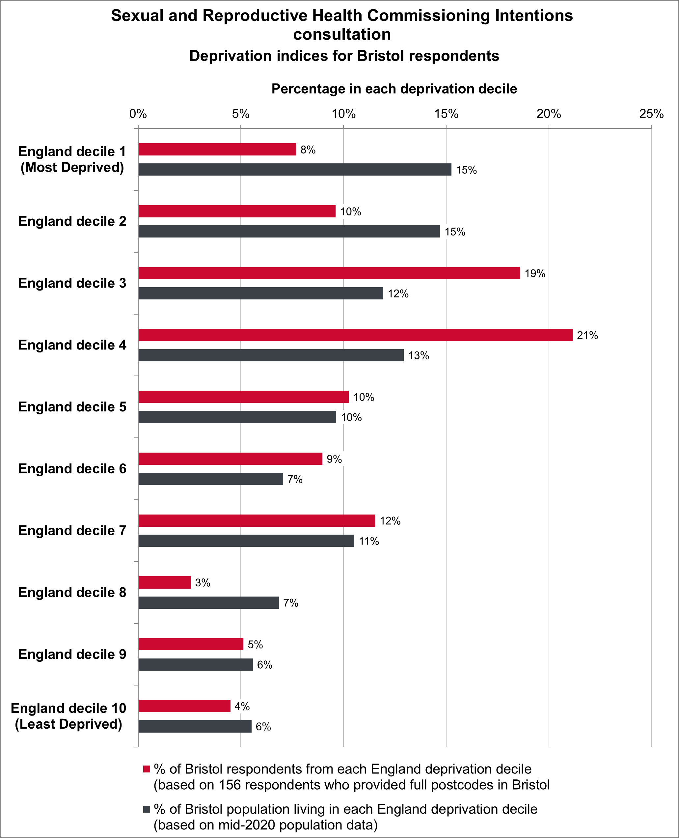
Figure 5 shows there was an underrepresentation of responses from the most deprived two deciles (deciles 1 and 2) and from two of the least deprived deciles in Bristol (deciles 8 and 10). Responses from deciles 3, 4, 6 and 7 were overrepresented.
Responses from deciles 5 and 9 closely matched the proportion of people living in those deciles.
Figure 6: Response rate from high and low deprivation areas in South Gloucestershire
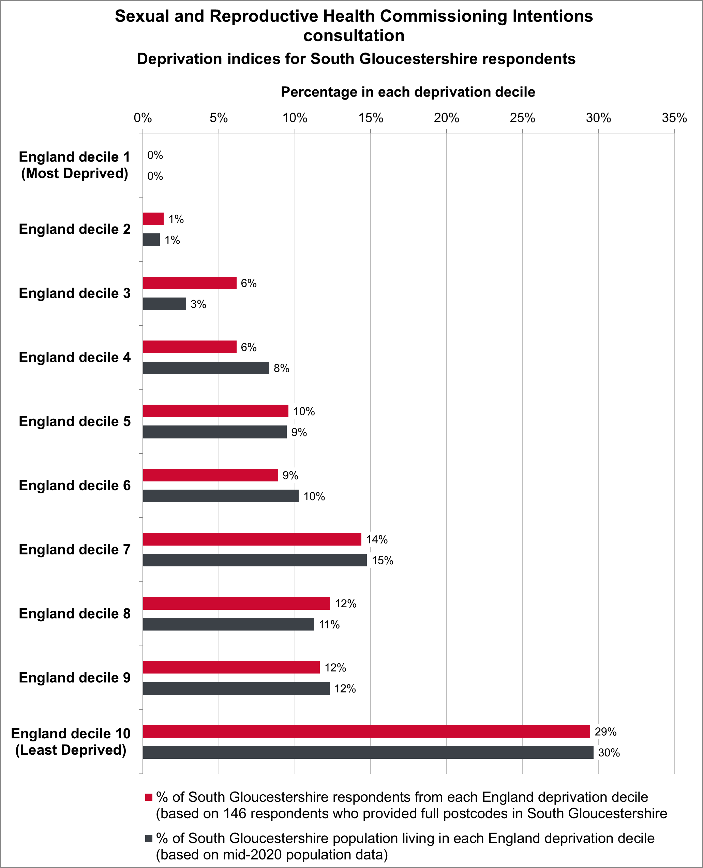
Figure 6 shows responses from the most deprived parts of South Gloucestershire (decile 2) closely matched the proportion of people living in those areas. Response rates from the least deprived deciles 5, 6, 7, 8, 9 and 10 also closely matched the population profile.
Responses from decile 3 were overrepresented and from decile 4 were underrepresented.
No parts of South Gloucestershire are in the most deprived 10% of English areas (decile 1) and there can therefore be no respondents from decile 1.
Figure 7: Response rate from high and low deprivation areas in North Somerset
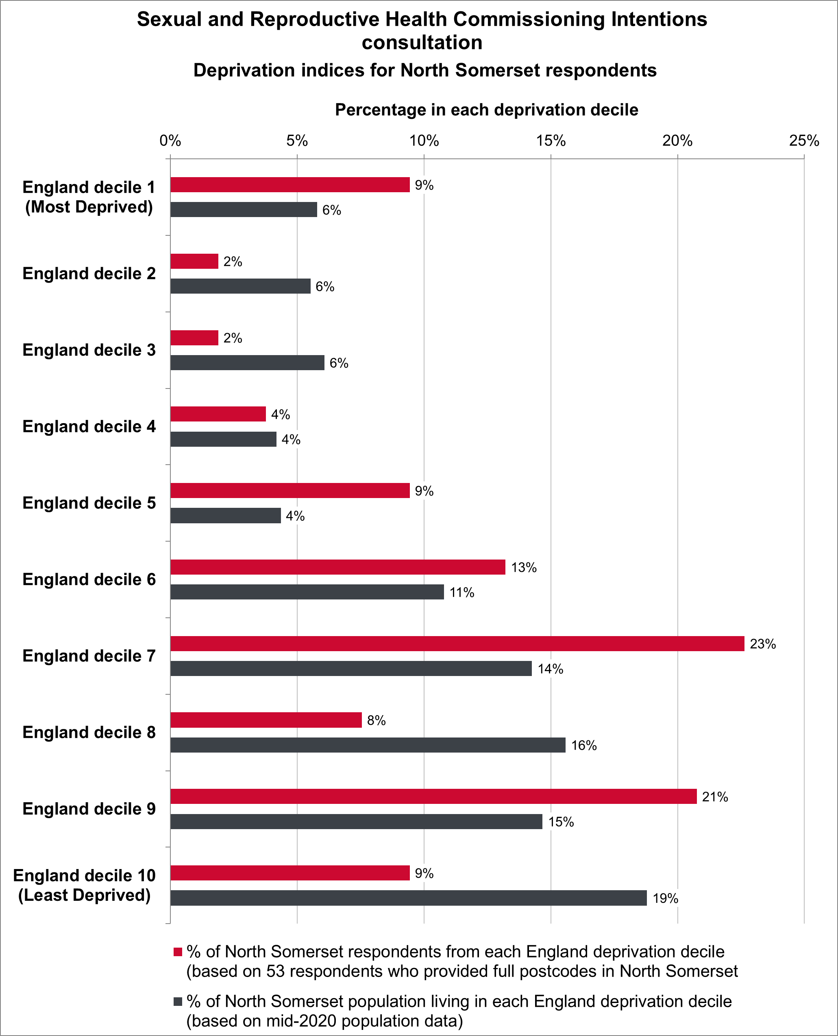
Figure 7 shows responses from the most deprived areas in North Somerset (decile 1) were overrepresented, as were responses from deciles 5, 6, 7 and 9.
Responses from deciles 2, 3, 8, and the 10% least deprived areas of North Somerset (decile 10) were underrepresented.
Responses from decile 4 closely matched the proportion of people living in that decile.

Characteristics of respondents

Overview
537 (97%) people answered one or more of the equalities monitoring questions in the survey. The proportions of respondents with each protected characteristic defined in the Equality Act 2010 are summarised below.
Figures 8 to 14 compare respondents’ protected characteristics with the profile for the resident population in the BNSSG area for seven protected characteristics (age, Disability, ethnicity, religion/faith, sex, transgender status, and sexual orientation) for which population data are available from the 2021 Census. Figures 8 to 14 show:
- All respondents: Proportions of protected characteristics for all respondents who answered the equalities questions
- BNSSG respondents: Proportions of protected characteristics of respondents who provided a postcode in Bristol, South Gloucestershire or North Somerset, or stated in question 1 which of the three authorities they live in
- BNSSG population: Proportions of each protected characteristic for the resident population in the BNSSG area based on the 2021 Census.

Figures 15, 16, and 17 show the proportions of all respondents and BNSSG respondents for three characteristics for which Census data are not available. These are pregnancy and recent maternity status (a protected characteristic) and two characteristics - carer status and refugee/asylum seeker status - that are not covered by the Equality Act.
In summary, the following groups were under-represented in the responses:
- Children and young people aged 24 years and younger, and people aged 65 and older
- People of Asian or Asian British backgrounds and Mixed or multiple ethnic groups
- Christians, Muslims, Hindus and Sikhs
- Males
- Heterosexual citizens.

The following groups responded in higher numbers than their proportion in the population:
- People aged 25 to 64 years
- Disabled people
- Black/African/Caribbean/Black British citizens, Gypsy/Roma/Travellers, White British respondents, Other White respondents,
- People with no religion, Buddhists, Jews, and people who specified ‘Other religion’
- Females
- Transgender respondents
- Bi, Gay / Lesbian, and people who use another term to describe their sexual orientation.
Chapter 5 describes the effects that respondents said the proposals would have on them because of their protected characteristics.

Age
The highest number of responses were from respondents aged 35-44 years (29%), followed by 25-34 (21%) and 45-54 (20%). All age groups between 25 and 64 responded in higher proportions than these ages in the population. Survey responses from children (under 18), young people aged 18-24, people aged 65 and older were under-represented (Figure 8).
Figure 8: Age of respondents
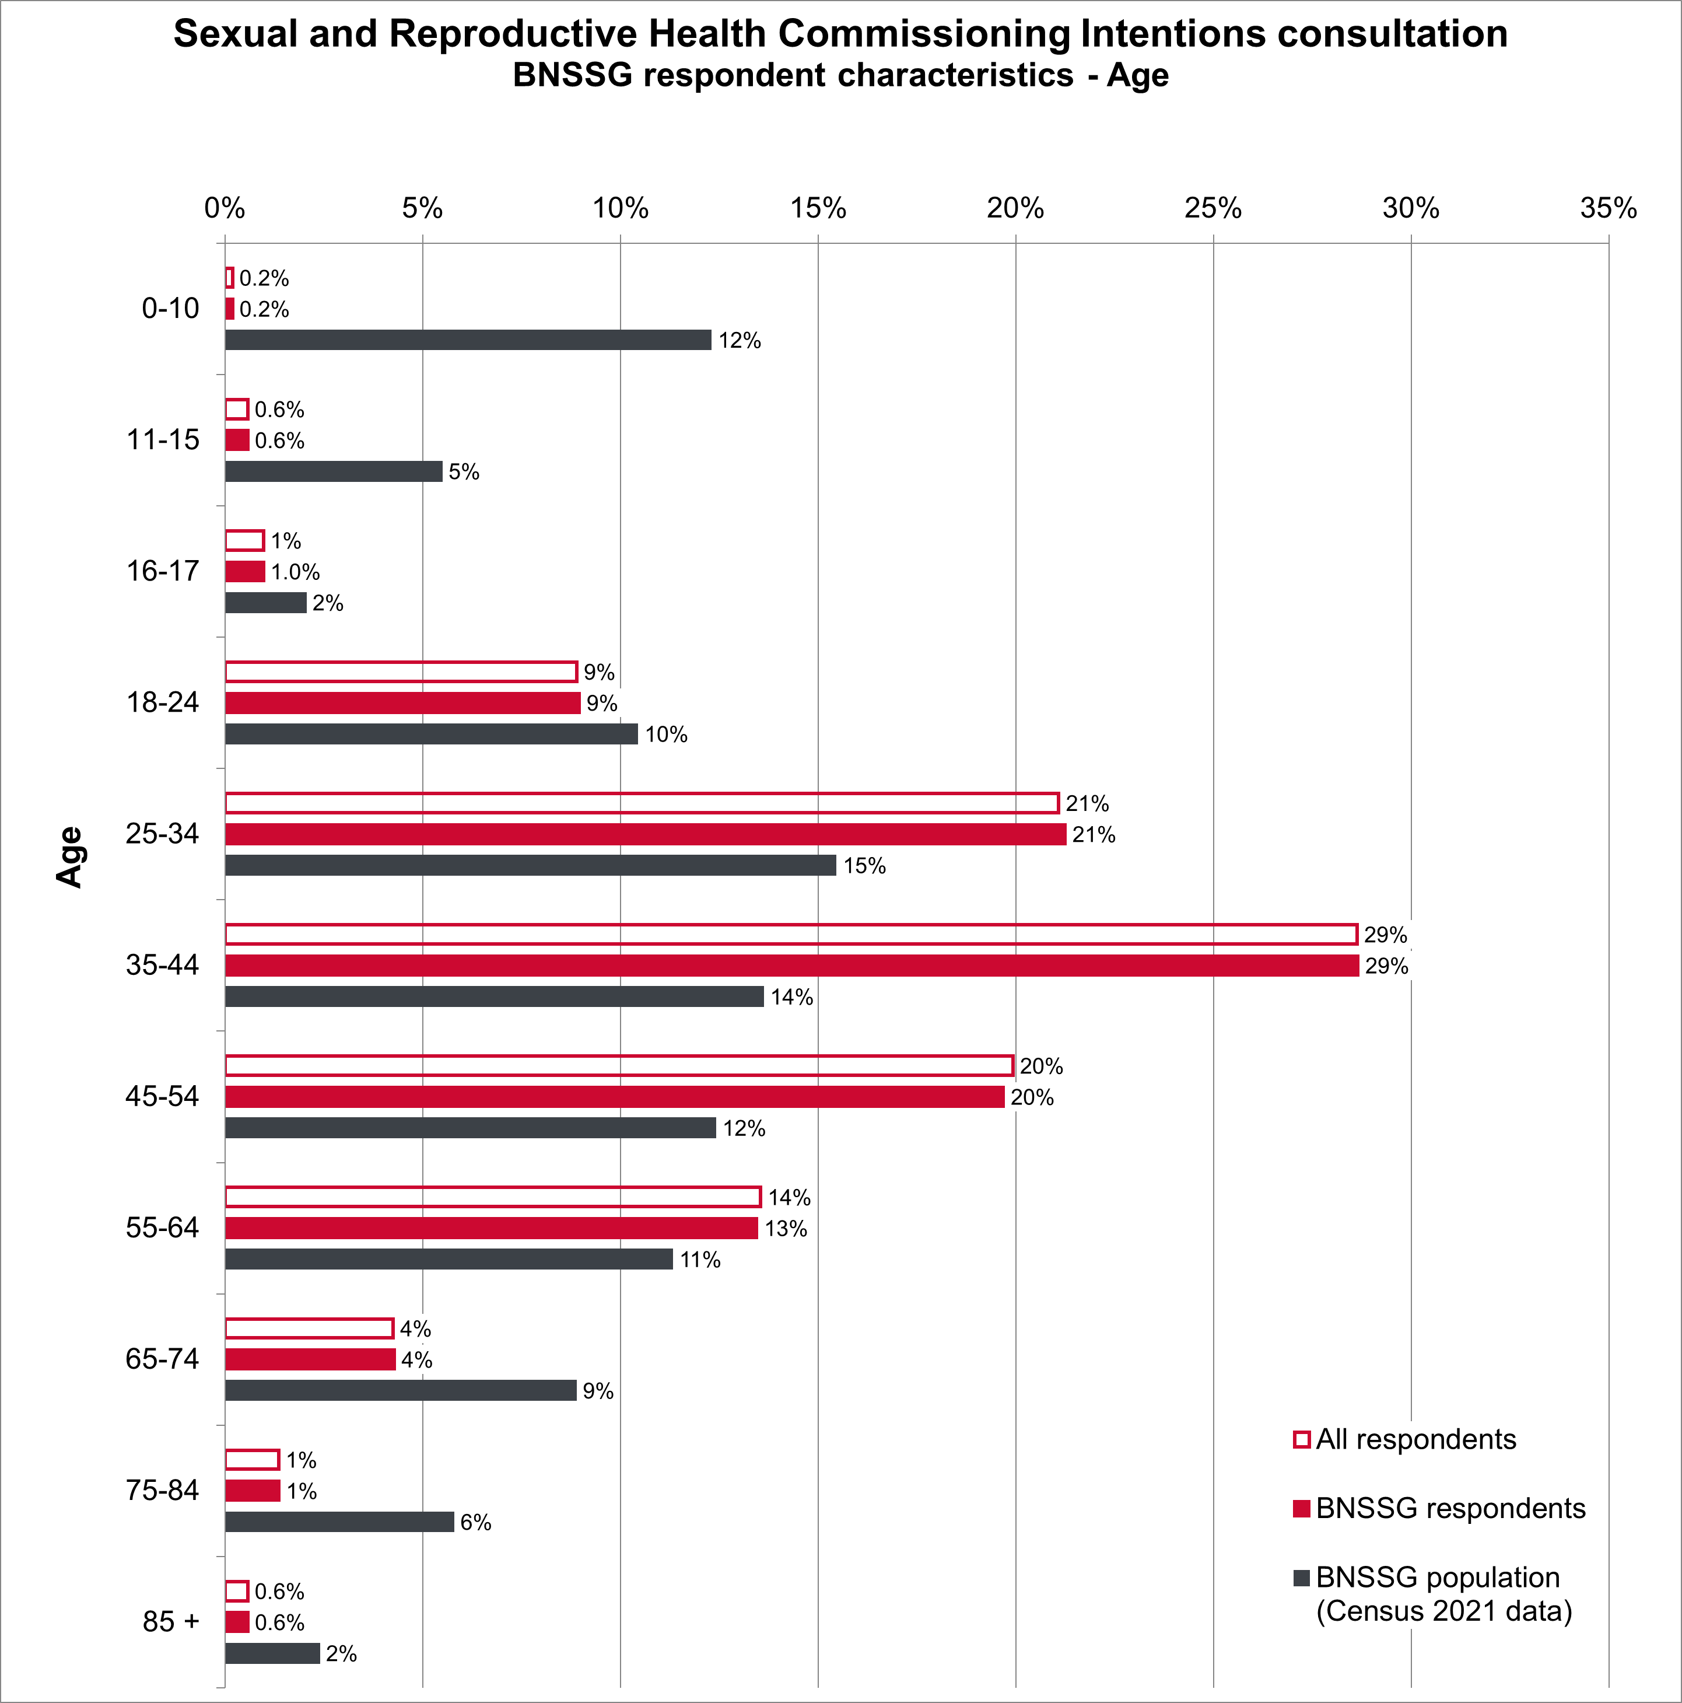

Disability
Disabled respondents (13% of all respondents; 13% of BNSSG respondents) were
over-represented compared with the proportion of Disabled people living in the BNSSG area (Figure 9).
Figure 9: Disability
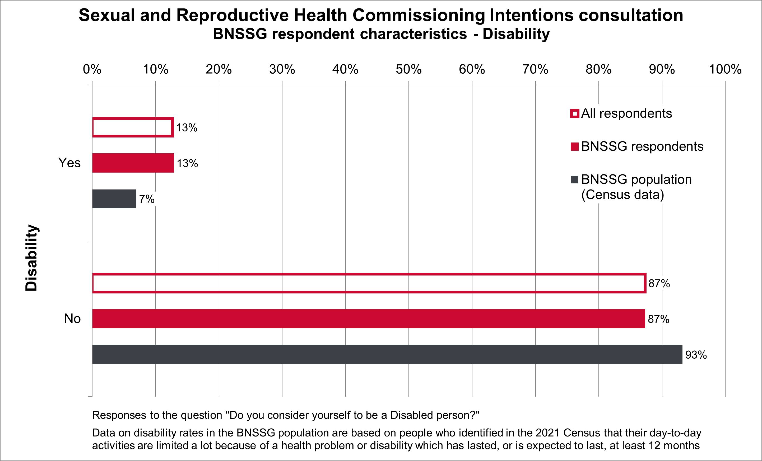

Ethnicity
Response rates from White British respondents (82%), Other White respondents (8%), Black/African/Caribbean/Black British citizens (4%), and Gypsy/Roma/Travellers (0.4%) are slightly higher than the proportions of these groups resident in the BNSSG population.
Asian / Asian British citizens and Mixed/multi-ethnic citizens were under-represented in the response rates compared to the proportion of people in each of these ethnic groups living in the BNSSG area.
The response rate from people with an “other ethnic background” (1%) closely matches the proportions of people in these ethnic groups living in the BNSSG area (Figure 10).
Figure 10: Ethnicity of respondents
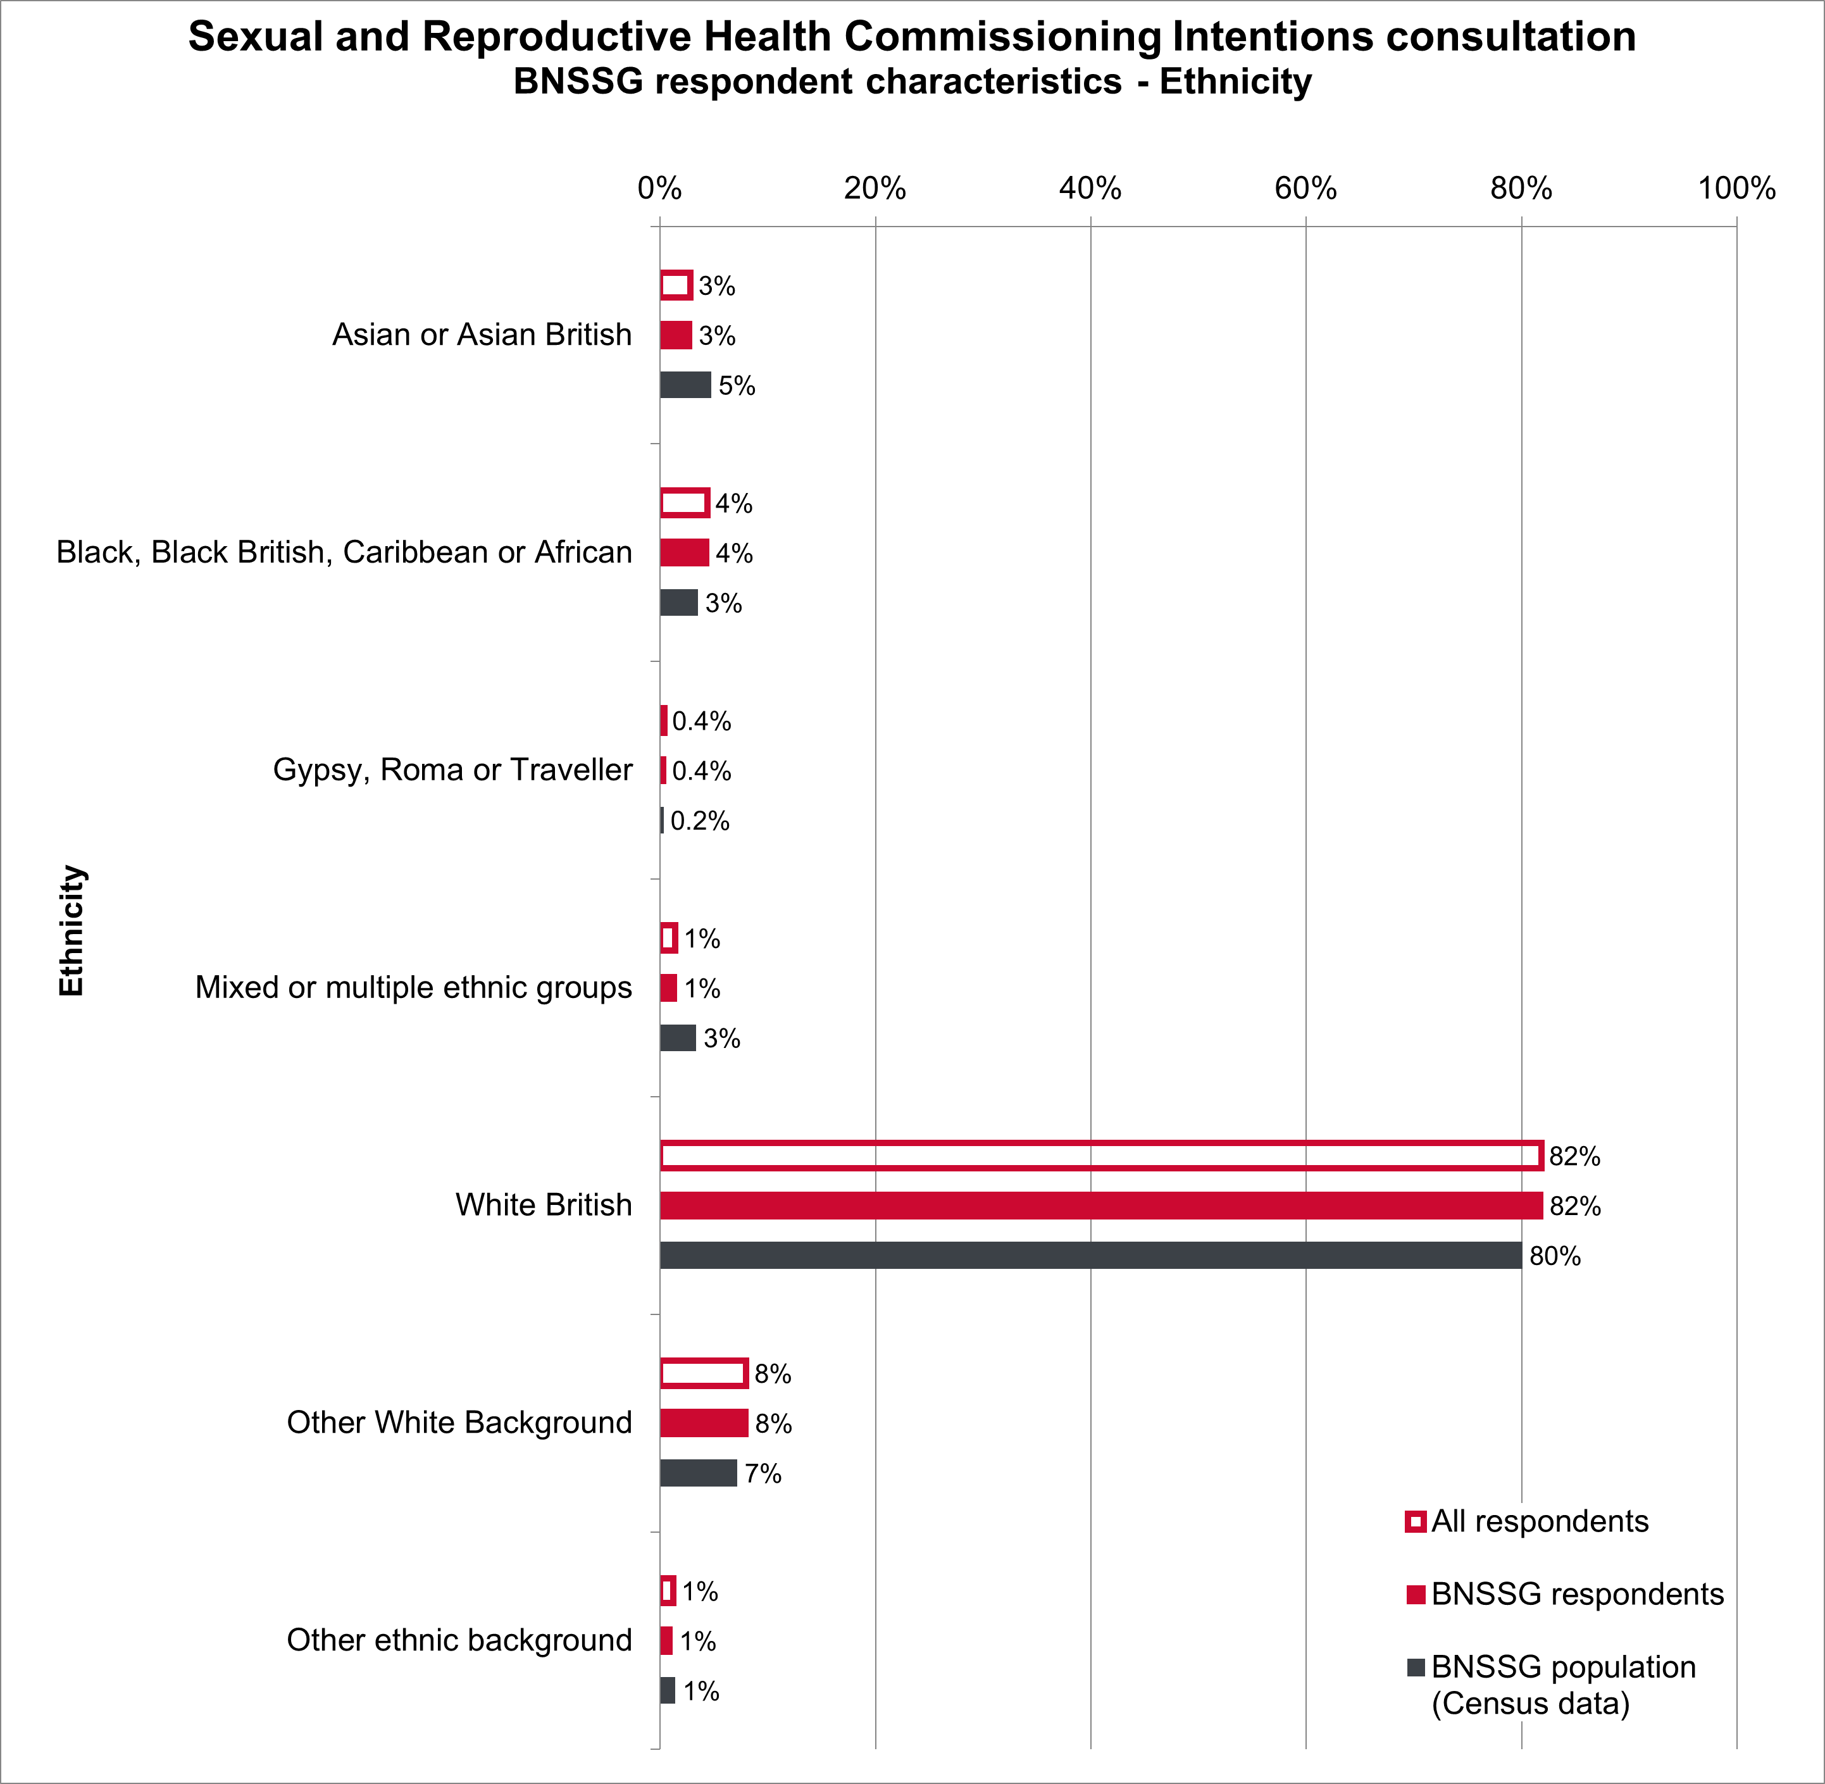

Religion/faith
People with no religion (63% of respondents) responded in higher proportion than people of no religion in BNSSG’s population (52%). Buddhists (3%), Jews (0.4%), and people who specified ‘Other religion’ (2%) also responded in greater numbers than the proportions of these faiths in the BNSSG area.
Christians (29%), Muslims (0.8%), Hindus (0.4%) and Sikhs (0%) were underrepresented compared to the proportions of these faiths living in the BNSSG area (Figure 11).
2% of respondents were Pagan. There are no Census 2021 data for the proportion of Pagans in the population.
Figure 11: Religion/faith of respondents
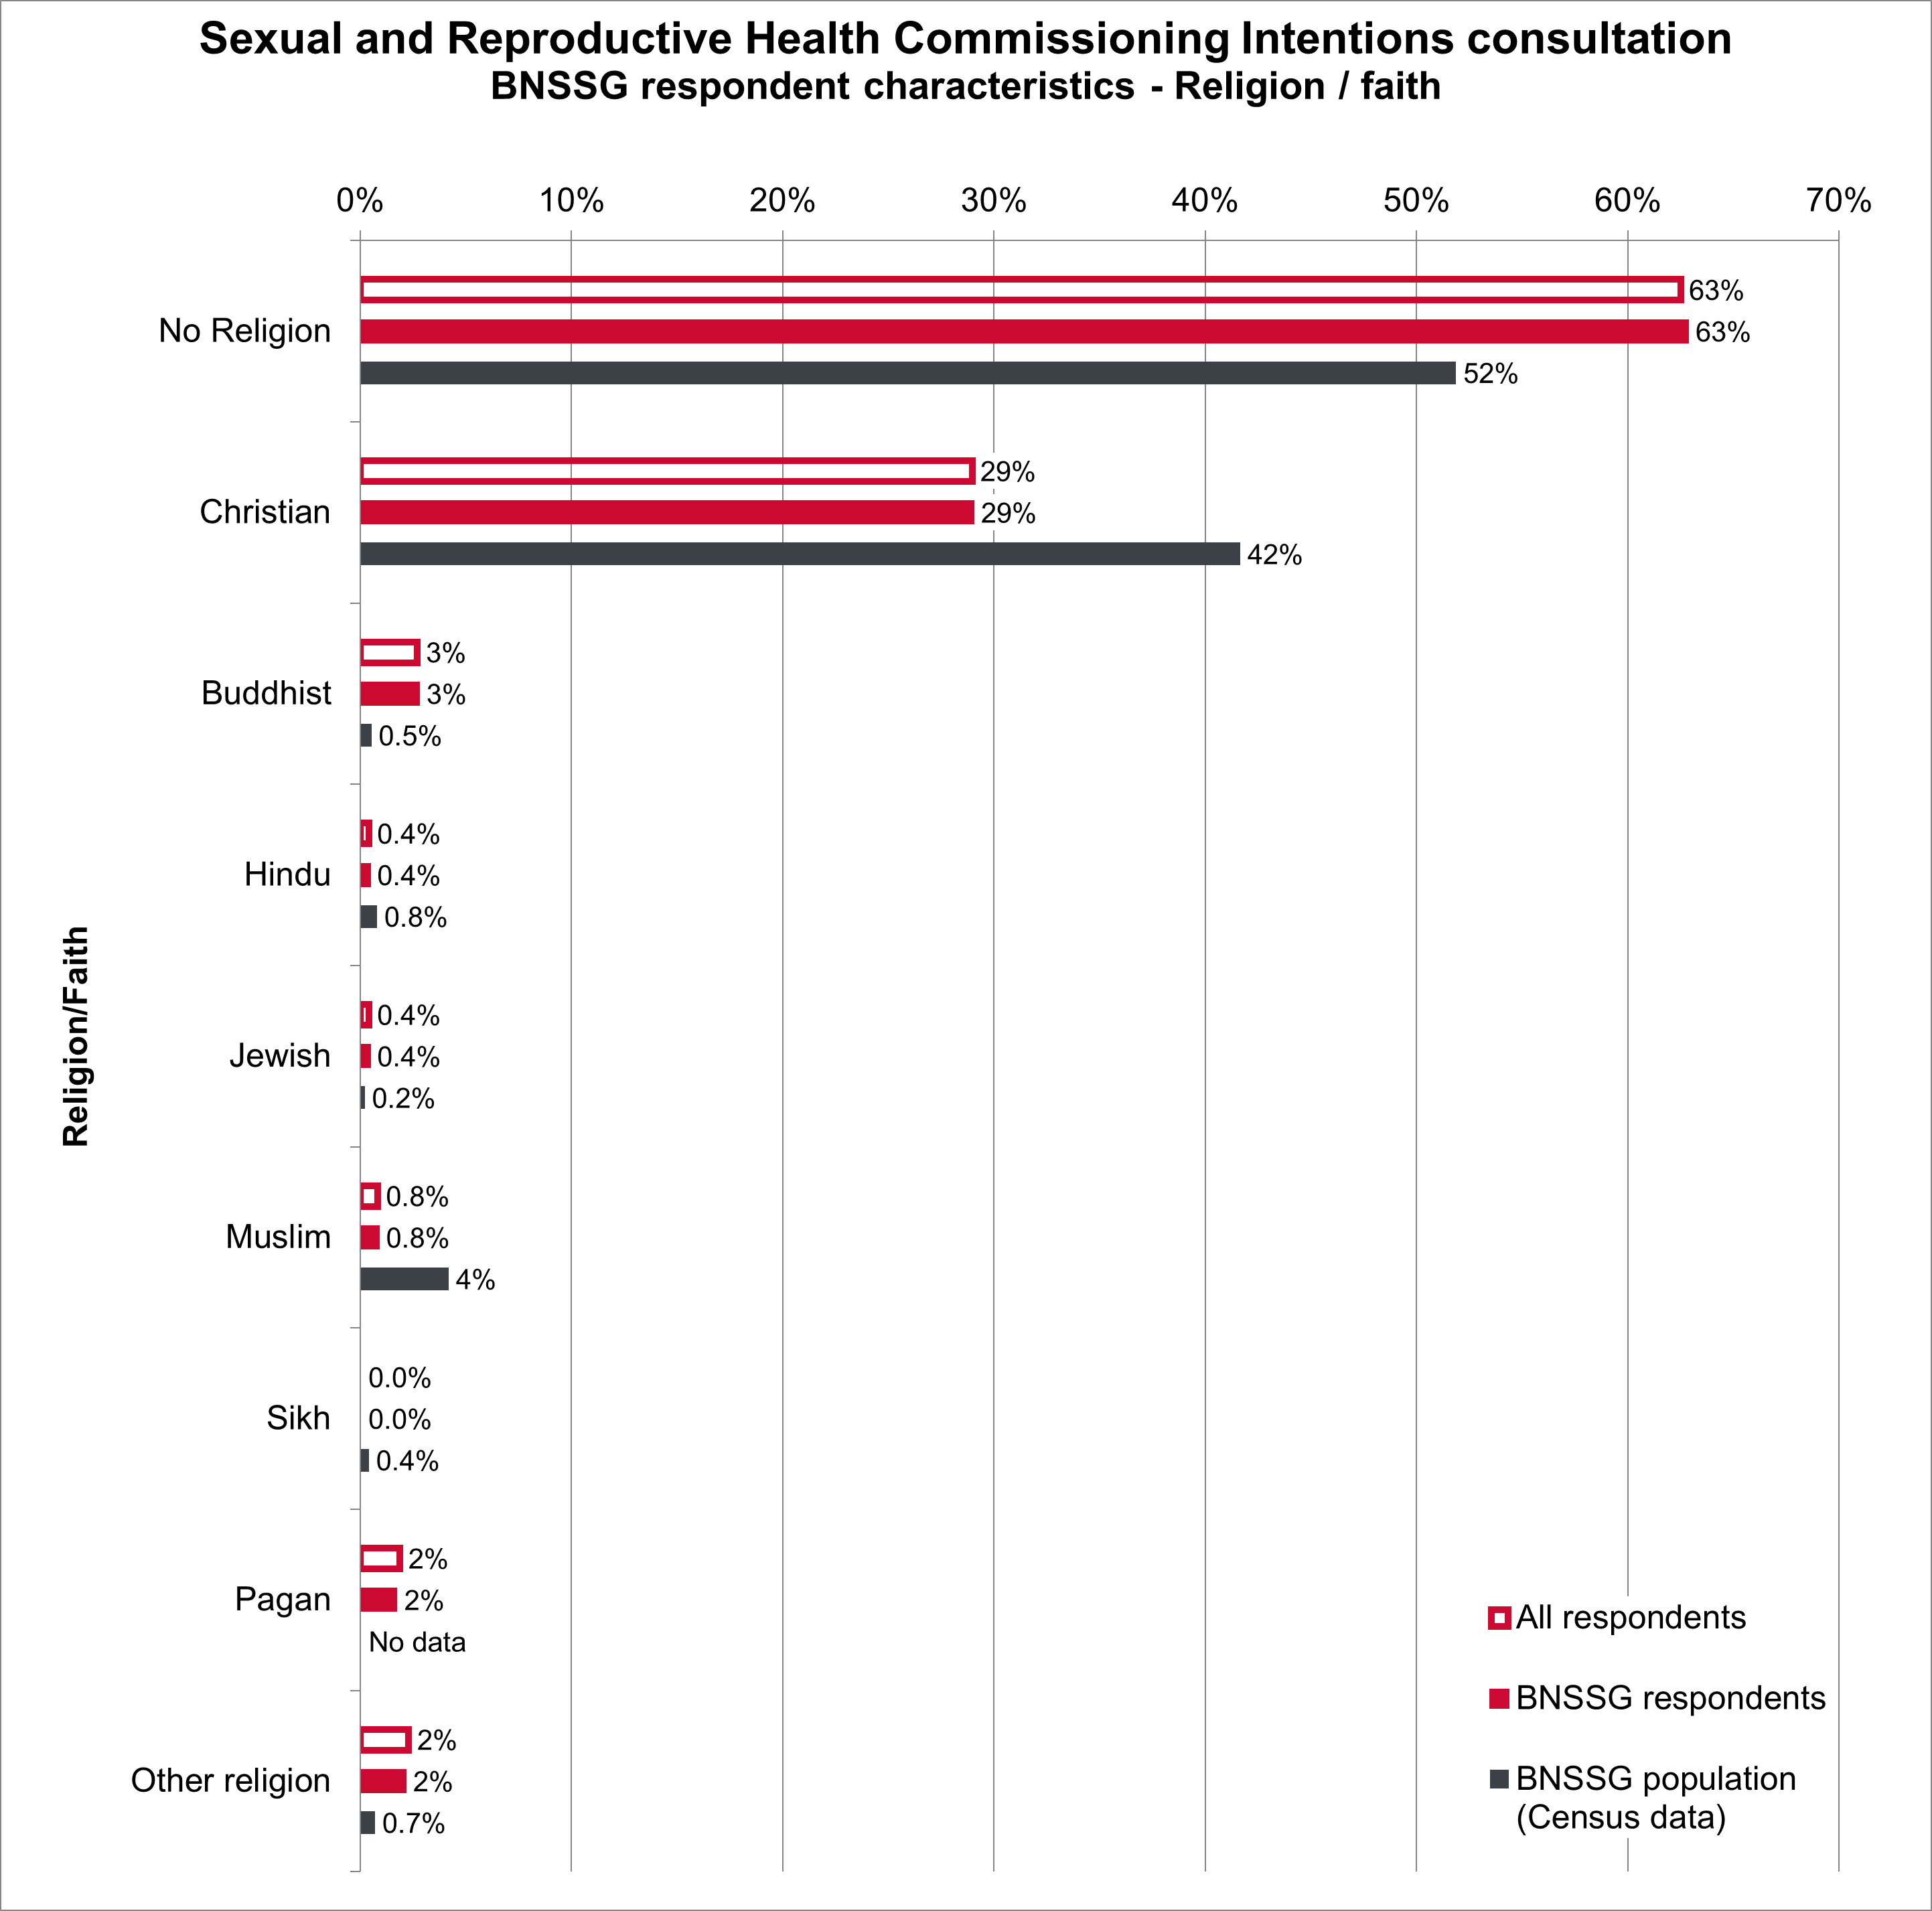

Sex
72% of all respondents were female, significantly more than the 51% of the population who are female in the BNSSG area.
Male respondents are underrepresented; 28% of responses compared to 49% of the BNSSG population that are male.
0.4% of responses were from people who stated their sex as ‘other’ (Figure 12).
Figure 12: Sex of respondents
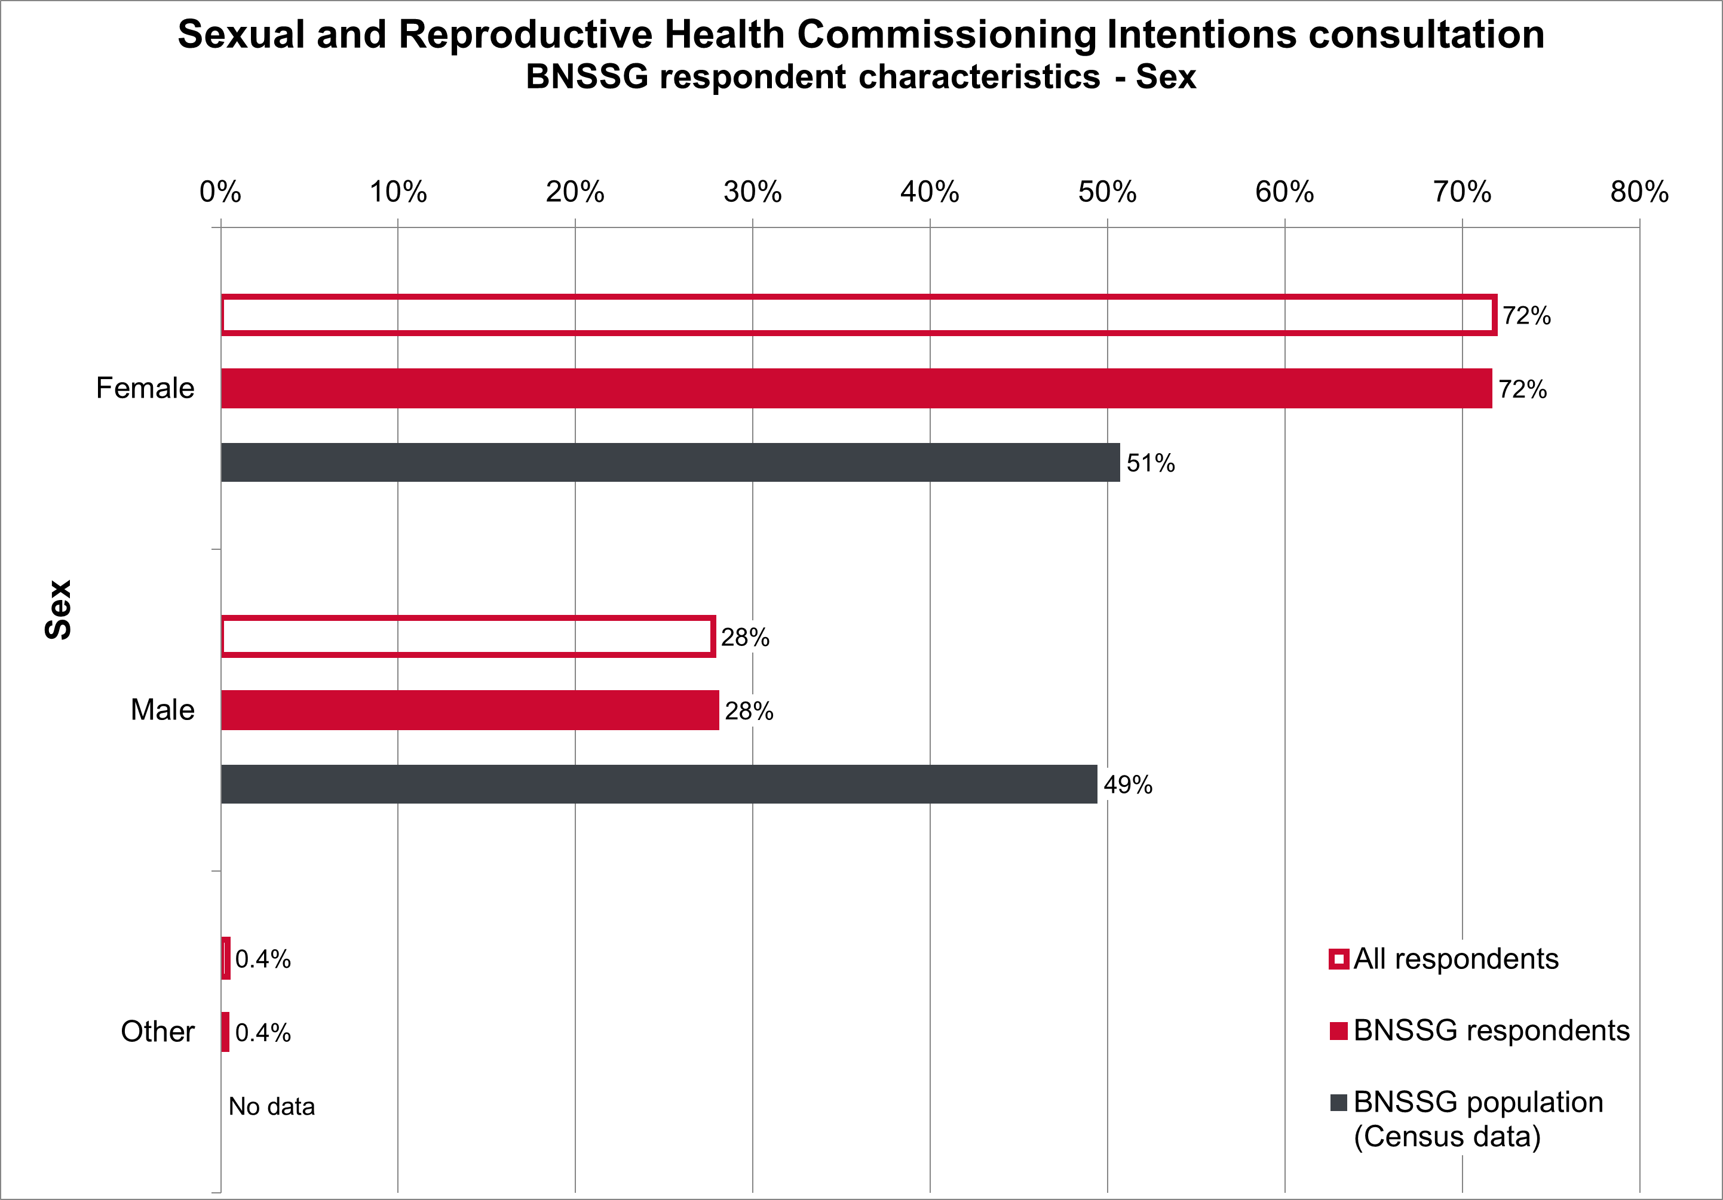

Gender reassignment
3% of respondents stated they have a gender identity different from their sex recorded at birth. This is higher than the 1% of the population in the BNSSG area. (Figure 13).
Figure 13: Gender reassignment
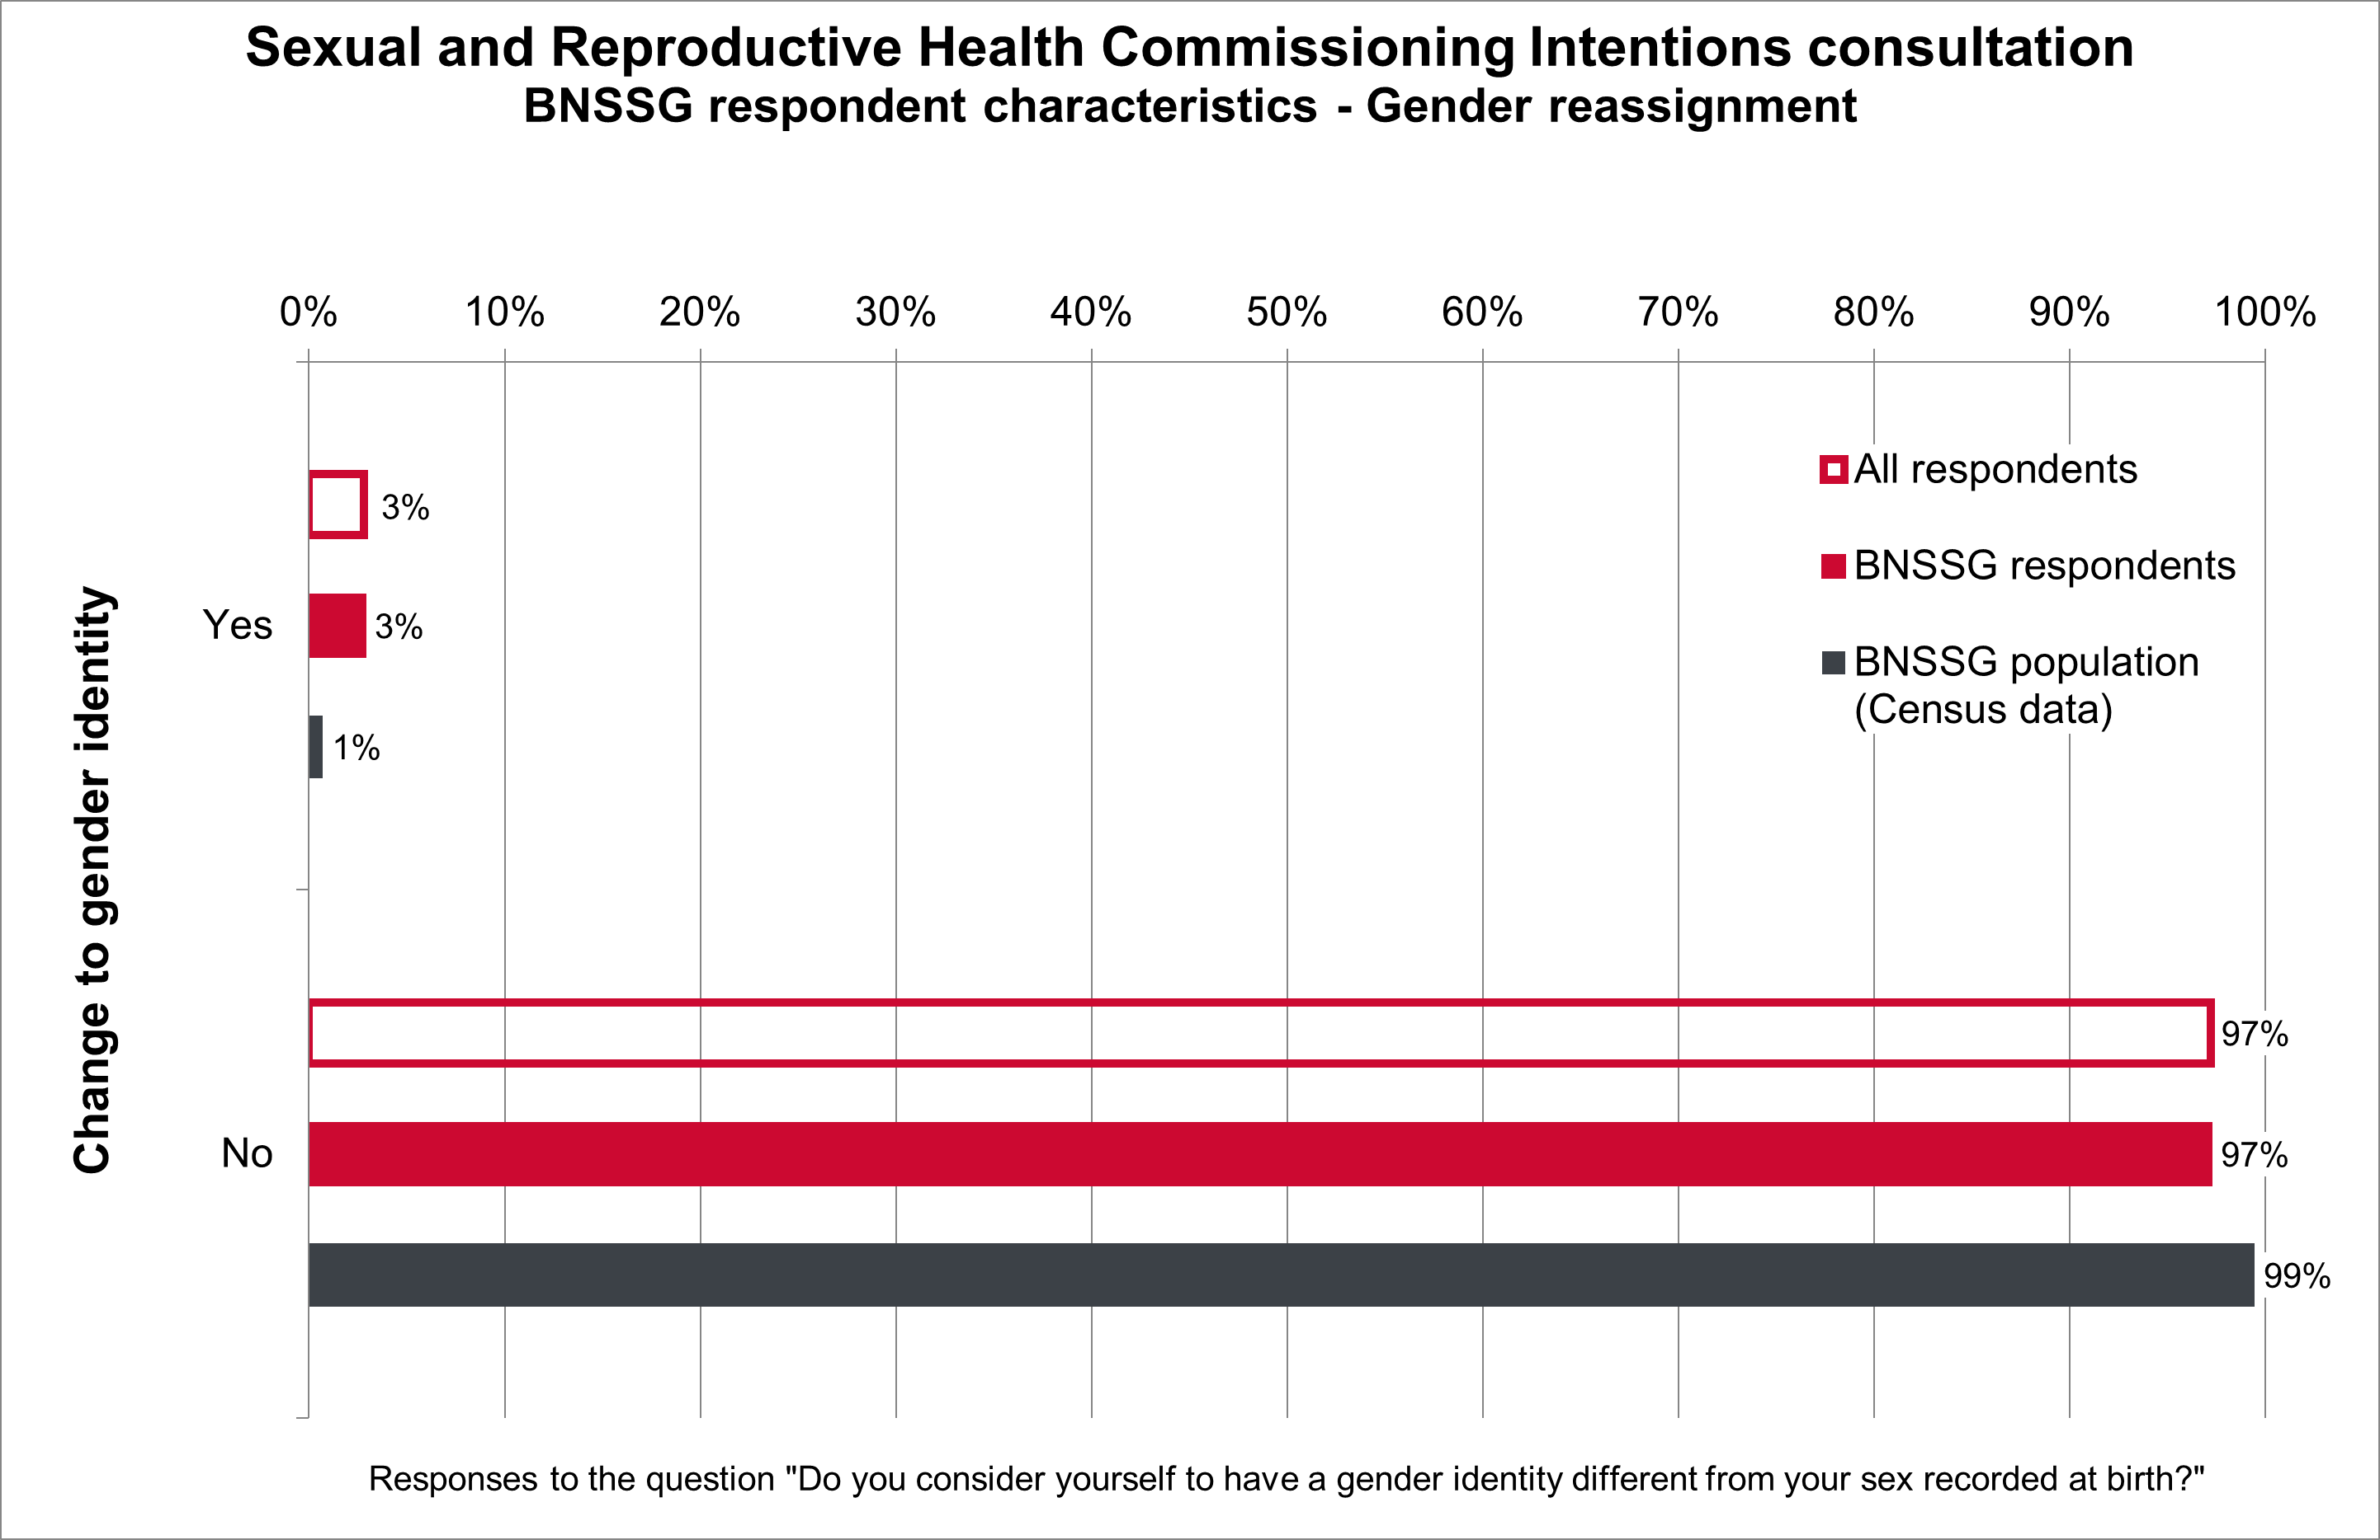

Sexual orientation
Heterosexual respondents (74% of respondents) were underrepresented compared to the proportion of heterosexual people in the BNSSG population (95%).
Gay / Lesbian respondents (12%), Bi respondents (11%), and people who use another term to describe their sexual orientation (3%) were over-represented compared with the BNSSG population (Figure 14).
Figure 14: Sexual orientation of respondents
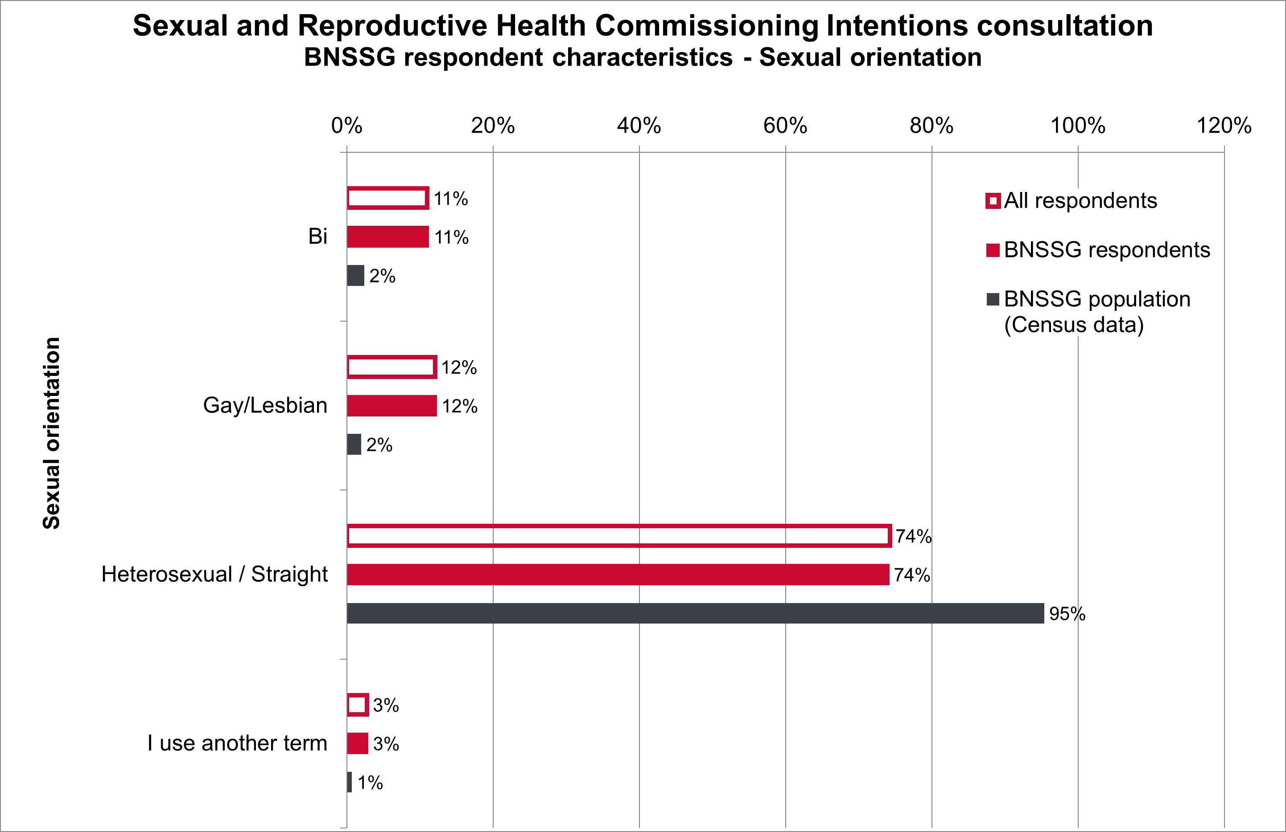

Pregnancy and maternity, carer status and and refugee/asylum status
The survey also asked respondents about their pregnancy and recent maternity status, if they are a carer, and if they are a refugee or asylum seeker.
Census data are not available for the proportion of people with these characteristics living in the BNSSG area. Figures 15, 16, and 17 show the proportions of all respondents and BNSSG respondents for each of these characteristics. The proportion of each characteristic for all respondents closely matches the proportion for BNSSG respondents.
Figure 15: Pregnancy/Maternity
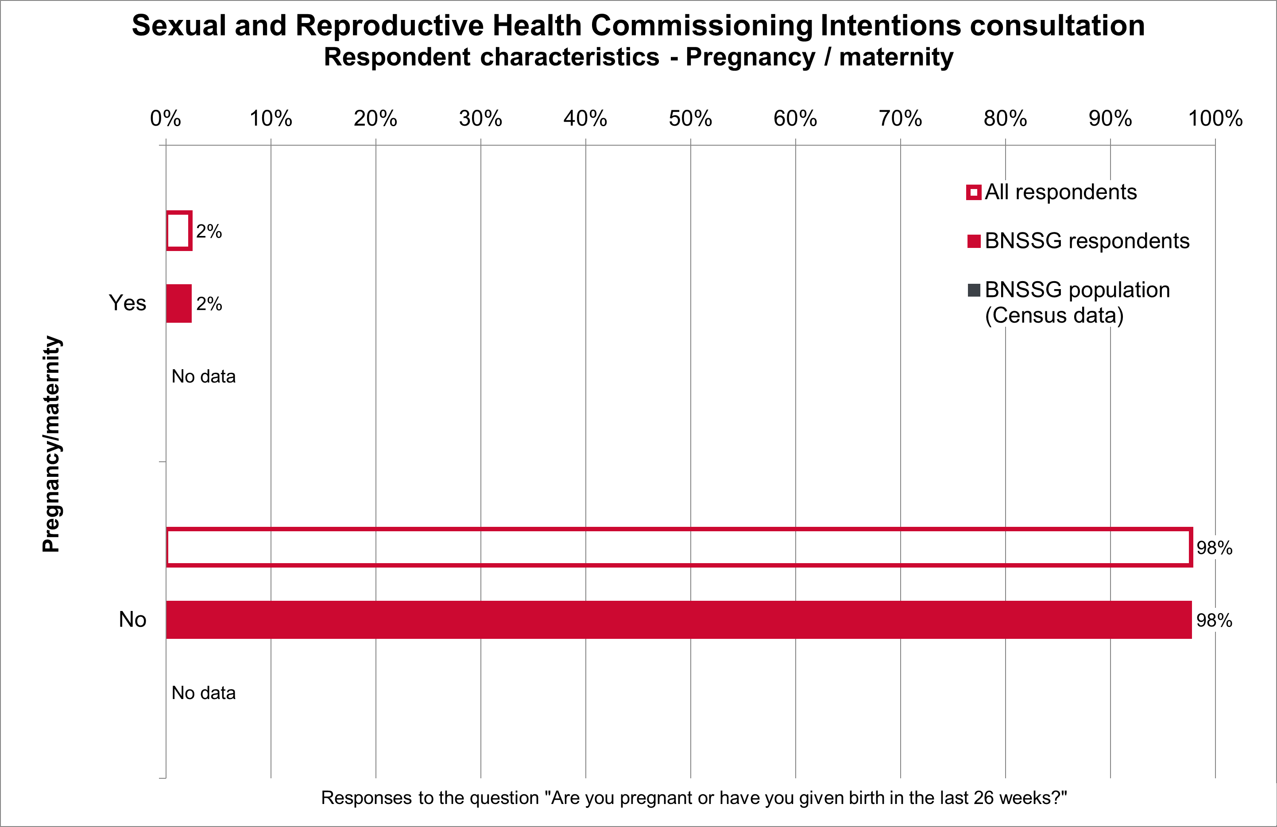
Figure 16: Carer status
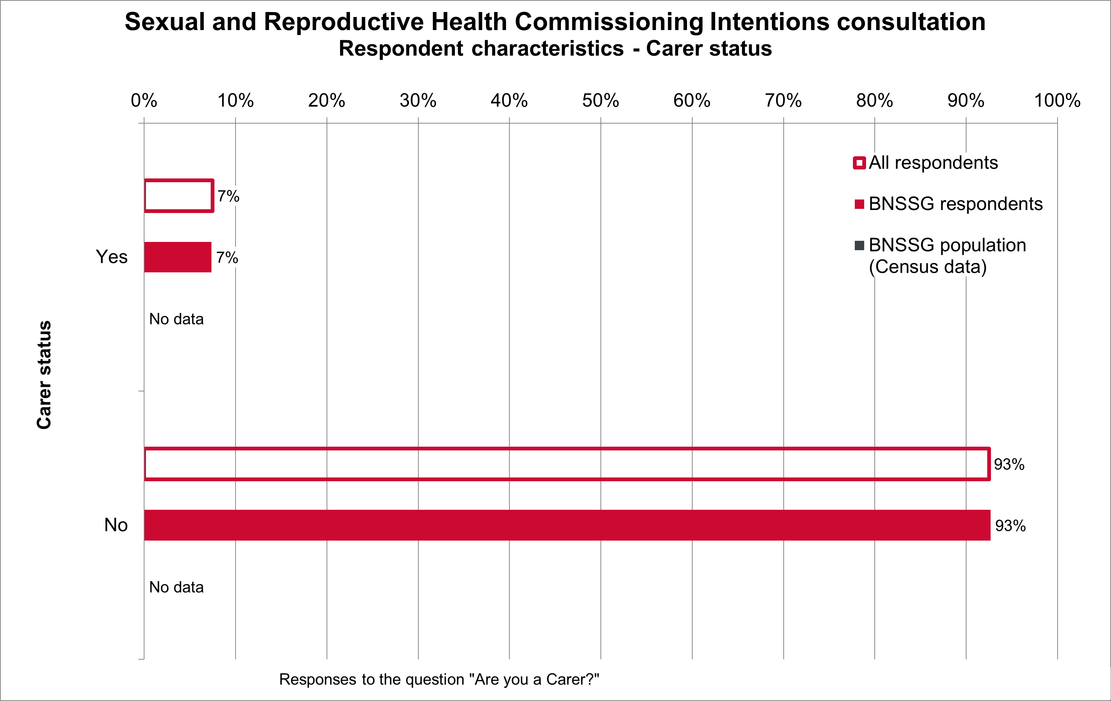
Figure 17: Refugee or asylum seeker status
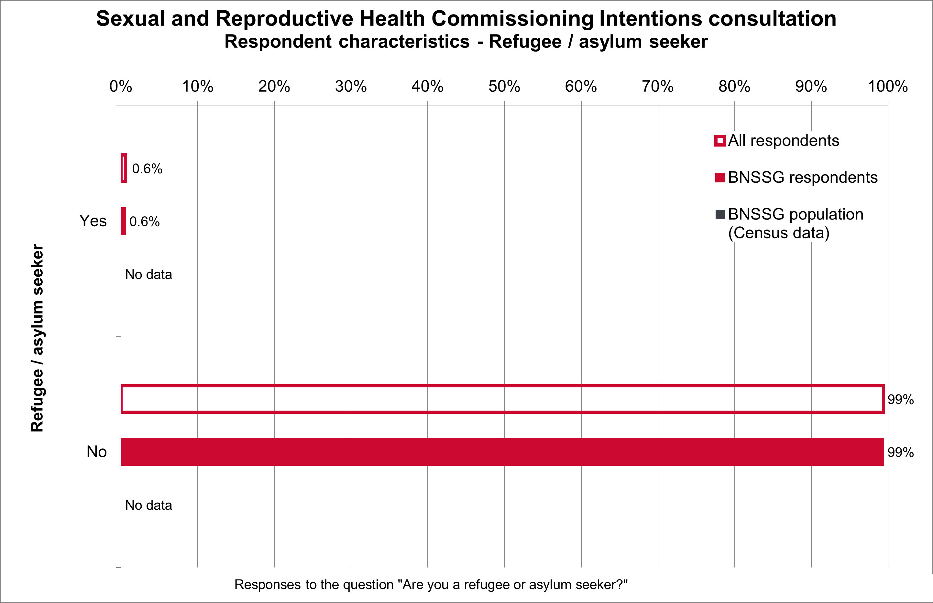

Survey results

Views on the vision

All respondents
Respondents were asked to rate the proposed vision on a scale of strongly agree to strongly disagree (Figure 18). Of the 549 respondents to the question:
- 283 (52%) strongly agreed
- 215 (39%) agreed
- 34 (6%) neither agreed nor disagreed
- 7 (1%) disagreed
- 10 (2%) strongly disagreed.
Figure 18: Views on the vision - all respondents
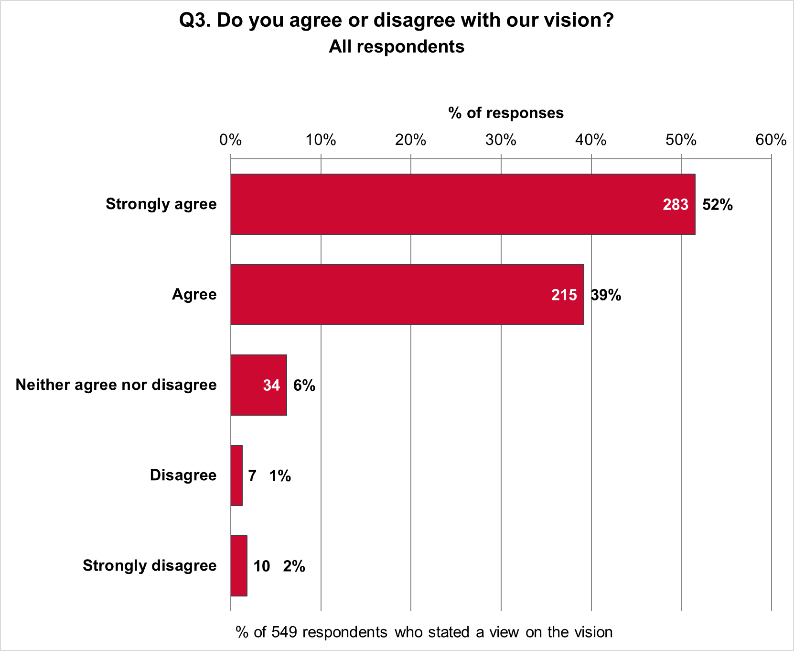

Views on the vision by sex
Figure 19 shows the proportions of 362 female and 140 male respondents who stated if they agreed or disagreed with the vision. Also shown are combined proportions for two respondents who identified as other sex and 45 respondents who did not state their sex.
The vision was more popular among women than among men, and least popular among the other sex / sex not stated group.
- 93% of women strongly agreed or agreed, compared with 87% of men and 85% of other sex / sex not stated.
- 6% of women neither agreed nor disagreed, compared with 7% of men and 6% of other sex / sex not stated.
- 1% of women strongly disagreed or disagreed compared with 6% of men and 9% of other sex / sex not stated.
Figure 19: Views on the vision by sex
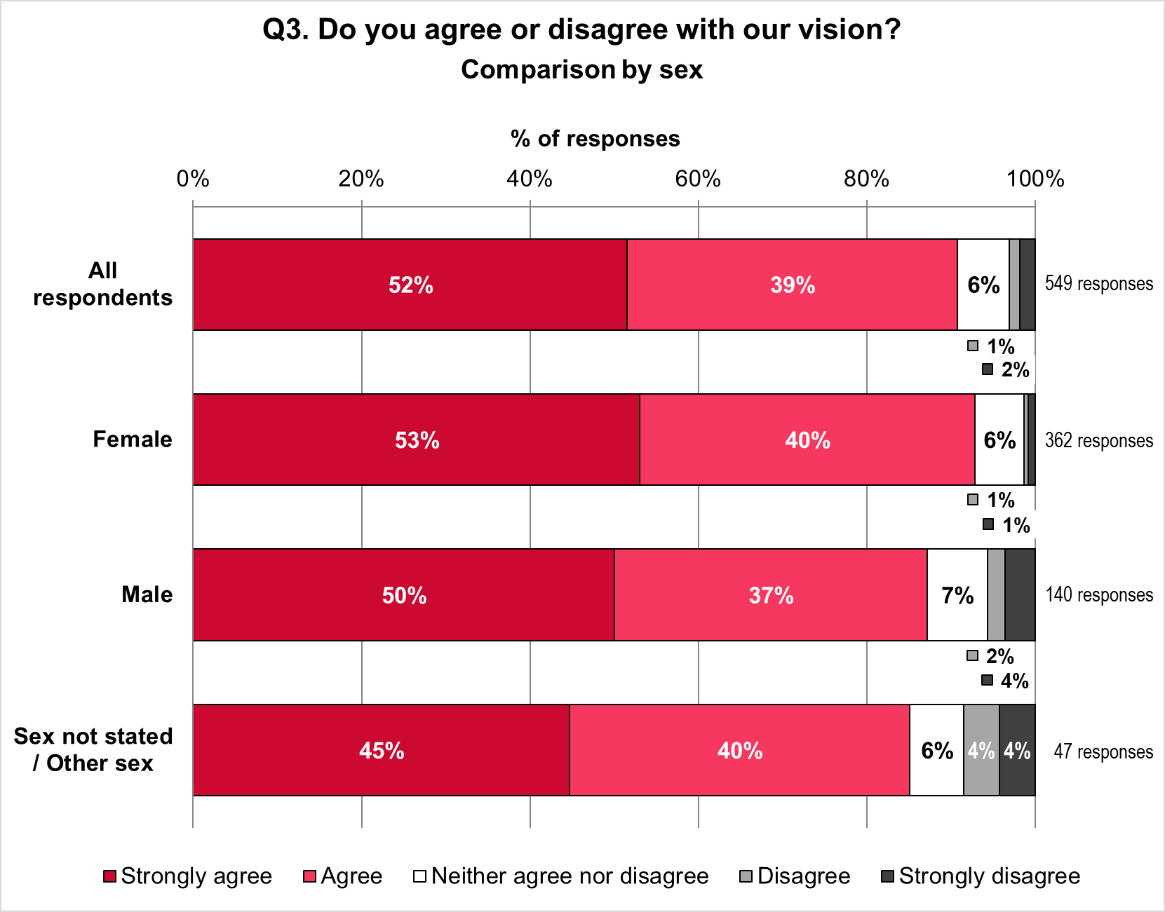

Views on the vision by ethnicity
Figure 20 compares the views of respondents on the vision, for all respondents and three ethnic groups. The groups are:
- 449 White British and White Other respondents
- 51 respondents of ‘Other ethnicity’, including Black, Black British, Caribbean, or African; Asian or Asian British; Mixed, or multiple ethnic groups; Gypsy, Roma or Traveller; and other ethnic background
- 49 respondents who did not state their ethnicity.
Figure 20: Views on the vision by ethnic group
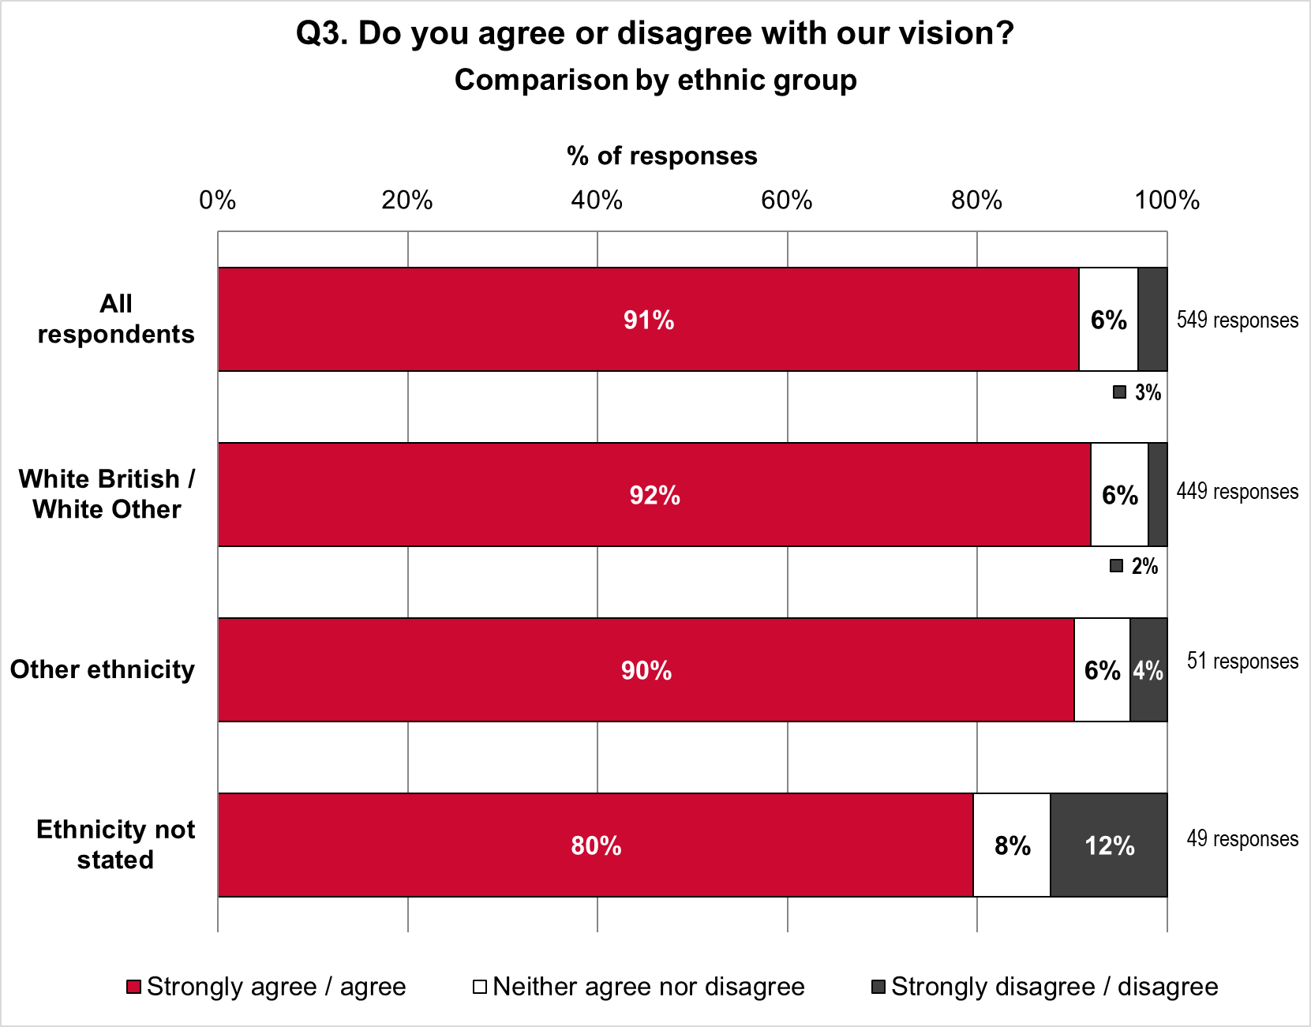
The vision was slightly more popular among White British and White Other people than for the other ethnic groups, and least popular among those who did not state their ethnicity.
- 92% of White British / White Other people strongly agreed or agreed with the vision, compared with 90% for respondents of Other Ethnicity and 80% for respondents who did not state their ethnicity.
- 6% of White British / White Other people neither agreed nor disagreed with the vision; this matches the 6% for respondents of Other Ethnicity and is less than the 8% for people who did not state their ethnicity.
- 2% of White British / White Other people strongly disagreed or disagreed with the vision, compared with 4% for Other Ethnicity and 12% for those not stating ethnicity.

Views on the vision by Disability
Figure 21 shows the proportions of 64 Disabled respondents and 441 not-Disabled respondents who agreed or disagreed with the vision. Also shown are the proportions of
44 respondents who did not state if they are Disabled or not.
Support for the vision was similar among both Disabled and not-Disabled respondents and respondents who did not say if they are Disabled or not.
- 91% of Disabled respondents and 91% of not-Disabled respondents strongly agreed or agreed with the vision. This compares to 89% for respondents who did not say if they are Disabled.
- 5% of Disabled respondents neither agreed nor disagreed with the vision compared with 6% of not-Disabled respondents and 7% who did not say if they are Disabled.
- 5% Disabled respondents strongly disagreed or disagreed with the vision, compared with 3% not-Disabled respondents and 5% who did not say if they are Disabled.
Figure 21: Views on the vision by Disability
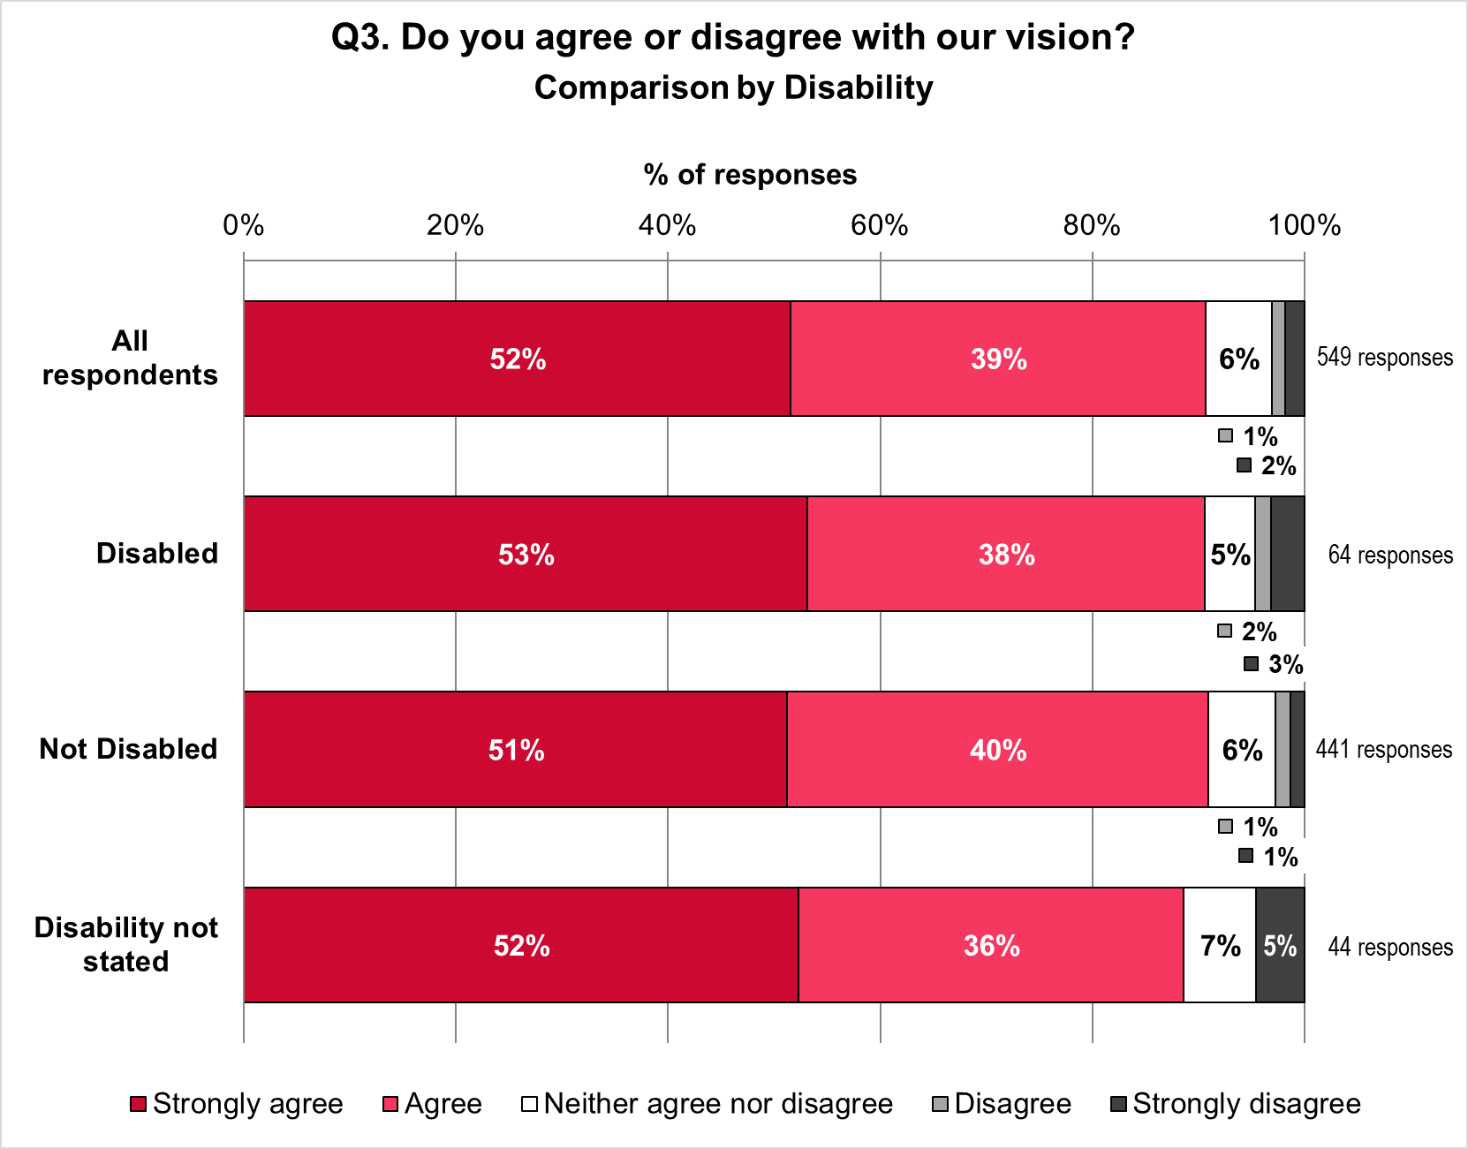

Views on the vision by age
Figure 22 compares the views of respondents on the vision, for all respondents and four age groups. The groups are
- 55 respondents aged 24 and younger
- 360 respondents aged 25 to 54
- 102 respondents aged 55 and older
- 32 respondents who did not state their age.
The vision received highest agreement among respondents aged 25 to 54, followed by respondents aged 24 and younger. However, respondents aged 24 and younger also had the highest proportion who disagreed.
- 92% respondents aged 25 to 54 strongly agreed or agreed with the vision, compared with 91% aged 24 and younger, 88% aged 55 and older, and 88% for age not stated.
- 6% respondents aged 25 to 54 neither agreed nor disagreed with the vision, compared with 2% aged 24 and younger, 8% aged 55 and older, and 9% for age not stated.
- 2% respondents aged 25 to 54 strongly disagreed or disagreed with the vision, compared with 7% aged 24 and younger, 4% aged 55 and older, and 3% for age not stated.
Figure 22: Views on the vision by age group
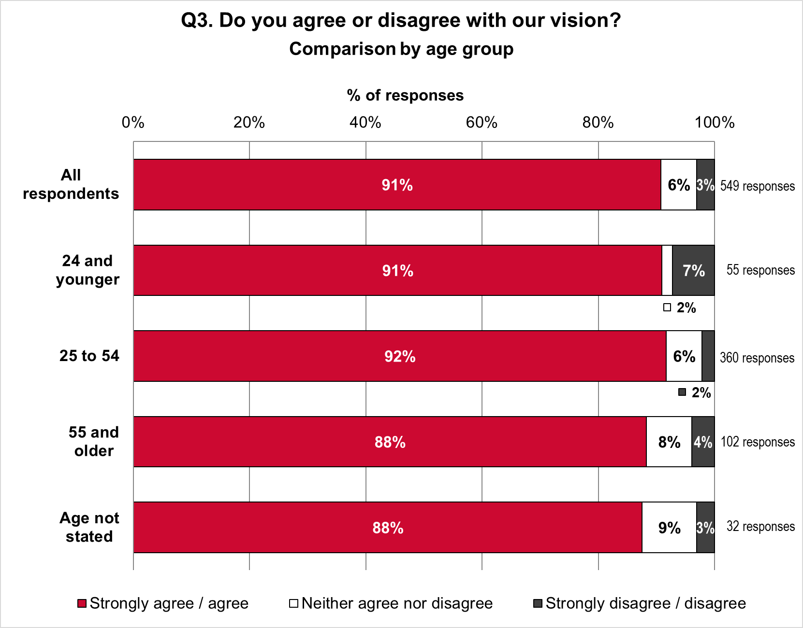

Views on the vision by sexual orientation
Figure 23 compares views on the vision for all respondents and five groups. These are:
- 52 respondents who are Bi
- 57 respondents who are Gay / Lesbian
- 352 respondents who are Heterosexual / Straight
- 13 respondents who define their sexuality using another term
- 75 respondents who did not state their sexual orientation.
Figure 23: Views on the vision by sexual orientation
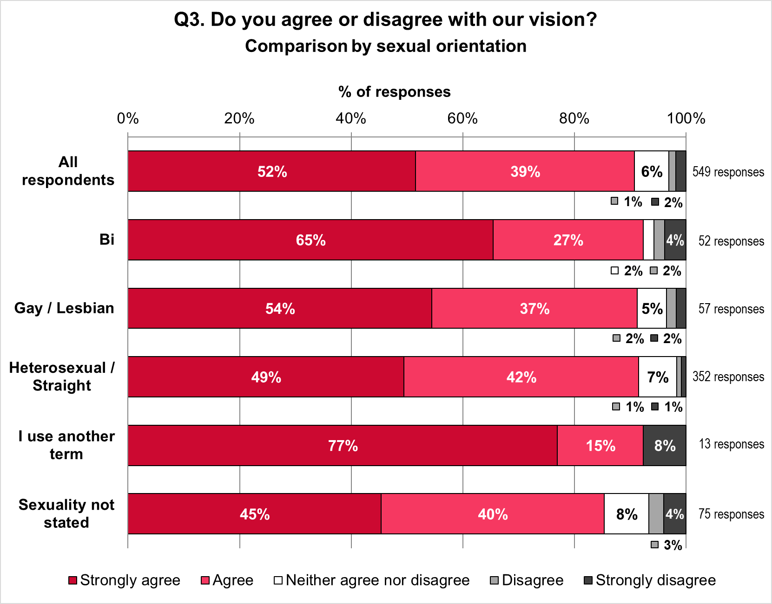
The vision was most popular among Bi respondents and people who use another term, followed closely by Heterosexual / Straight and Gay / Lesbian respondents. The vision was supported least by people who did not state their sexual orientation.
- 92% of Bi respondents and 92% people who use another term strongly agreed or agreed with the vision. This compares with 91% for both Heterosexual / Straight and
Gay / Lesbian respondents, and 85% for people who did not state a sexual orientation.
- 2% of Bi respondents neither agreed nor disagreed with the vision, compared with
0% who use another term, 5% Gay / Lesbian, 7% Heterosexual / Straight, and 8% for respondents who did not state their sexual orientation.

- 6% of Bi respondents strongly disagreed or disagreed with the vision, compared with 8% who use another term, 4% Gay / Lesbian, 2% Heterosexual / Straight people and 7% for respondents who did not state their sexual orientation.

Free text responses
A total of 83 respondents provided additional comments relating to the vision. These were broadly themed into concerns or questions about how the vision will translate into service delivery (59%), use of language in the vision being vague, inaccessible, or incomplete (33%), suggested areas to focus the vision, specifically prevention and a community focus (23%), support for the vision (16%) and an assertion that current services already align with the vision (6%). Some respondents commented on more than one theme hence the total does not equate to 100%.
Figure 24: Q3 Free text themes

The theme ‘translating vision into service delivery’ included queries about how the vision would be delivered and what exactly it would deliver e.g. “the vision is good, but the important thing is how it is delivered”. This theme was further broken down into subthemes (see Figure 25).
Figure 25: Q3 Free text subthemes: Translating the vision into service delivery

Just under half of responses regarding translation of vision into service delivery commented on access to services in terms of physical location of clinics stating “Services should be available locally…, not centred entirely in Bristol” and “Having some local services in Yate would be extremely beneficial”; appointment times e.g. “have clinics on an evening so people from school and work can attend without having to inform people for time off”; and inclusivity e.g. “how will you ensure that all users have equitable access?” and “(GRT) feel that they are the main community that is discriminated against and not considered when policies are being considered.” Respondents queried how service users would be involved asking “How will we be able to provide feedback and ensure local thoughts and ideas are heard?” and “What will the ‘ongoing conversations’ actually look like and how will you ensure you reach everyone?”. Concerns were raised over how the vision would translate to service delivery in terms of resource and funding that “…is not realistic to meet the need of the whole population” and that services need to be run efficiently with an awareness there is a “limited pot of money and whilst we should absolutely be working with and responding to communities’ needs, [they] are diverse and may have very different needs. It may not be efficient of equitable to provide services that meet ALL the needs of every group”. A common concern was that splitting the service into ‘lots’ could lead to fragmentation and “break up services… rather than have a seamless approach as quoted”. Issues raised include “barriers to data sharing, different and non-integrated electronic patient record systems” and respondents urged a “cautious approach to dividing the service” and that “community engagement and public consultation must continue to help shape the services”.

Over a third of comments related to language used in the vision with some specifically noting the word ‘timely’ missing in terms of access and almost 80% describing the vision as vague or inaccessible stating it was “very wordy”, “I needed help to understand it”, “I fully support this vision however when I shared this with my clients… they had trouble understanding what this means” and “not very community / people friendly – too much jargon”.

A number of respondents suggested specific areas of focus, namely prevention and an emphasis on community. This ranged from comments about the need for local clinics as people “feel really comfortable there” and the closure of Yate Unity services being a “lifeline lost by the entire northern area of South Glos” to the need for population specific and outreach clinics such as “services for homeless people / people where rough sleeping at venues where they feel comfortable”. There were a few comments that there should be more focus on treatment and a few highlighting women’s health.

A small number of comments alluded to current sexual health services already aligning with this vision and delivering well against it i.e. “having services run by the NHS trust lets them easily talk to other departments for onward referrals”.

Views on the proposal for to improving how people can access sexual and reproductive health services via online (digital) routes

All respondents
Respondents were asked to rate the proposal for online services on a scale of strongly agree to strongly disagree (Figure 26). Of the 550 respondents to the question:
- 325 (59%) strongly agreed
- 178 (32%) agreed
- 22 (4%) neither agreed nor disagreed
- 18 (3%) disagreed
- 7 (1%) strongly disagreed.
Figure 26: Views on access to sexual and reproductive health via online routes– all respondents
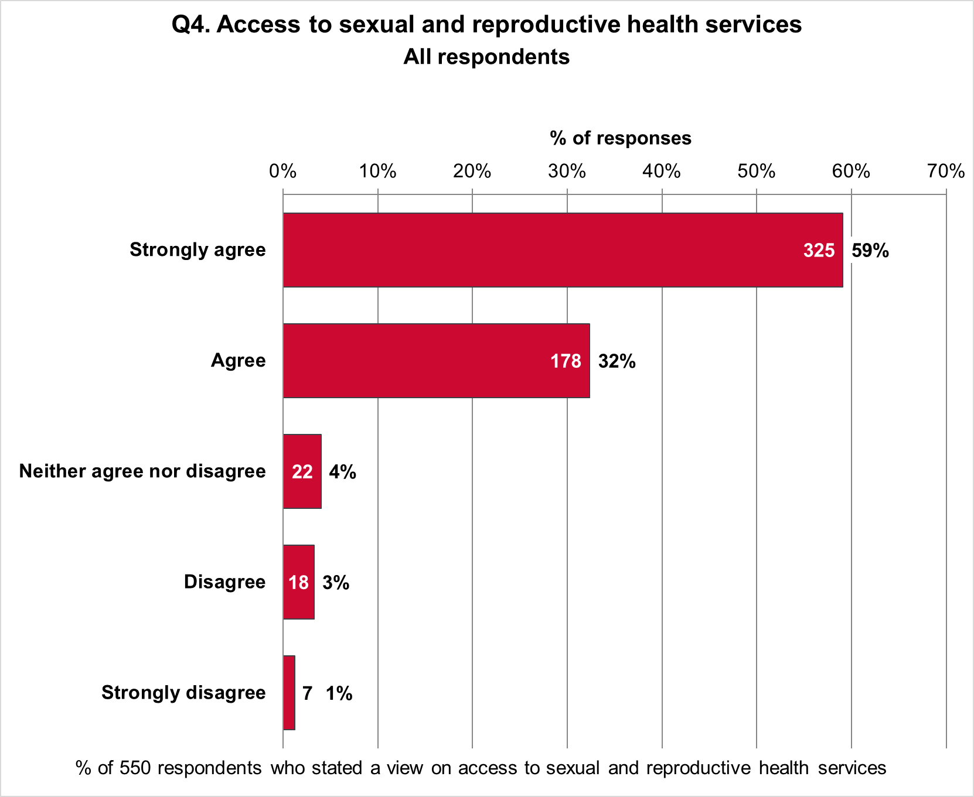

Views on access to sexual and reproductive health services via online routes by sex
Figure 27 shows the proportions of 362 female respondents and 140 male respondents who agreed or disagreed with this proposal. Also shown are combined proportions for two respondents who identified as other sex and 46 respondents who did not state their sex.
The proposal was slightly more popular among women than among men.
- 94% of women strongly agreed or agreed, compared with 89% of men and 81% of other sex / sex not stated.
- 4% of women neither agreed nor disagreed, compared with 3% of men and 10% of other sex / sex not stated.
- 3% of women strongly disagreed or disagreed compared with 8% of men and 8% of other sex / sex not stated.
Figure 27: Views on access to sexual and reproductive health via online routes by sex
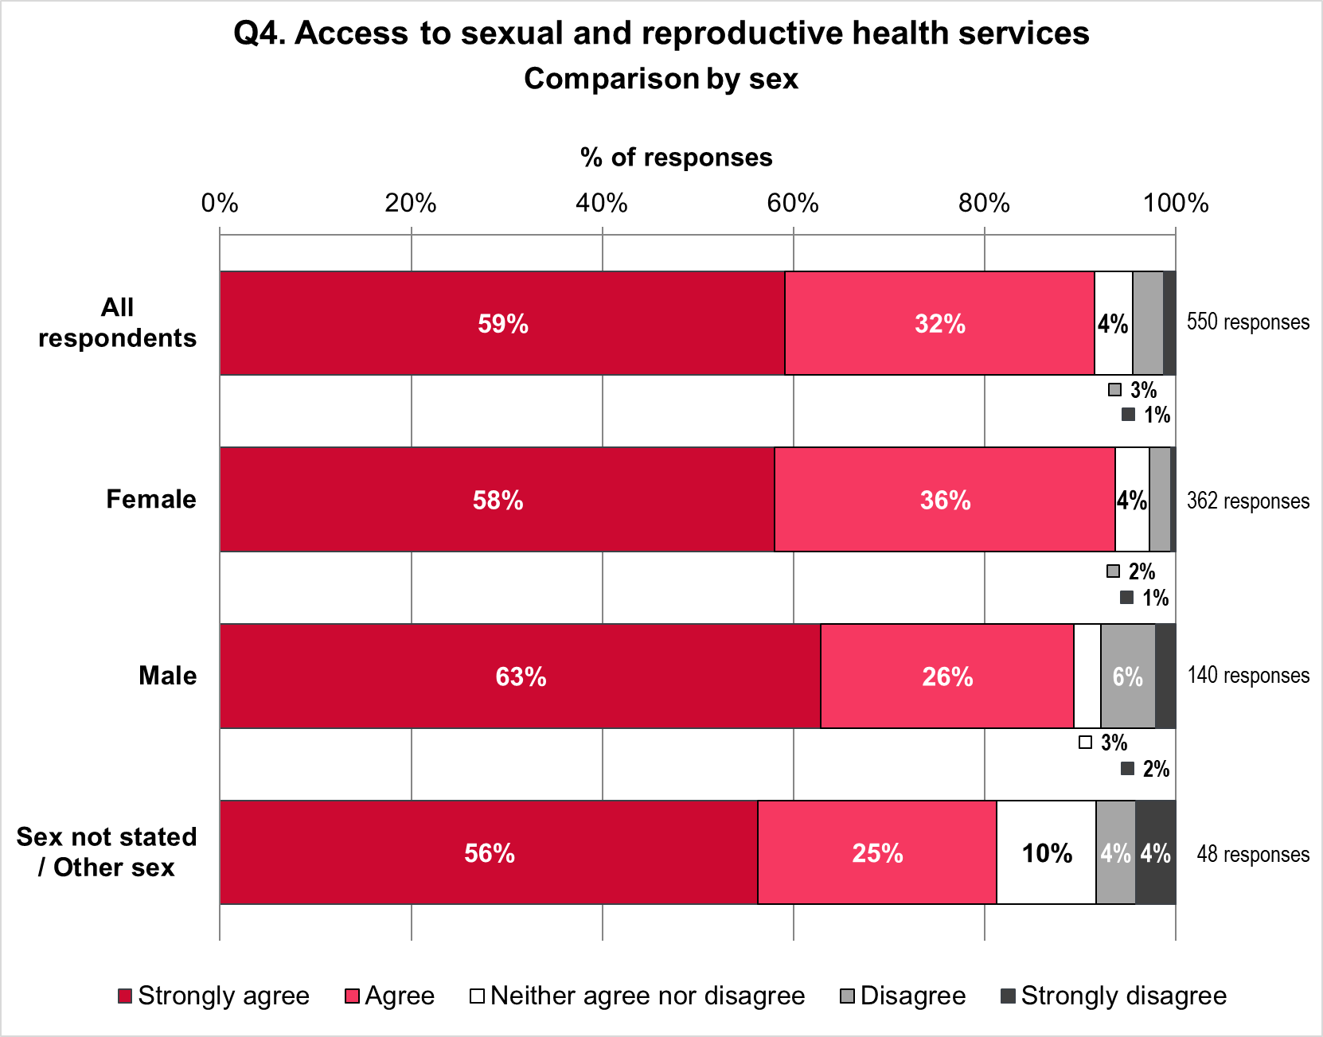

Views on access to sexual and reproductive health services via online routes by ethnicity
Figure 28 compares the views of respondents on the proposals for access to sexual and reproductive health services, for all respondents and three ethnic groups. The groups are:
- 449 White British and White Other respondents
- 51 respondents of ‘other ethnicity’, including Black, Black British, Caribbean, or African; Asian or Asian British; Mixed, or multiple ethnic groups; Gypsy, Roma or Traveller; and other ethnic background
- 50 respondents who did not state their ethnicity.
Figure 28: Views on access to sexual and reproductive health via online routes by ethnicity
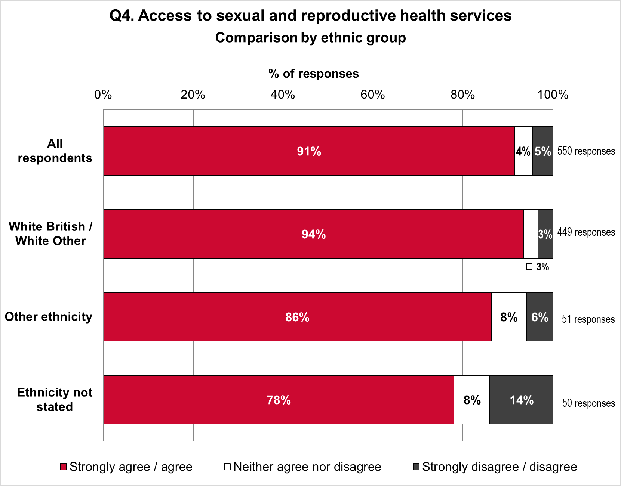
The proposal was more popular among White British and White Other people than for the other ethnic groups, and least popular among those who did not state their ethnicity.
- 94% of White British / White Other people strongly agreed or agreed with the proposal, compared with 86% for respondents of Other Ethnicity and 78% for respondents who did not state their ethnicity.
- 3% of White British / White Other people neither agreed nor disagreed with the proposal; compared with 8% for respondents of Other Ethnicity, and 8% not stating their ethnicity.
- 3% of White British / White Other people strongly disagreed or disagreed with the proposal, compared with 6% for Other Ethnicity and 14% for those not stating ethnicity.

Views on access to sexual and reproductive health services via online routes by Disability
Figure 29 shows the proportions of 64 Disabled respondents and 441 not-Disabled respondents who agreed or disagreed with the proposal. Also shown are the proportions of
45 respondents who did not state if they are Disabled or not.
Support for the proposal was slightly higher for not-Disabled than Disabled respondents. Support was lowest among respondents who did not say if they are Disabled or not.
- 91% of Disabled respondents and 92% of not-Disabled respondents strongly agreed or agreed with the proposal. This compares to 87% for respondents who did not say if they are Disabled.
- 5% of Disabled respondents neither agreed nor disagreed with the proposal, compared with 3% of not-Disabled respondents and 9% of respondents who did not say if they are Disabled.
- 5% of Disabled respondents strongly disagreed or disagreed with the proposal, compared with 5% of not-Disabled respondents and 4% of respondents who did not say if they are Disabled.
Figure 29: Views on access to sexual and reproductive health via online routes by Disability
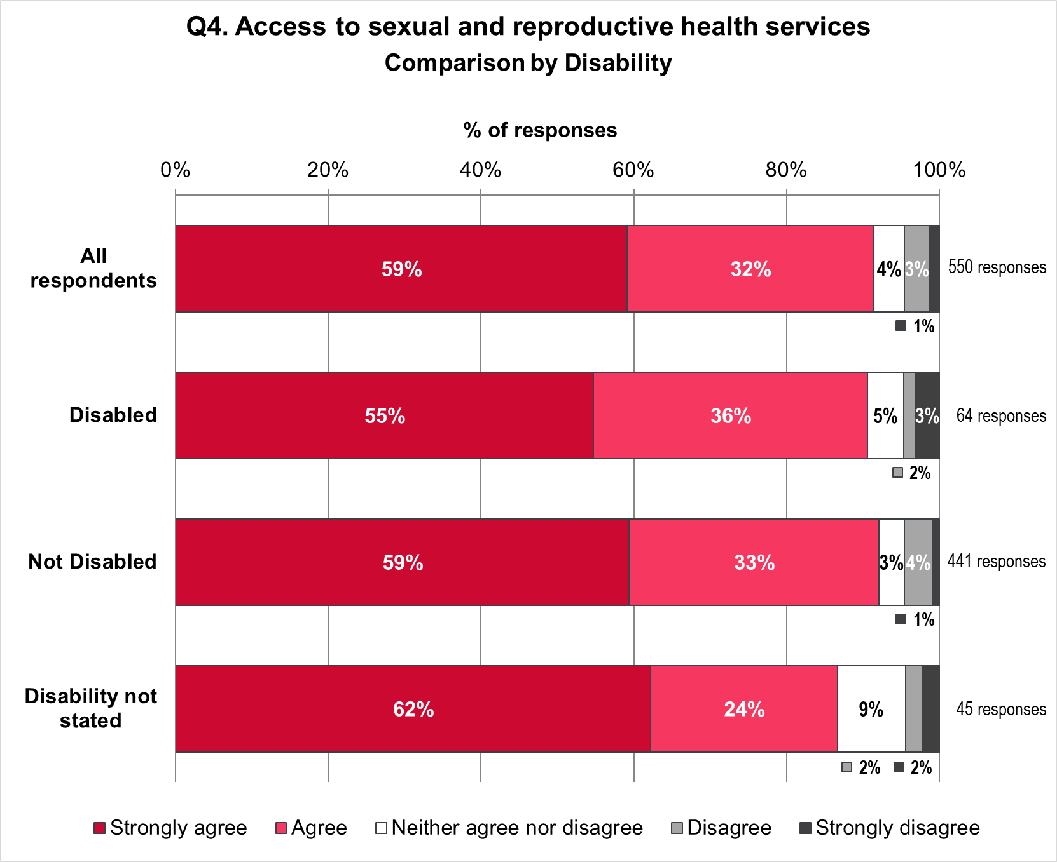

Views on access to sexual and reproductive health services via online routes by age
Figure 30 compares the views of respondents on the proposal for access to sexual and reproductive health services, for all respondents and four age groups. The groups are
- 55 respondents aged 24 and younger
- 360 respondents aged 25 to 54
- 102 respondents aged 55 and older
- 33 respondents who did not state their age.
Support for the proposal decreases with increasing age; the proposal was most popular among respondents aged 24 and younger, followed by respondents aged 25 to 54. There was least support among respondents who did not state their age.
- 96% respondents aged 24 and younger strongly agreed or agreed with the proposal, compared with 92% aged 25 to 54, 89% aged 55 and older, and 85% for age not stated.
- No respondents aged 24 and younger neither agreed nor disagreed with the proposal, compared with 3% aged 25 to 54, 6% aged 55 and older, and 12% for age not stated.
- 4% respondents aged 24 and younger strongly disagreed or disagreed with the proposal, compared with 5% aged 25 to 54, 5% aged 55 and older, and 3% for age not stated.
Figure30: Views on access to sexual and reproductive health via online routes by age
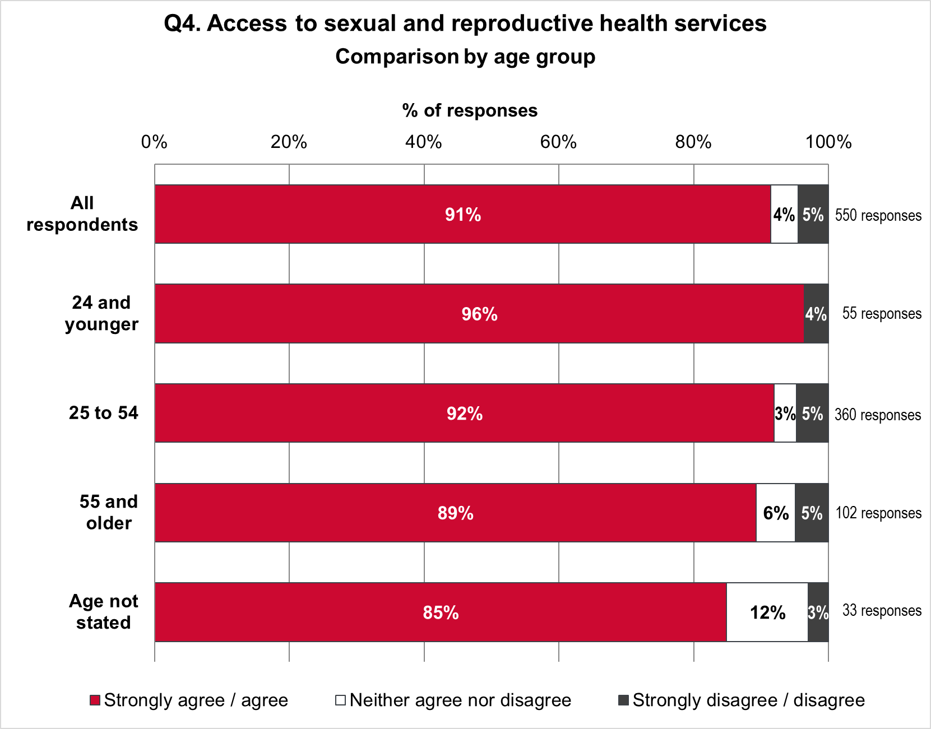

Views on access to sexual and reproductive health services via online routes by sexual orientation
Figure 31 compares views on the proposal for all respondents and five groups. These are:
- 52 respondents who are Bi
- 57 respondents who are Gay / Lesbian
- 352 respondents who are Heterosexual / Straight
- 13 respondents who define their sexuality using another term
- 76 respondents who did not state their sexual orientation.
Figure 31: Views on access to sexual and reproductive health via online routes by sexual orientation
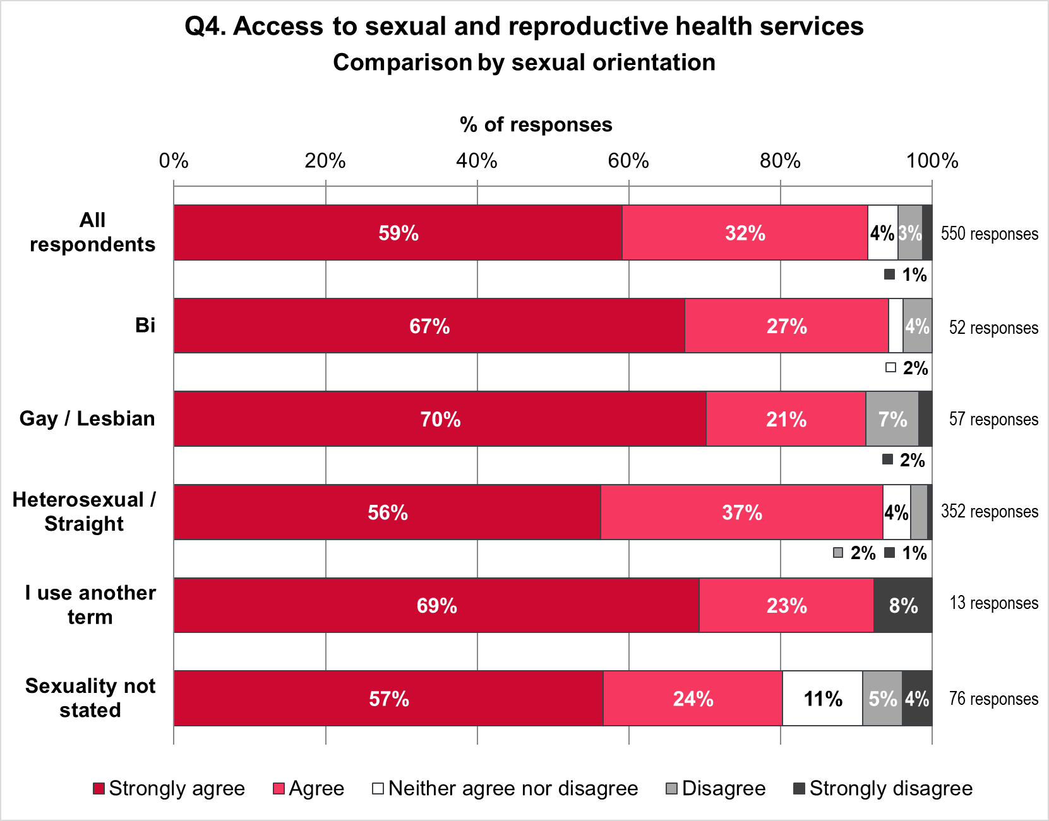
The proposal was most popular among Bi respondents and Heterosexual / Straight respondents, followed closely by people who use another term. The proposal was supported least by people who did not state their sexual orientation.
- 94% of Bi and 93% of Heterosexual / Straight respondents strongly agreed or agreed with the proposal. This compares with 92% for people who use another term, 91% for Gay / Lesbian respondents, and 80% for people who did not state their sexual orientation.
- 2% of Bi respondents and 4% of Heterosexual / Straight respondents neither agreed nor disagreed with the proposal. This compares with 11% for people who did not state a sexual orientation. No Gay / Lesbian respondents and no people who use another term selected neither agree nor disagree.
- 4% of Bi respondents and 3% of Heterosexual / Straight respondents disagreed or strongly disagreed with the proposal. This compares with 8% who use another term,
9% of Gay / Lesbian respondents and 9% of respondents who did not state their sexual orientation.

Free text responses
A total of 161 respondents provided additional comments about accessing services online (digitally). These were broadly themed as comments relating to access (96%), functionality of online services (30%), available resources (6%) and an assertion that online services are already provided sufficiently (2%). Some respondents commented on more than one theme hence the total does not equate to 100%.
Figure 32: Q4 Free text themes

The theme ‘access’ was further broken down into comments that an online service would improve access (29%), those stating a preference for in-person services (5%), risks of excluding certain groups (24%), an emphasis on online services complementing rather than replacing in-person services (32%) and issues with online information quality (10%).
Figure 33: Q4 Free text subthemes: Access to online services

Comments relating to improved access include “online services [will] streamline the process for patients and reduce waiting times” and “can overcome worries about confidentiality” and “can reduce embarrassment”. Respondents highlighted online services improving access for particularly vulnerable groups stating that “phone services are quite unhelpful for deaf patients”, “some people with disabilities would appreciate being able to access online”, “this will significantly benefit young people”, “digital provides convenient and accessible care for service-users, including those most at risk of poor sexual health” and “from a trauma-experienced person’s perspective, it is also preferable”. Around a third of respondents highlighting access issues emphasised that online services “should complement rather than replace other routes” and warned that “useful to have online access, but without losing face to face provision… to ensure good and safe care can be provided” and that “digital and home provision needs to be accompanied by scale up of clinical in person capacity”. A quarter of responses warned of risks of excluding marginalised groups e.g.“would exclude people who [are] homeless / rough sleeping” and those with less digital literacy or access to smart phones and computers. Language was noted as a potential barrier as “people whose first language isn’t English would struggle” and “not everyone feels safe to [access online] such as those at risk or victims of domestic violence”. Around 10% of responses alluded to the need for more improved and accessible information to support online access stating that “the website, online accounts and system are massively outdated… and social media and communications side of things are dire / non-existent”. There was a call for “advice and info about what is available online vs in-person to be clear and accessible” and some concerns about digital advice provided via AI tools.

The theme “functionality of online services” was further broken down into services available online (63%), anticipated issues (24%) and the need for them to be quick and simple to use (12%).
Figure 34: Q4 Free text subthemes: Functionality of online services

The types of services respondents wanted to be able to access online were wide ranging and included:
- Flexibility in being able to “choose and book in-person appointments” and “video-consultations”
- Birth control options such as “self-booking for LARC” and “digital ordering of morning after pills” (supplemented by “information that is extremely clear, including the legality issues”)
- Appointments for other women’s health issues e.g. cervical smears, menopause and pelvic health consultations
- Appointments for “routine blood tests” (noting particularly reference to blood test kits being difficult to use particularly for those with a previous diagnosis of syphilis and “blood samples rarely fulfil testing requirements”)
- Access to results noting delays and inconsistencies in how results are provided
Anticipated problems included “digital access can be obstructive” with potential limits on testing kits and specific questions around reassurance that a “non-NHS provider… won’t put a cap on kits” and a lack of available appointments to book. Others commented on online services not being “able to give individualised advice people need” and “health promotional interventions can often be missed”. There were some safety concerns whether “proposals put people at the centre of their care”.
A number of comments related to available financial, staff and infrastructure resources to implement the online proposals stating that “good quality digital services are dependent on funding fit-for-purpose IT” and the need for any online services to be well integrated to “reduce risk of duplicating work or not providing services to complex groups”. It was also noted that “digital sexual health services require appropriately trained, specialist staff who are efficient working in a digital-first environment”.
A small number of responses referred to the service already providing online services and querying what is new about the proposals.

Views on the proposal for in-person clinics

All respondents
Respondents were asked to rate the proposed in-person clinics on a scale of strongly agree to strongly disagree (Figure 35). Of the 546 respondents to the question:
- 391 (72%) strongly agreed
- 128 (23%) agreed
- 12 (2%) neither agreed nor disagreed
- 9 (2%) disagreed
- 6 (1%) strongly disagreed.
Figure 35: Views on in-person clinics – all respondents
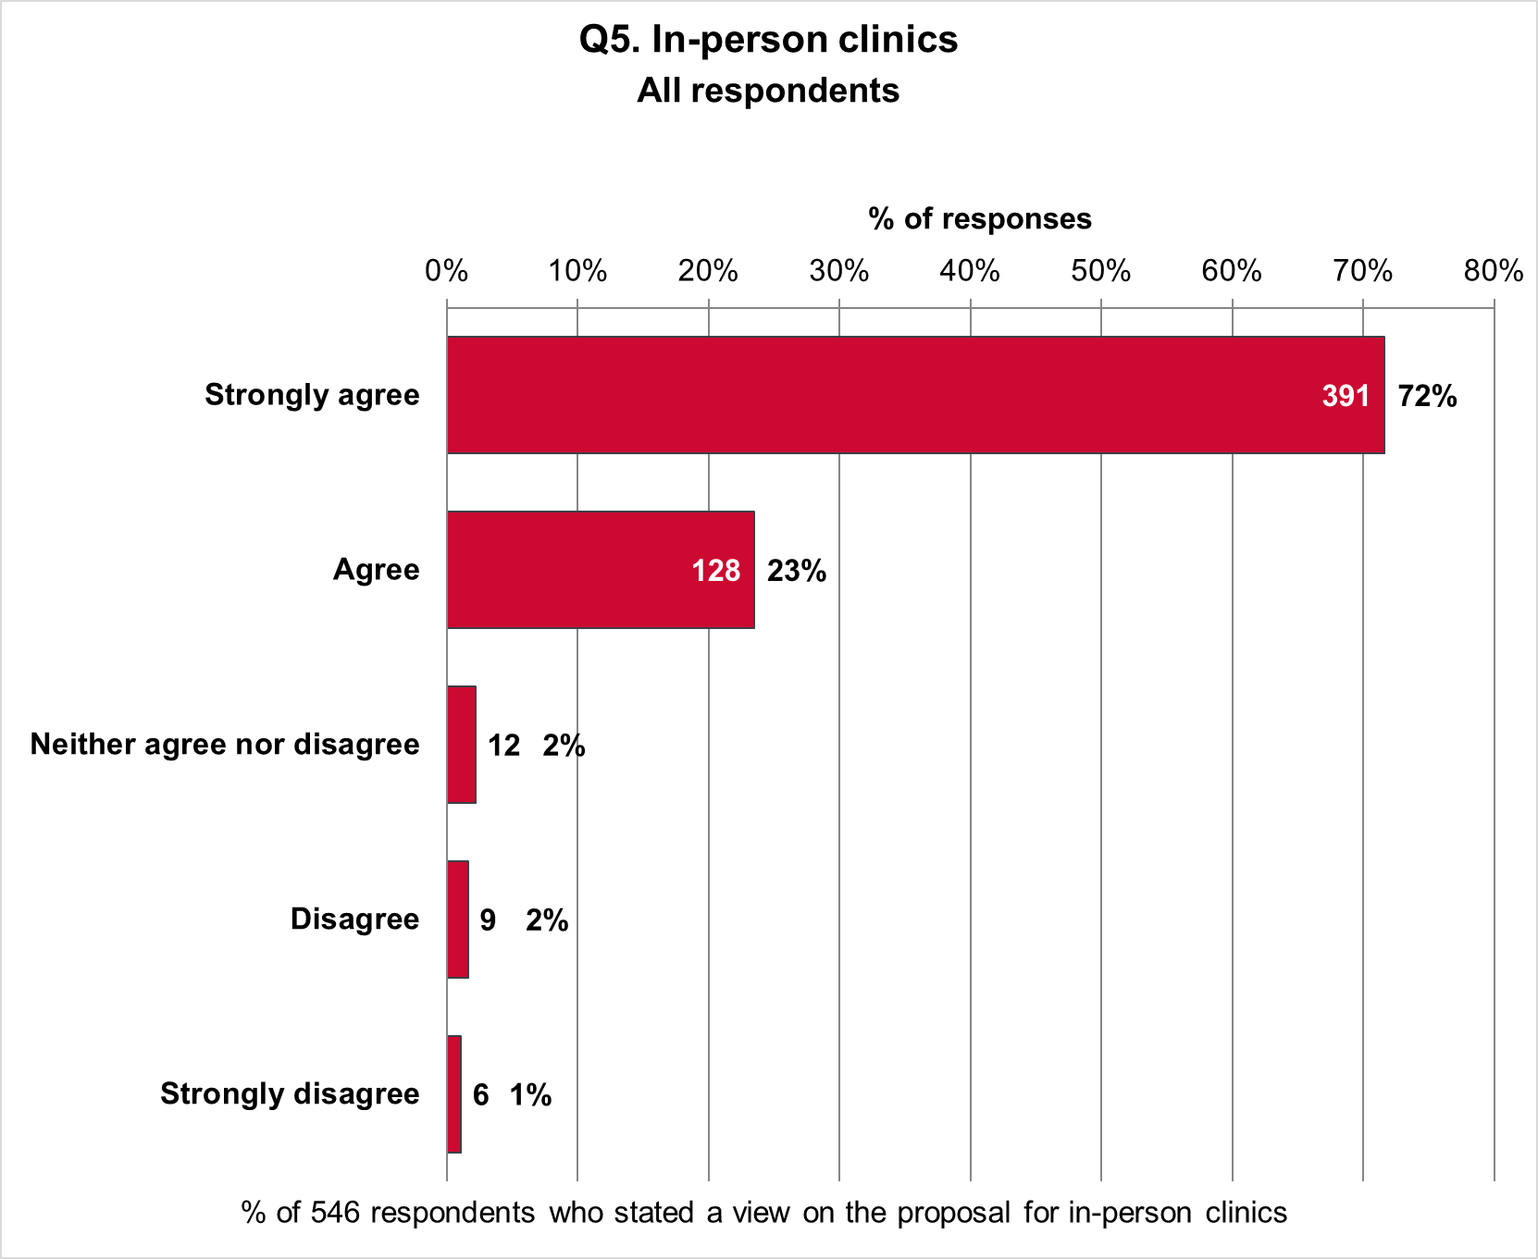

Views on in-person clinics by sex
Figure 36 shows the proportions of 361 female respondents and 138 male respondents who agreed or disagreed with the proposal. Also shown are combined proportions for two respondents who identified as other sex and 45 respondents who did not state their sex
The popularity of the proposal was similar among men and women, but there was less support among the other sex / sex not stated group.
- 96% of women strongly agreed or agreed, compared with 96% of men and 85% of other sex / sex not stated.
- 1% of women neither agreed nor disagreed, compared with 2% of men and 9% of other sex / sex not stated.
- 3% of women strongly disagreed or disagreed compared with 2% of men and 6% of other sex / sex not stated.
Figure 36: Views on in-person clinics by sex
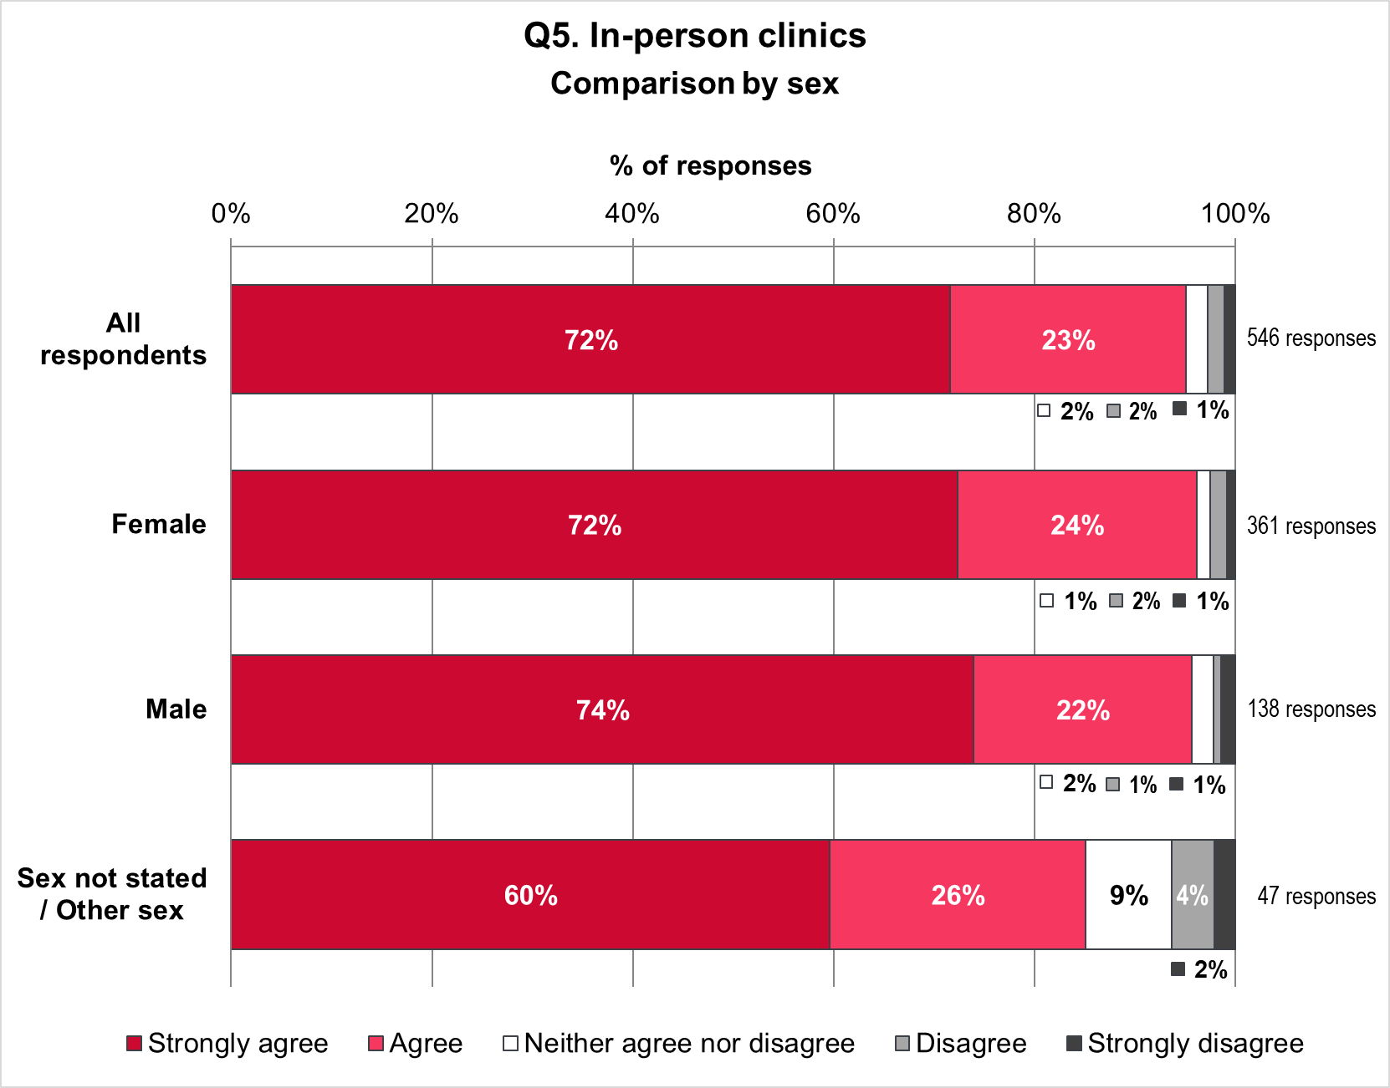

Views on in-person clinics by ethnicity
Figure 37 compares the views of respondents on the proposals for in-person clinics, for all respondents and three ethnic groups. The groups are:
- 446 White British and White Other respondents
- 51 respondents of ‘other ethnicity’, including Black, Black British, Caribbean, or African; Asian or Asian British; Mixed, or multiple ethnic groups; Gypsy, Roma or Traveller; and other ethnic background
- 49 respondents who did not state their ethnicity.
Figure 37: Views on in-person clinics by ethnicity
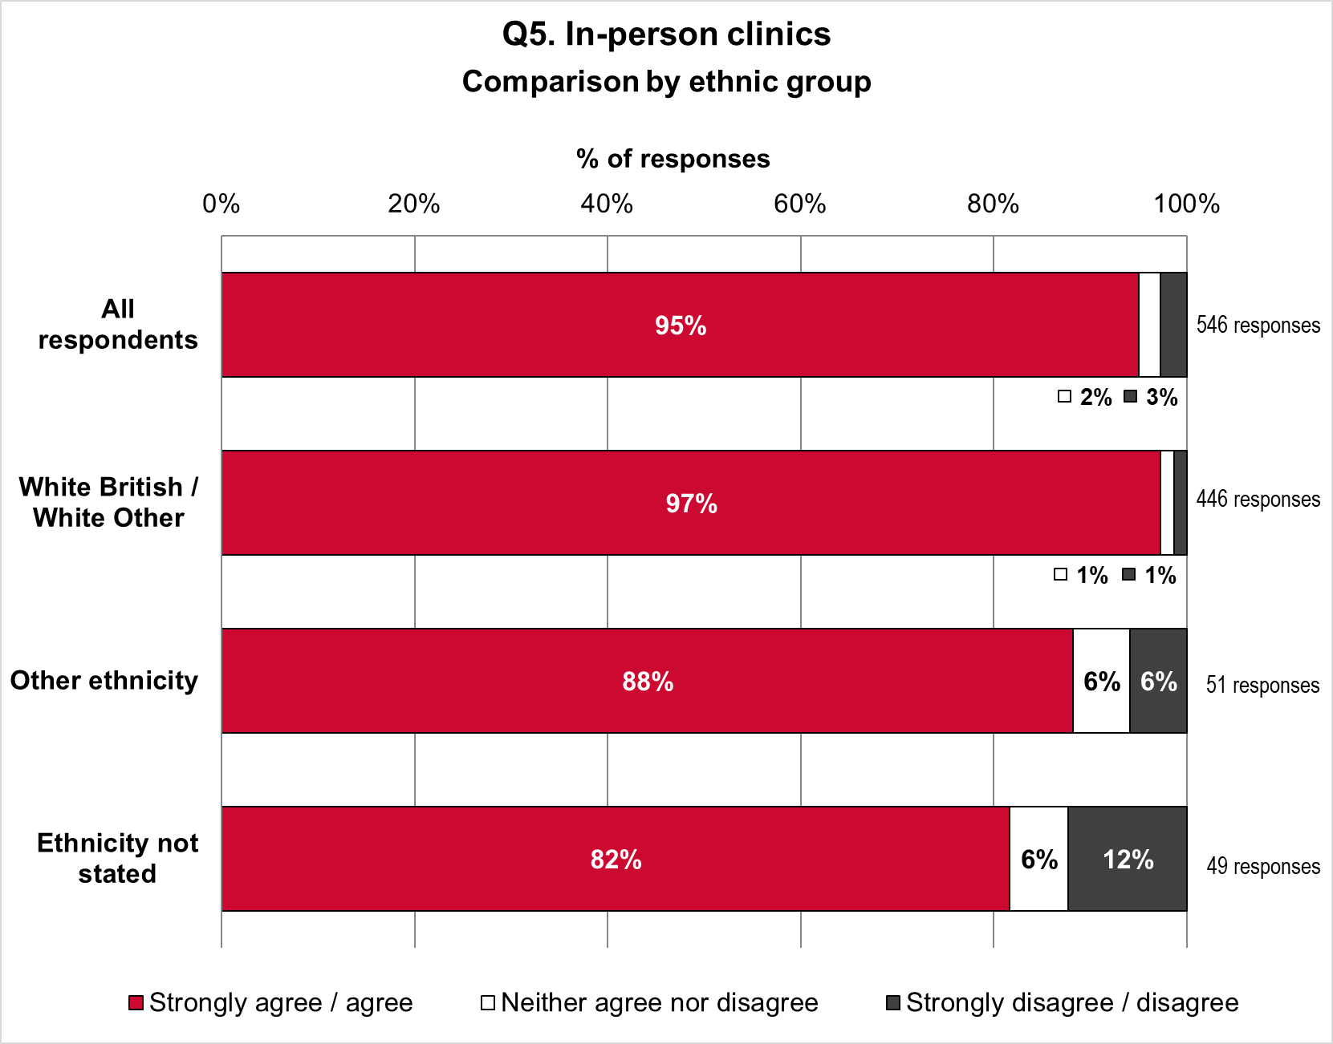
The proposal was more popular among White British and White Other people than for the other ethnic groups, and least popular among those who did not state their ethnicity.
- 97% of White British / White Other people strongly agreed or agreed with the proposal, compared with 88% for respondents of Other Ethnicity and 82% for respondents who did not state their ethnicity.
- 1% of White British / White Other people neither agreed nor disagreed with the proposal; compared with 6% for respondents of Other Ethnicity, and 6% not stating their ethnicity.
- 1% of White British / White Other people strongly disagreed or disagreed with the proposal, compared with 6% for Other Ethnicity and 12% for those not stating ethnicity.

Views on in-person clinics by Disability
Figure 38 shows the proportions of 63 Disabled respondents and 439 not-Disabled respondents who agreed or disagreed with the proposal. Also shown are the proportions of
44 respondents who did not state if they are Disabled or not.
Support for the proposal was higher for not-Disabled than Disabled respondents. Support was lowest among respondents who did not say if they are Disabled or not.
- 92% of Disabled respondents and 96% of not-Disabled respondents strongly agreed or agreed with the proposal. This compares to 89% for respondents who did not say if they are Disabled.
- 3% of Disabled respondents neither agreed nor disagreed with the proposal, compared with 1% of not-Disabled respondents and 9% of respondents who did not say if they are Disabled.
- 5% of Disabled respondents strongly disagreed or disagreed with the proposal, compared with 3% of not-Disabled respondents and 2% of respondents who did not say if they are Disabled.
Figure 38: Views on in-person clinics by Disability
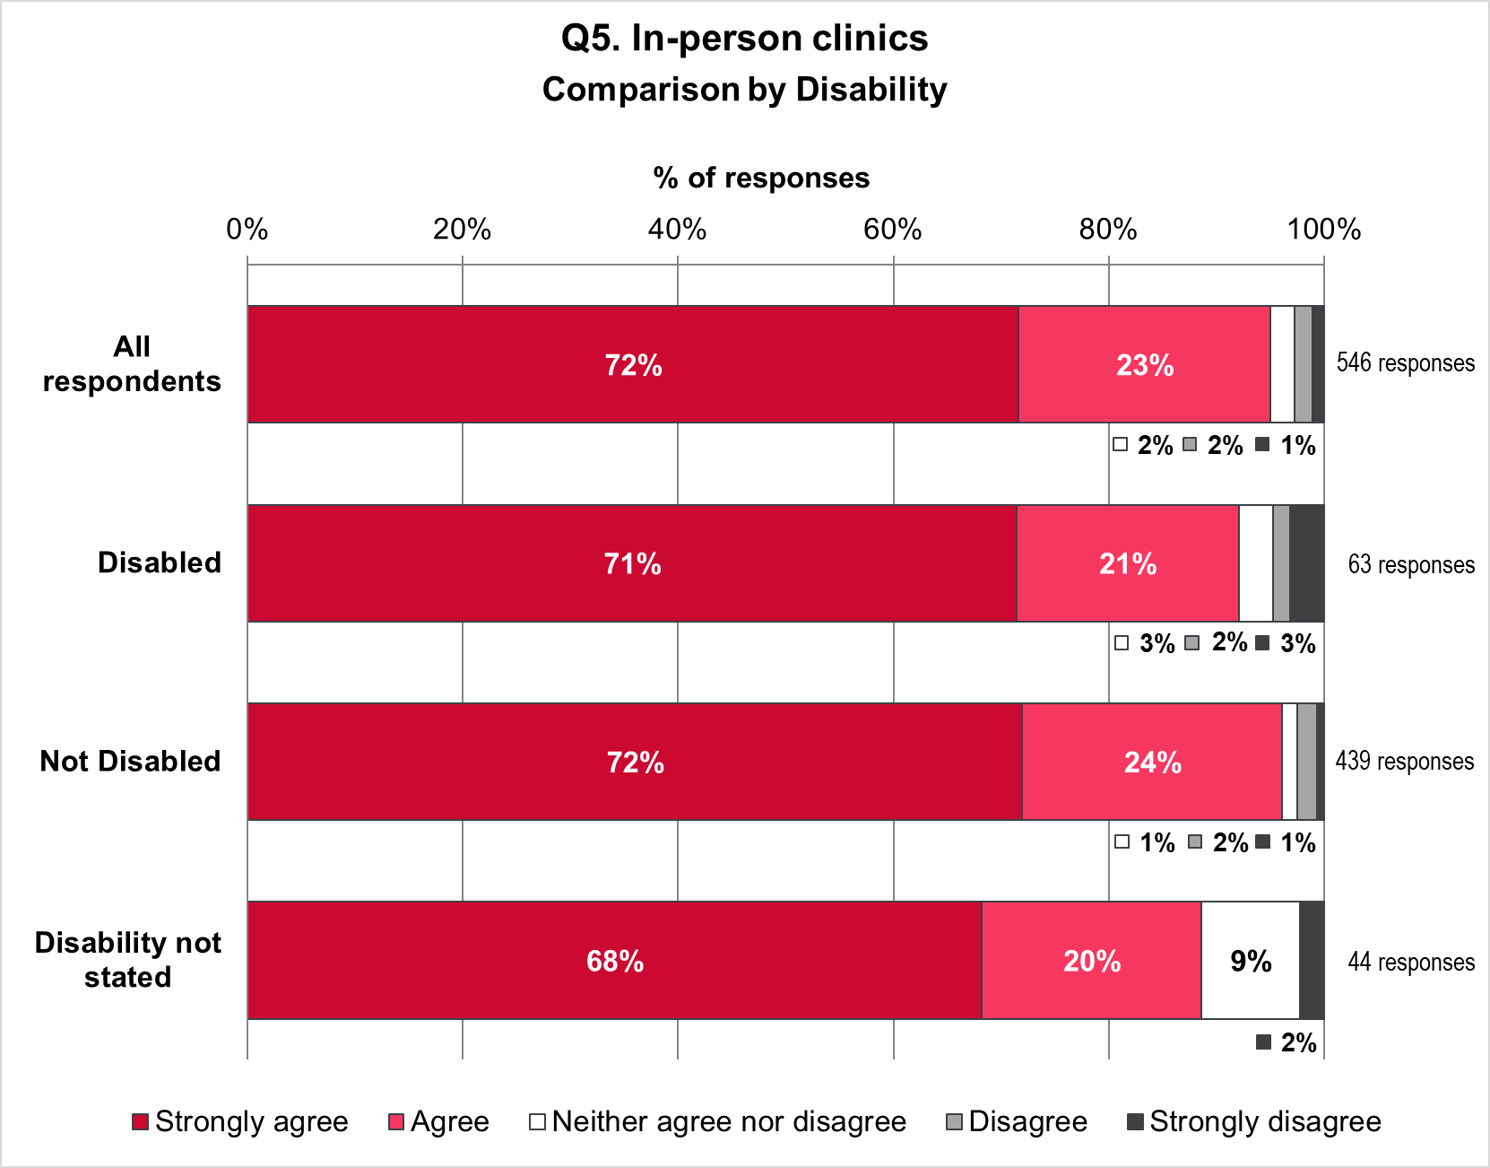

Views on in-person clinics by age
Figure 39 compares the views of respondents on the proposal for access to sexual and reproductive health services, for all respondents and four age groups. The groups are
- 55 respondents aged 24 and younger
- 359 respondents aged 25 to 54
- 100 respondents aged 55 and older
- 32 respondents who did not state their age.
Support for the proposal increases with increasing age; the proposal was most popular among respondents aged 55 and older, followed by respondents aged 25 to 54. There was least support among respondents who did not state their age.
- 91% of respondents aged 24 and younger strongly agreed or agreed with the proposal, compared with 96% aged 25 to 54, 97% aged 55 and older, and 88% for age not stated.
- 4% of respondents aged 24 and younger neither agreed nor disagreed with the proposal, compared with 1% aged 25 to 54, 2% aged 55 and older, and 13% for age not stated.
- 5% respondents aged 24 and younger strongly disagreed or disagreed with the proposal, compared with 3% aged 25 to 54, 1% aged 55 and older, and 13% for age not stated.
Figure 39: Views on in-person clinics by age
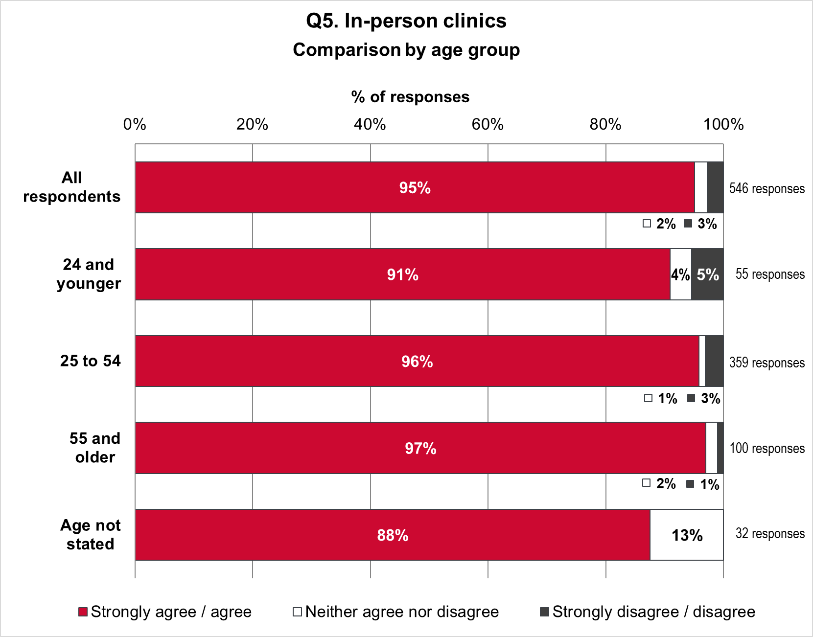

Views on in-person clinics by sexual orientation
Figure 40 compares views on the proposal for all respondents and five groups. These are:
- 52 respondents who are Bi
- 56 respondents who are Gay / Lesbian
- 351 respondents who are Heterosexual / Straight
- 13 respondents who define their sexuality using another term
- 74 respondents who did not state their sexual orientation.
Figure 40: Views on in-person clinics by sexual orientation
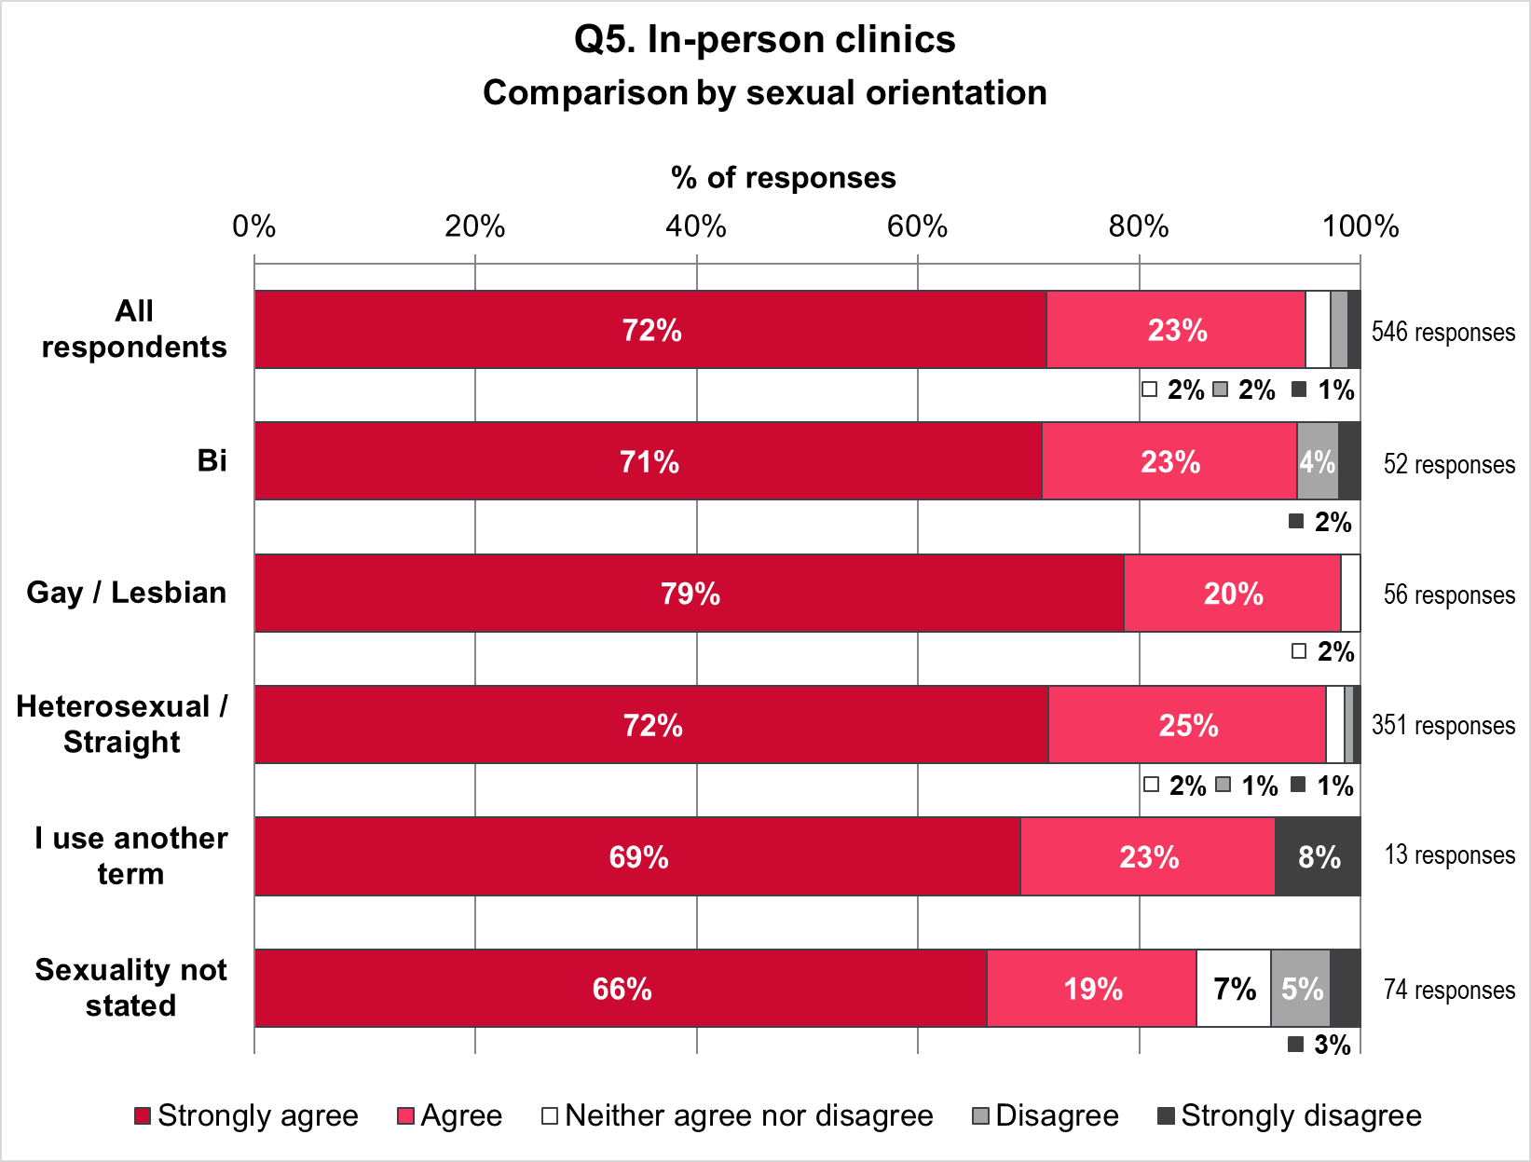
The proposal for in-person clinics was most popular among Gay / Lesbian respondents, closely followed by Heterosexual / Straight respondents and Bi respondents. The proposal was supported least by people who did not state their sexual orientation.
- 98% of Gay / Lesbian respondents strongly agreed or agreed with the proposal. This compares with 97% of Heterosexual / Straight respondents, 94% of Bi respondents, 92% of people who use another term, and 85% for people who did not state their sexual orientation.
- 2% of Gay / Lesbian respondents and 2% of Heterosexual / Straight respondents neither agreed nor disagreed with the proposal. This compares with 7% for people who did not state a sexual orientation. No Bi respondents and no people who use another term selected neither agree nor disagree.
- No Gay / Lesbian respondents strongly disagreed or disagreed with the proposal. 1% of Heterosexual / Straight respondents, 6% of Bi respondents, 8% of people who use another term and 8% of respondents who did not state their sexual orientation disagreed or strongly disagreed with the proposal for in-person clinics.

Free text responses
A total of 106 respondents provided additional comments about in-person clinics in the community. They were broadly themed into access concerns (59%), resource concerns (27%), support for proposals (35%), and an assertion that these services are already provided (7%). Some responses were assigned to more than one theme hence the total is greater than 100%.

Figure 41: Q5 Free text themes

The theme ‘access concerns” was further broken down to comments about location of services (38%), timing of appointments (11%), inclusivity (24%), volume of appointments (11%), dedicated services e.g. for young people (11%) and signposting / information (5%).

Figure 42: Q5 Free text subthemes: Access to in-person clinics

Comments about the location of services were most common, specifically “proximity of clinics and testing centres”, the need to “get specialist services locally”, and in “places patients can get to – centrally located on bus routes – not everyone has their own transport”. A number of comments emphasised the need for “more locations than currently provided” noting “for adults you are really limited to only visiting the Central Clinic in Bristol. This is really difficult for those in rural South Gloucestershire” and “In North Somerset the rurality of patients must be taken into consideration…looking at the PCNs or locality might be useful way of delivering these services”. There were suggestions that GP surgeries are “already ideally located and set up to be welcoming” and an emphasis on community clinics for “people who have trouble accessing Weston or Bristol”. The closure of some services since 2020 has had a clear impact e.g.in Yate “at West Walk Surgery, leaving our residents without sexual health services until the end of 2023 – and when the services reopened were very poor”. Inclusivity was the second most common subtheme with “services need[ing] to be located where the most marginalised people can access them”. Specific groups that were highlighted for consideration were trans and non-binary people, homeless and rough sleepers, sex workers, neurodivergent people, the Gypsy, Roma and Traveller (GRT) community, people with a disability, young and older people. Suggestions for more inclusive services were “services will need to go where [homeless or rough sleepers] feel comfortable” and for gender identity to be considered for “in-person appointments, waiting rooms and booking systems”. There were a smaller number of responses referring to timing of appointments “beyond office hours” and volume of appointments meeting the needs of service users with “well-staffed walk-in times for people unable to commit to specific appointments” and “those with psychosexual issues find it hard to get past triage... as patients with symptoms have to be prioritised”. Dedicated services, particularly for young people, were deemed important to “help young people to keep returning to a clinic”. Dedicated contraception services were also highlighted with “walk in services needed for all age groups”. A few respondents stressed the need for better ‘signposting and information’ so service users “are clear and up to date about how to access these”. One respondent suggested “a single website or link detailing all the available services in the area - that can give to a patient, the most convenient one to them first”.
Concerns regarding the availability of resources commented on whether there would be sufficient funding, staffing and infrastructure to support the proposals noting “services already providing clinics are popular and are struggling to keep up with increasing demand [and] it is also extremely difficult… to identify suitable clinical space in a community space” and that multiple clinic sites make the service “more difficult to run, with a limited number of staff, due to limited funding”.
There were a significant number of comments demonstrating support for the plans and emphasising the need to have a range of options. The balance between online and in person services was noted as “a simultaneous face to face offering is essential to support the online system”, and “a good online service is key to opening up face to face appointments” recognising that “engaging people… in face to face discussion and onward referral, as well as safeguarding… is often missed online”. Multiple respondents noted how critical face-to-face appointments are, stating “options of pre-bookable and walk in appointments are helpful for our most vulnerable clients”, “walk in appointments are a necessity to support health care in this area” and “decrease anxiety for the person seeking help”.
A small number of responses stated that “this service is already available” and queried what was new or different.

Views on proposals for prevention activities

All respondents
Respondents were asked to rate the proposed prevention activities on a scale of strongly agree to strongly disagree (Figure 43). Of the 546 respondents to the question:
- 332 (61%) strongly agreed
- 172 (32%) agreed
- 30 (5%) neither agreed nor disagreed
- 7 (1%) disagreed
- 5 (1%) strongly disagreed.
Figure 43: Views on prevention activities - all respondents
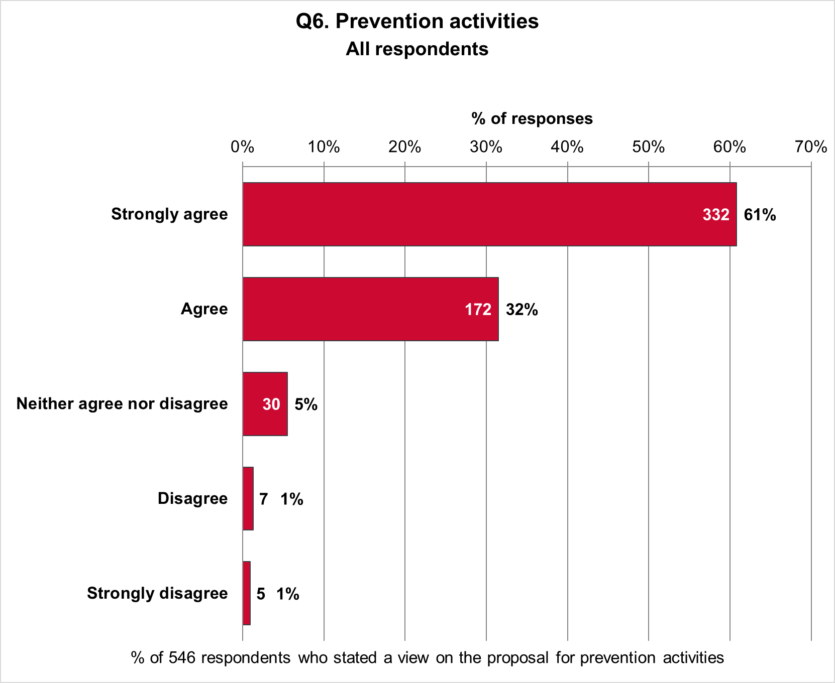

Views on prevention activities by sex
Figure 44 shows the proportions of 361 female respondents and 139 male respondents who agreed or disagreed with the proposal. The proposal was more popular among women than among men. Also shown are combined proportions for two respondents who identified as other sex and 44 respondents who did not state their sex.
The proposal was more popular among females than males.
- 96% of women strongly agreed or agreed, compared with 86% of men and 87% of other sex / sex not stated.
- 3% of women neither agreed nor disagreed, compared with 10% of men and 9% of other sex / sex not stated.
- 1% of women strongly disagreed or disagreed compared with 4% of men and 4% of other sex / sex not stated.
Figure 44: Views on prevention activities by sex
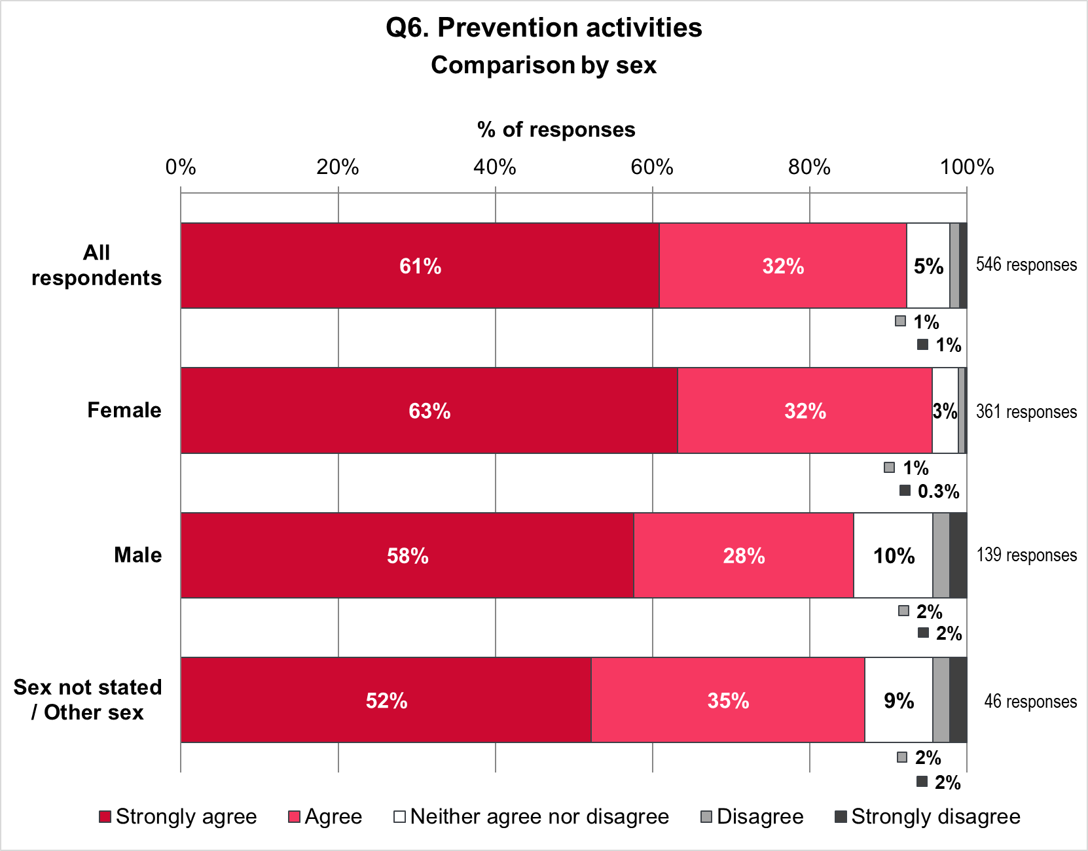

Views on prevention activities by ethnicity
Figure 45 compares the views of respondents on the proposals for prevention activities, for all respondents and three ethnic groups. The groups are:
- 446 White British and White Other respondents
- 51 respondents of ‘other ethnicity’, including Black, Black British, Caribbean, or African; Asian or Asian British; Mixed, or multiple ethnic groups; Gypsy, Roma or Traveller; and other ethnic background
- 49 respondents who did not state their ethnicity.
Figure 45: Views on prevention activities by ethnicity
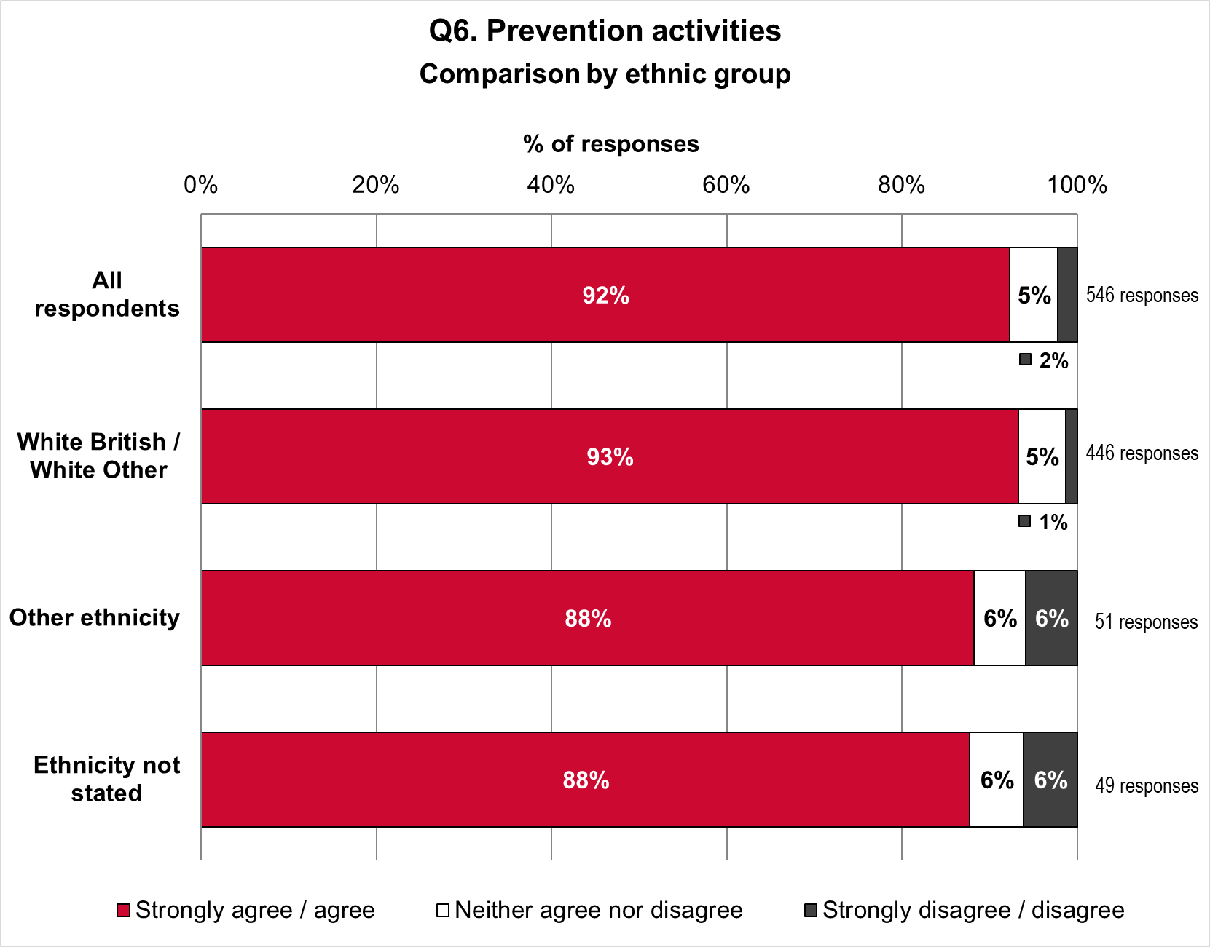
The proposal was most popular among White British and White Other people. Other ethnic groups expressed similar levels of support to respondents who did not state their ethnicity.
- 93% of White British / White Other people strongly agreed or agreed with the proposal, compared with 88% for respondents of Other Ethnicity and 88% for respondents who did not state their ethnicity.
- 5% of White British / White Other people neither agreed nor disagreed with the proposal; compared with 6% for respondents of Other Ethnicity, and 6% not stating their ethnicity.
- 1% of White British / White Other people strongly disagreed or disagreed with the proposal, compared with 6% for Other Ethnicity and 6% for those not stating ethnicity.

Views on prevention activities by Disability
Figure 46 shows the proportions of 64 Disabled respondents and 438 not-Disabled respondents who agreed or disagreed with the proposal. Also shown are the proportions of
44 respondents who did not state if they are Disabled or not.
Support for the proposal was higher for not-Disabled than Disabled respondents. Support was highest among respondents who did not say if they are Disabled or not.
- 89% of Disabled respondents and 92% of not-Disabled respondents strongly agreed or agreed with the proposal. This compares to 95% for respondents who did not say if they are Disabled.
- 6% of Disabled respondents neither agreed nor disagreed with the proposal, compared with 5% of not-Disabled respondents and 5% of respondents who did not say if they are Disabled.
- 5% of Disabled respondents strongly disagreed or disagreed with the proposal, compared with 2% of not-Disabled respondents and none of the respondents who did not say if they are Disabled.
Figure 46: Views on prevention activities by Disability
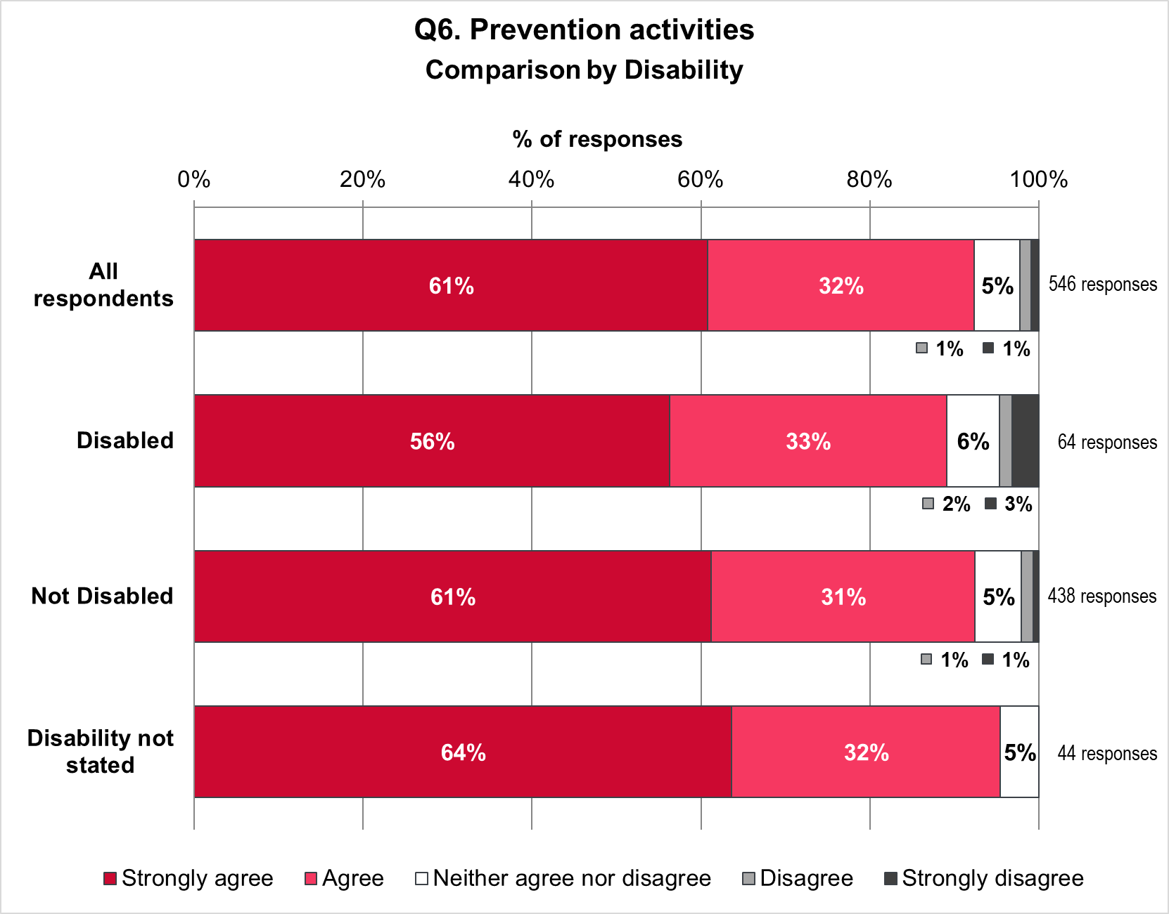

Views on prevention activities by age
Figure 47 compares the views of respondents on the proposal for prevention activities, for all respondents and four age groups. The groups are:
- 55 respondents aged 24 and younger
- 357 respondents aged 25 to 54
- 102 respondents aged 55 and older
- 32 respondents who did not state their age.
Support for the proposal is similar across all age groups and increases slightly with increasing age. The proposal was most popular among respondents who did not state their age.
- 91% of respondents aged 24 and younger strongly agreed or agreed with the proposal, compared with 92% aged 25 to 54, 93% aged 55 and older, and 94% for age not stated.
- 5% of respondents aged 24 and younger neither agreed nor disagreed with the proposal, compared with 6% aged 25 to 54, 5% aged 55 and older, and 6% for age not stated.
- 4% respondents aged 24 and younger strongly disagreed or disagreed with the proposal, compared with 2% aged 25 to 54, and 2% aged 55 and older. No respondents in the age not stated group strongly disagreed or disagreed with the proposal.
Figure 47: Views on prevention activities by age
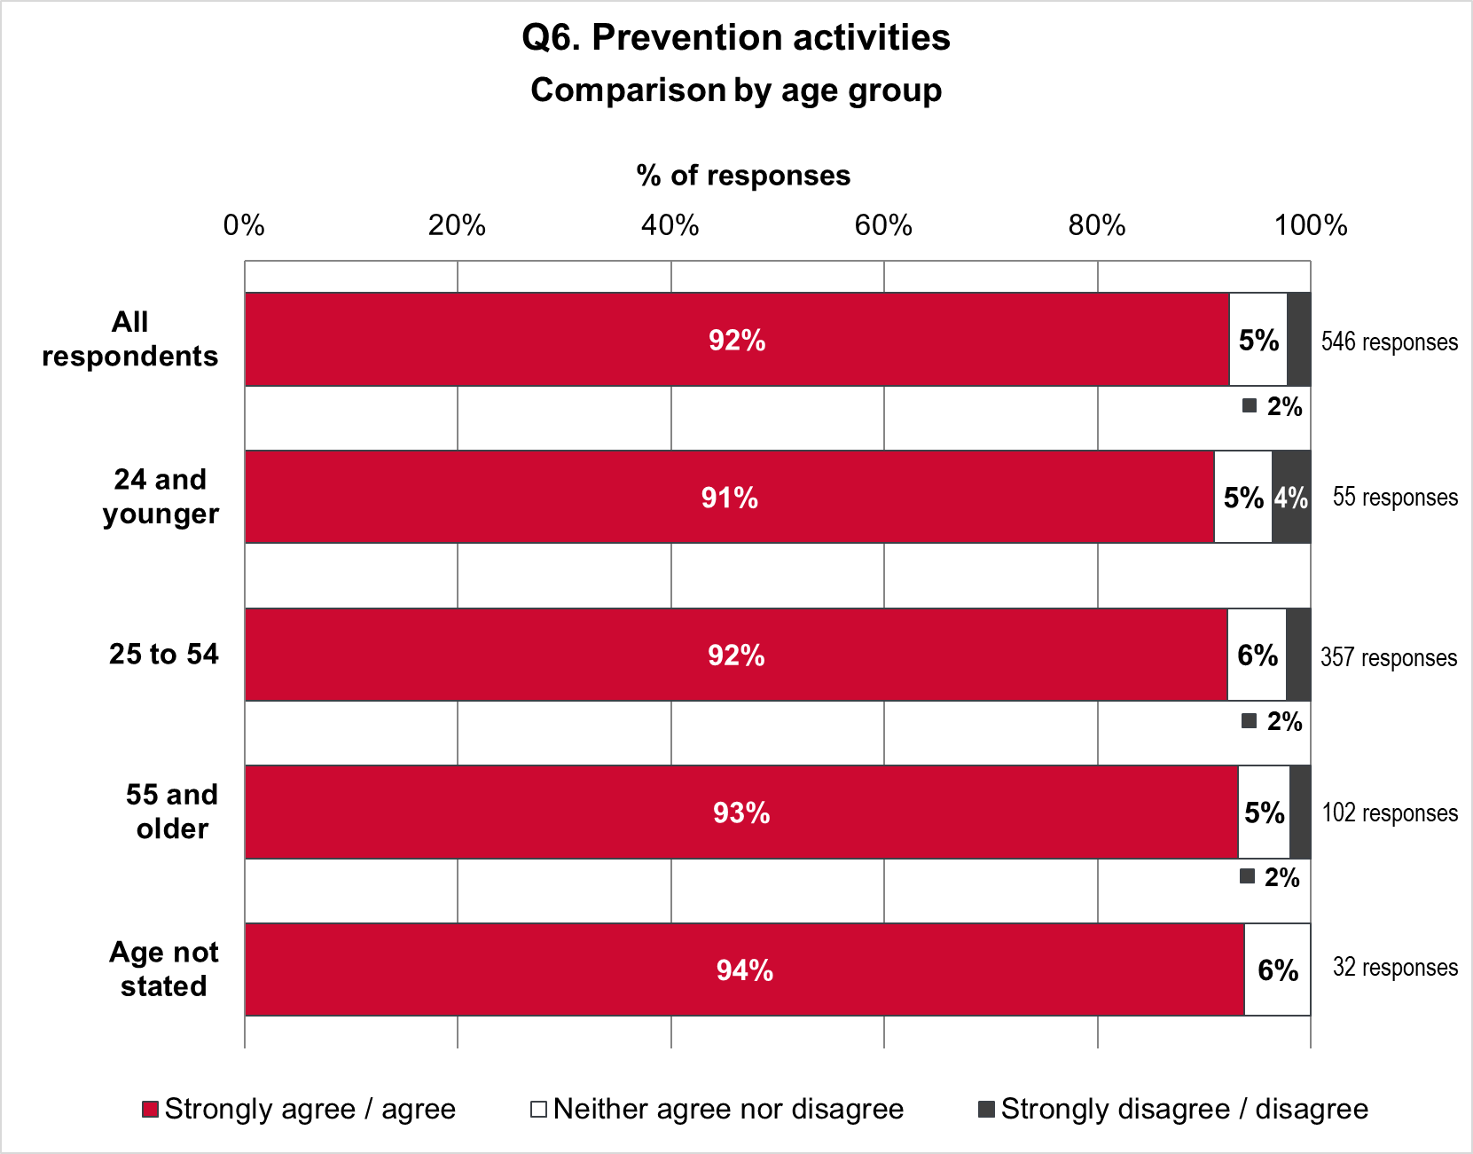

Views on prevention activities by sexual orientation
Figure 48 compares views on the proposal for all respondents and five groups. These are:
- 51 respondents who are Bi
- 57 respondents who are Gay / Lesbian
- 351 respondents who are Heterosexual / Straight
- 13 respondents who define their sexuality using another term
- 74 respondents who did not state their sexual orientation.
Figure 48: Views on prevention activities by sexual orientation
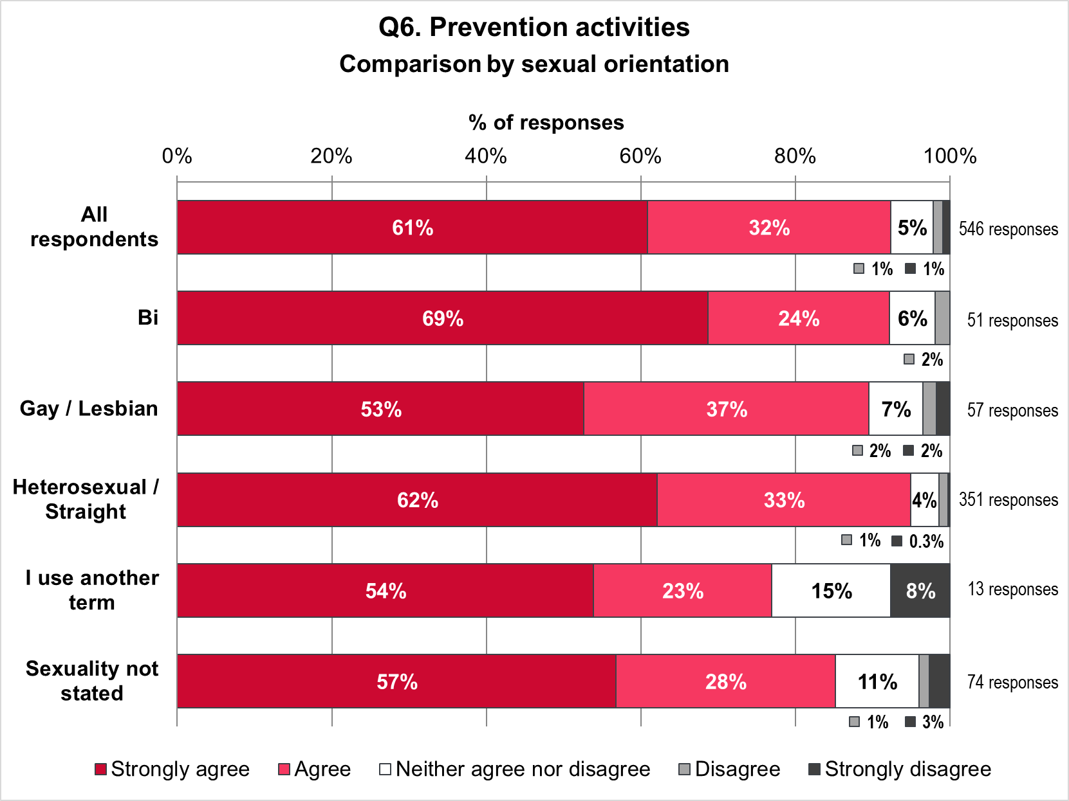
The proposal for prevention activities was most popular among Heterosexual / Straight respondents, followed by Bi and Gay / Lesbian respondents. The proposal was supported least by people who describe their sexual orientation using another term.
- 95% of Heterosexual / Straight respondents strongly agreed or agreed with the proposal. This compares with 92% of Bi respondents, 89% of Gay / Lesbian respondents, 85% for people who did not state a sexual orientation, and 77% of people who use another term.
- 4% of Heterosexual / Straight respondents, 6% of Bi respondents 7% of Gay / Lesbian respondents and respondents neither agreed nor disagreed with the proposal. This compares with 11% for people who did not state a sexual orientation and 15% for people who use another term.

- 1% of Heterosexual / Straight respondents strongly disagreed or disagreed with the proposal. This compares to 2% of Bi respondents, 4% of Gay / Lesbian respondents, 4% of respondents who did not state their sexual orientation, and 8% of people who use another term.

Free text responses

A total of 95 respondents provided additional comments about the approach to prevention. These were broadly themed into comments regarding communication and education (45%), collaboration with community partners (29%), more focus on testing and treatment (17%), resource concerns (12%), support for proposals (7%) and an assertion that these services are already provided (2%)

Figure 49: Q6 Free text themes

The theme ‘communication and education’ was further broken down into comments about information quality / language (37%), digital information and use of social media (19%), target vulnerable groups (21%), public campaigns (14%) and co-production (9%).

Figure 50: Q6 Free text subthemes: Communication and Education

Information quality and language was the most common subtheme. Information quality referred to “up to date and factual knowledge need[ing] to be shared and made available” and “to be relevant to the population” noting the diverse range of backgrounds service users come from. The type of language used is important and numerous respondents emphasised a “no shame or judgement approach”. The term ‘health behaviours’ wasn’t liked by some respondents who described the language as “pathologising”, “demonising”, "patronising” and “a bit preachy". One respondent felt “the messages need to have a positive slant as much as possible”. The need for a greater social media presence “on platforms that are popular” was reflected in responses. An example was “TikTok and using influencers needs to feature in reaching CYP”. Some added that a social media presence would help to tackle what was described as “misogynistic” and “extreme” information online, noting “huge amounts of people get inaccurate information about contraception and sexual health [and] need to have a social media presence to combat this”. Respondents emphasised the importance of public campaigns calling for them to include information on “condom use and safe sex” and “more education around HIV”. One respondent called for something similar to the “HIV U=U billboard campaigns around the city”. The need for campaigns to “connect to communities, particularly marginalised communities, rather than alienate them” and “feature a diverse range of people” underpinned the focus on vulnerable groups such as “those at risk of domestic abuse”, ethnic minorities, GRT community, young and older people, and the LGBTQ+ community. A small number made the case for a co-production approach to campaigns and education, noting “empowering people isn't always about outreach, but communities coming up with solutions themselves. We need to think outside traditional public health campaigns box”.
The theme ‘collaboration with community partners’ highlights the call for “more investment in community outreach programmes, involving sexual and reproductive health services across the BNSSG area”. A significant number emphasised working with educational settings including “schools, youth provision and alternative education settings”, “college / uni freshers week info” and “train the trainer programmes... and training for young people to provide peer-to-peer support”. Working with “trusted community members and small-grass root organisations to improve outreach, especially among minoritised ethnicities” was also highlighted noting “outreach already exists to BASE, ONE25, and via Common Ambition”. There was a call for “links between sexual health and domestic abuse / coercion and exploitation prevention [to] be made more explicit”.
Comments regarding ‘more focus on clinical care and treatment’, either advocated for better access to services as the required approach to prevention or an altogether lower focus on prevention. The majority of comments were regarding better access e.g.to chlamydia and gonorrhoea screening as an asymptomatic male, “more access to contraception” including LARC and “greater provision of condoms”, “trained psychological / therapeutic practitioners who can help with behaviour change”, availability of PrEP and “need for testing, diagnosis and timely treatment of sexually transmitted diseases”. However, a small number saw prevention efforts as futile and wanted to see more attention given to treatment, stating that the “budget should be focused on cure”.
Comments regarding ‘resource concerns’ were particularly concerned with appropriately trained staff and insufficient funding meaning cuts to other services. Specifically, it was commented that outreach is a particularly expensive part of any service so “how would this be paid for [and] what will be lost in terms of staff time and funding?”
Comments ‘supportive of plans’ noted that “people need to be informed” and “awareness is needed... there are still taboos and the more people are comfortable talking about the better”. A small number of respondents commented that this service is already provided and the “current service... is pretty good at this”.

Do you have any additional comments on the draft plans?
A total of 156 respondents provided additional comments about the overall draft plans. These were broadly themed into identified priority areas (57%), neglected or poorly understood areas (7%), potential risks to service provision (28%), support for plans (9%), lack of detail provided in plans (6%), assertion that these services are already provided (1%) and sexual health not considered a priority (3%).

Figure 51: Q7 Free text themes

The theme ‘identified priority areas’ was further broken down to improve access (39%), education / health promotion (16%), services to be inclusive and safe (27%) and working in and with community partners (18%).
Figure 52: Q7 Free text subthemes: Priority Areas

The most significant proportion of these comments saw a focus on improving access as a priority and this was reflected through the responses to previous questions. Access issues were wide ranging from location of services to timely access to appointments and results to digital vs. in-person access. One respondent commented how they would like to see “a faster turnaround of results and outcomes. At present it can take up to 2-3 weeks for a STI result to come back”. Many were concerned about access to in-person appointments. “My only fear would be when things get pushed towards a technology platform there has to be a plan in place to back up when that fails, and will it cause any issues for the human side of working/clinic running?” Although others stated how they were “pleased to see that availability of online digital services as a key focus”. Comments about location and access included “The local clinics should be reopened. People should be able to self-refer for all services, not need to go their GP first, which adds further delay and barriers”. A considerable number cited how long waiting times, particularly on the current telephone service is a barrier to access, one even stating how the phone line “is dangerous as [there’s] such long wait[ing] times often without a solution at the end”.
Provision of inclusive and safe services was the second most common priority area identified. This included tackling discrimination, continuation of specific young people’s service, having accessible language with less technical “jargon”, support for the LGBTQ+ community, especially for transgender people, and improvement in access for people with disabilities. One respondent stated how “healthcare in general discriminates against people so a fairer system needs to be in place”.
Working in and with community partners was another priority area with schools, youth clubs, charities and organisations highlighted to target young people. One respondent specifically called for “proper sex and relationship sessions in schools and youth clubs by outside professionals”. Others advocated for outreach to marginalised populations in the community as a priority, calling for outreach “into communities that are hard to reach, particularly heterosexual MSM groups”. The final area which some respondents gave priority was education and health promotion. These comments called for sex education as a priority, asking for “more awareness” and that “knowledge is power”. Some of these comments stated that this education could help in tackling stigma around STIs and help to “normalise” them. Some also overlapped with calls for education for young people and education in schools.

The theme ‘potential risks to service provision’ was further broken down to resource concerns (30%), fragmented / non-NHS provided services (30%), loss of existing provider benefits (30%) and other (4%).
Figure 53: Q6 Free text subthemes: Potential risks to service provision

One area of concern in terms of potential risks to service provision was inadequate resources, most notably in terms of funding but also some staffing concerns. Many made comments such as “I hope there is a budget increase in this re-commissioning, all the below in context of dramatic and short-sighted budget cuts”. Another noted “no mention on how [commissioners] will fund/increase testing capacity over what already offer[ed]”. Another area of concern was that division of services into ‘lots’ could lead to fragmented services, particularly if non-NHS providers awarded contracts. Comments included “NHS services are trusted by the public and easier to access for marginalised communities”, “one [single] organisation reduces infrastructure costs and allows for staff flexibility between sites” and greater ability for oversight which strengthens safeguarding. One respondent argued that “it is essential that service-users, no matter where or how they access [sexual and reproductive health (SRH)] services, only need to tell their story once and all steps are taken to minimise the chance of disengagement and loss to follow up”. Another that “NHS run services avoid conflicted interests inherent in 3rd party organisations”. A third area of concern is the potential loss of benefits from existing providers. This included acknowledgement that “once you get into the service the staff are great and conscientious and caring” and “the importance of having strong and immediate links with NHS specialists... for joint / shared care”. Another key concern is the potential reduction or loss of current termination of pregnancy services, “especially for the ‘complex’ cohort” and if “NHS abortion services were to cease... [and be] provided by an independent sector provider (ISP), there would be a significant number who could not be managed by an ISP, and the complex termination service does not have capacity to manage this volume of patients”.
A minority of comments relating to potential risks to service provision were concerned about the primary care / sexual health interface and emphasised the need to “find ways to ensure provision across primary care in an integrated way”. Similarly, a small number of comments highlighted the psychological impact of the tender process on staff, with one respondent suggesting that “the reason that patients receive such a good service in Unity, is down to good management and psychological support of staff”.

A less prominent theme was ‘neglected and/or poorly understood areas’ however this represented some personal and passionate comments about a range of important health issues. The most common area of which respondents felt is poorly understood and neglected in the proposals was psychosexual health stating “it is not clear what psycho-sexual services and counselling will be available” and requested that “sufficient priority is given to this service”. Women’s health was also highlighted e.g. “I have been so disappointed with how poorly women's health is treated, particularly period issues and coil pain, so I am sad to see this doesn't seem to tackle anything” Support with miscarriage was raised as a neglected area with one respondent providing an account of their personal experience:
“I had a 12-week miscarriage recently and was disappointed how care quickly drops off once you are miscarrying and no longer in the 'pregnant' category - e.g. no discussions about pain relief medication, no opportunity to meet with someone, no offer of being signed off work. What was most concerning was the lack of mental health care offered. The leaflet given to me when I was told I was miscarrying has mental health as a small mention at the back and that was it. Mental health is a huge priority when you go for your ante-natal appointments, but we completely forget to address this with miscarriage and pregnancy loss. Further to this, the arrangements for this were not joined up - no one seemed to know who to sign post me to, e.g. I was sent to attend an EPU appointment on site by A&E and turned up the next day to this to be told the clinic no longer took face to face appointments. I was essentially left to have a 12-week miscarriage at home by myself, with no insight as to what was going to happen - which in reality was incredibly painful and traumatic as essentially you go through a mini labour. Really shockingly poor levels of care in this area.”
Complex cases were another wider issue raised suggesting the proposed service “ensure that exceptions/complex cases and cases where something goes wrong are designed for”. The question was raised as to “How is mental health included within the vision? I recognise that the vision talks about a joined-up approach to support individuals as they move through a physical care pathway but how does wellbeing and mental health support wrap around this vision”.
A small number of comments described the proposals as being too “vague” due to a lack of detail. These comments claimed the proposals were more of a “vision rather than a ‘plan’”. A small number of comments stressed the proposals were no different to the current service provided, stating how it “seems like a lot of expense by the council to repeat what's already available”. A further small number opposed prioritising sexual health as a whole.
In contrast, there were a number of comments supportive of plans stating “[it] seems well thought out. It is a vital service for the community. The part of the document that resonated most was the recognition that accessing the services were time consuming and problematic…but that once you get into the system the clinicians are excellent”. Other supportive comments praised the proposals for a mix of online and in-person provision including walk in appointments saying it “covers the varying needs of the service users” and “encourages good sexual behaviour and regular checking”.

Impact of the proposals because of protected characteristics

Scale of effects
Respondents were asked what effect, if any, the proposals would have on them because of their protected characteristics. Of the 551 respondents to the survey, 500 (91%) answered the question (Figure 42). Of these:
- 36 (7%) said the proposals would have a very positive effect
- 56 (11%) said the proposals would have a slightly positive effect
- 382 (76%) said the proposals would have no effect
- 17 (3%) said the proposals would have a slightly negative effect
- 9 (2%) said the proposals would have a very negative effect.
Figure 42: Effect of the proposals because of protected characteristics
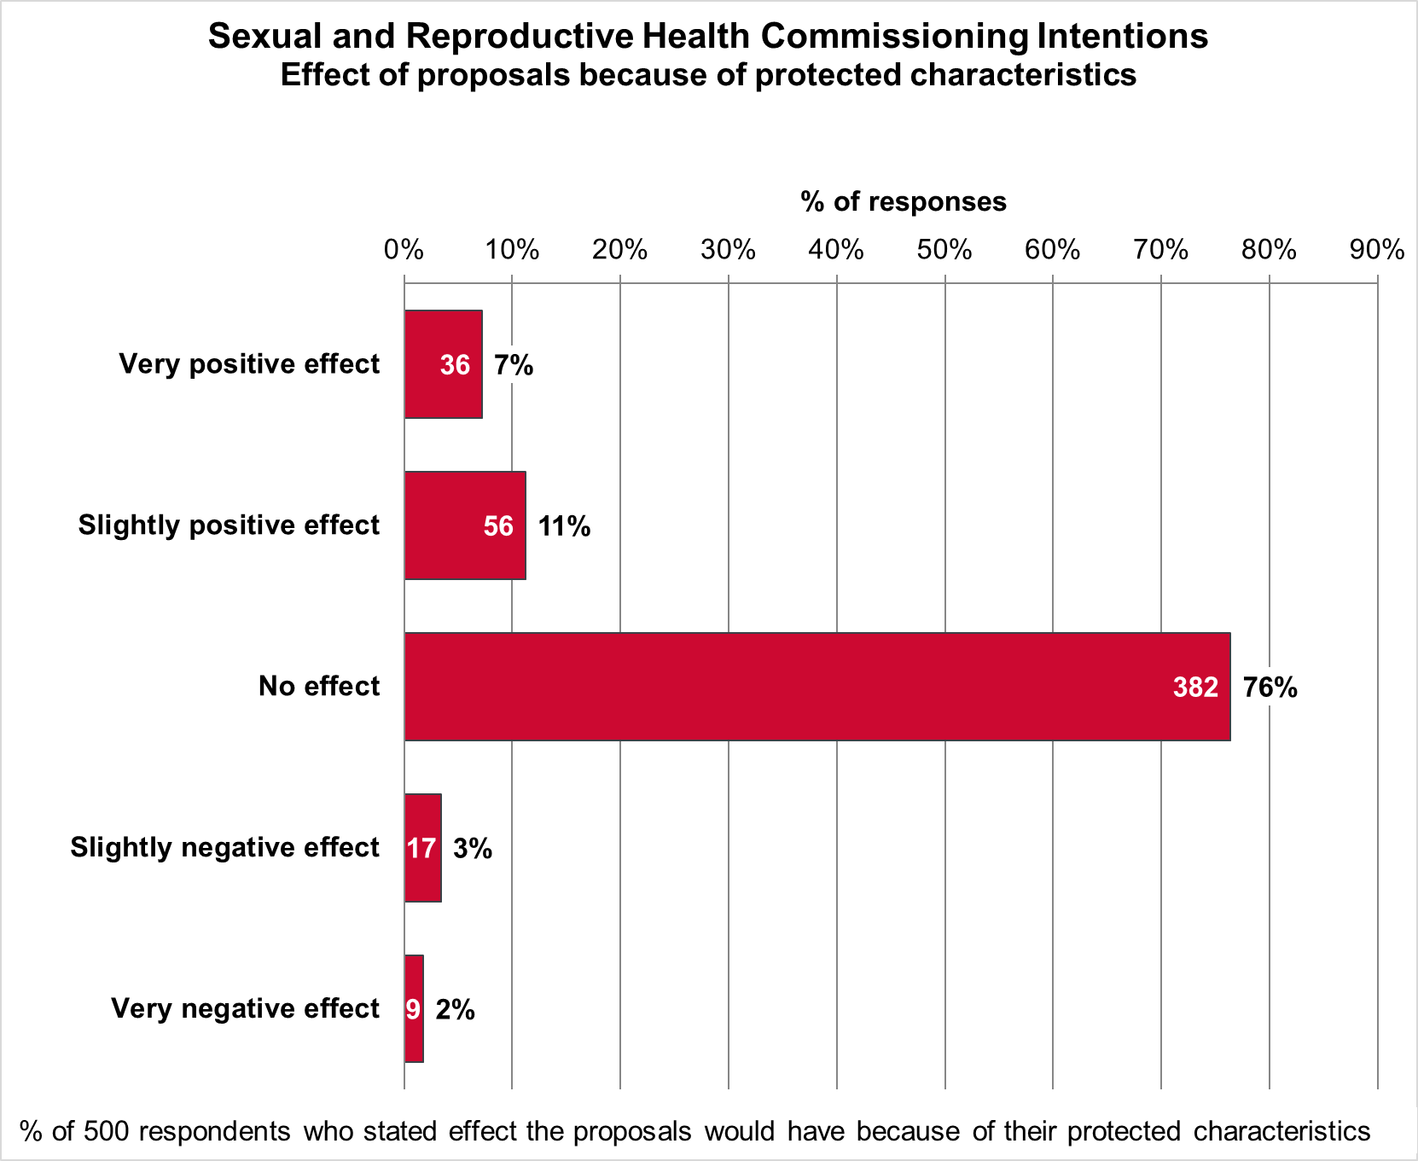

Reasons why the proposals would affect people because of protected characteristics
Respondents were also asked to explain how they believe the proposals would have an impact on themselves or others. A total of 40 respondents provided a free text response.
Eight of these respondents stated the proposals would have a slightly positive effect and seven a very positive effect. These respondents broadly talked about the proposals offering “improvement of accessibility to services” in reference to protected characteristics stating for example “more sexual health services for older users”, and “it will allow me to access services in a diverse way, without the concern of stigma being attached to my protected characteristics”. Some respondents specifically highlighted more flexibility being helpful to them and the benefits of online services for increasing access and flexibility.
A total of 6 respondents who answered the proposals would have no effect wanted to highlight the importance of these services for underserved and at risk groups and the need for “non-judgemental” services.
The 9 respondents who stated the proposals would have a slightly negative effect and two who felt they had a very negative effect raised concerns about discrimination and lack of inclusivity specifically in terms of ethnicity, LQBTQ+ status, trans- and non-binary, young people’s services, and disability. One respondent stated “I want… services embedded into the community within the NHS so there is seamless continuity. The level of care at Unity is exceptional with a multi-disciplinary approach that needs to be supported. I strongly feel that private services will not be able to provide the same level of care”.

How will this report be used?
The consultation feedback in this report has been considered at the Joint Sexual Health Commissioners board and will be used to inform the new service specifications.

Appendix 1: Consultation Engagement Plan
 | Bristol | North Somerset | South Gloucestershire
Service Users
Local Authority residents (population wide) | MPs, Councillors, City Partners and Community Groups via each local authority’s relevant bulletins, newsletters, emails or forums e.g. Communities and Public Health bulletin, Town and Parish Councils
Children & Young People | School Nurse Locality Leads (Sirona)
Children & Young People | Colleges including City of Bristol College, Weston College, SGS College and CLF Post 16
Children & Young People | University of Bristol & UWE Student Wellbeing Services
Children & Young People | Headteacher’s Bulletin
Children & Young People | Bristol Healthy Schools Newsletter |  | SG Foster Carers
Children & Young People | Freedom Youth |  | SG Youth Partnership
Children & Young People | Keeping Bristol Safe Partnership |  | SG Health Promotion in Education Settings Group
Children & Young People | Youth Council
Children & Young People | Barnardos
Children & Young People | Children in Care & Care Leavers Teams
Children & Young People | Family Hubs
Children & Young People | Families in Focus
Older People | Adult Care Partnership Boards
Older People | Bristol Older Peoples Forum |  | SG Over 50s Forum
Older People | Alive Activities
Vulnerable Girls and Women | Women’s Care Forum |  | BASE
Vulnerable Girls and Women | Bristol Women’s Voice (Nelson Trust) |  | SGC Domestic Abuse Team
Vulnerable Girls and Women | Next Link
Vulnerable Girls and Women | Domestic Abuse Survivor Forum
Vulnerable Girls and Women | Respite Rooms lead
Vulnerable Girls and Women | SARAS
Vulnerable Girls and Women | Changing Futures Housing
Vulnerable Girls and Women | One 25
LGBTQIA+ people | Terrence Higgins Trust
LGBTQIA+ people | LGBTQ+ Partnership | NS LGBT Forum | Diversity Trust
LGBTQIA+ people |  |  | LGBTQT+ Wellbeing Project
LGBTQIA+ people |  |  | Alphabets LGBTQ Youth Project
Minoritised ethnic groups | SARI
Minoritised ethnic groups | Bristol Race Equality Commission | Race Equality North Somerset (RENS) | Gypsy, Roma, Traveller Community via Senior Traveller sites Officer
Minoritised ethnic groups | Black Mothers Matter | GRT Steering Group | Faith Forum Group
Minoritised ethnic groups | Black SW Network |  | SGC Corporate Traveller Unit
Minoritised ethnic groups | Common Ambition Bristol |  | GRT Health Visitors
People with a disability | Learning Difficulties Partnership Board and Young Person Disability Services
People with a disability | Bristol Disability Equality Forum | North Somerset People First | SG Disability Equality Network
People with a disability | WECIL | Springboard | Community Learning Disability Team
People with a disability | People’s Voice Project
People with a disability | Centre for Deaf and Hard of Hearing
People with a disability | The Hive Avon
Rough sleepers / people who are homeless | Homeless Health
Rough sleepers / people who are homeless | Homeless Team
Rough sleepers / people who are homeless | 1625 Independent People
Rough sleepers / people who are homeless | St Mungo’s | Somewhere to Go | Julian House
Rough sleepers / people who are homeless |  | Homeless Outreach YMCA
Substance use service users & providers | Hawkspring | We Are With You | SG Young People’s Drug and Alcohol Service (YPDAS)
 | Bristol Drugs Project | Substance advice service
 | Developing Health & Independence (DHI)
Asylum seekers & refugees | The Haven
 | Bristol Refugee & Asylum Seeker Partnership (BRASP) | Refugees Welcome North Somerset | Julian House
 |  | Ukraine Scheme | Southern Brooks
Sexual health service users & people living with HIV | Unity Sexual Health Clinics
Sexual health service users & people living with HIV | Terrence Higgins Trust & Eddystone Trust
Sexual health service users & people living with HIV | Brigstowe
Sexual health service users & people living with HIV | NBT HIV Service
Service Providers
Primary care | One Care GP Bulletin, LMC, LPC, pharmacists via PharmOutcomes
Secondary care | Maternity Services, HIV Service
Sexual & Reproductive Health services | Unity, Brook, Brigstowe, MSI, BPAS, THT, Eddystone, C-card providers
Wider system | BNSSG ICB Newsletter, OHID & UKHSA colleagues

The Office for National Statistics (ONS) publishes information about deprivation for 32,844 small areas - known as ‘Lower Super Output Areas’ (LSOAs) - throughout England. For each LSOA, a measure of deprivation is published called ‘Indices of Multiple Deprivation’ (IMD), which takes account of 37 indicators that cover income, employment, education, health, crime, barriers to housing and services, and living environment. The postcodes provided by Bristol respondents enabled each to be matched to one of the 263 Lower Super Output Areas in the Bristol City Council area and thus to one of the deprivation deciles. Similarly, postcodes provided by South Gloucestershire and North Somerset respondents enabled each to be matched to one of the Lower Super Output Areas in those authorities. Note: postcodes provide approximate locations; they are not used to identify individuals or specific addresses.
Based on 156 respondents who provided full postcodes in the Bristol administrative area from which deprivation decile can be identified.
Based on 146 respondents in South Gloucestershire and 53 respondents in North Somerset who provided full postcodes from which deprivation decile can be identified.
Note: Combined percentages in the text who agree / strongly agree or disagree / strongly disagree may appear to differ from the separate percentages in Figure 19 due to rounding to the nearest whole number
Note: Combined percentages in the text who agree / strongly agree or disagree / strongly disagree may appear to differ from the separate percentages in Figure 21 due to rounding to the nearest whole number
The protected characteristics defined in the Equality Act 2010 are age; Disability; race including colour; nationality, ethnic or national origin; religion or belief; sex; gender reassignment; sexual orientation; being married or in a civil partnership; being pregnant or on maternity leave.

