
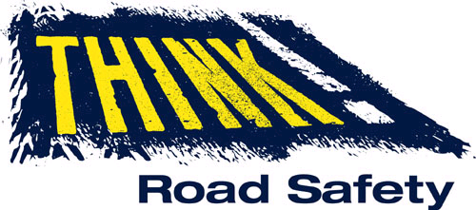

Personal Injury Road Collision Data
Enquiry Request Form
- Please fill in all the shaded boxes below.

- Please, send an e-mail with a map of the survey area to: Transport.data@bristol.gov.uk

If you have any queries, please e-mail Transport Data team.

Note: a charge may apply, which for a standard enquiry is £165.00 (plus V.A.T.), from 01/04/2022. Previously £150.

Contact details:

Date of Request:
Name:
Company / Org. (if applicable):

Dept. (if applicable):

Telephone (incl. area code):
E-mail:
Address:

Postcode:

Format of data required (tick/cross appropriate box)
- see report contents, below:

Summary Report
Interpreted Report
Both Reports

Summary Report, contents: | Interpreted Report, contents - a more detailed report, including:  :
- Police ref  - Date  - Casualty Severity  - Cyclists involved  - Pedestrians involved  - Children involved  - OAPs involved  - Visibility (light / dark)  - Manoeuvre  - Road Condition  - Time of day  - Easting  - Northing  - Location Description | - No. & type of vehicles involved  - Weather conditions  - Carriageway type  - Description of how accident happened  - Special site conditions (e.g. road works)  - Vehicle manoeuvres in more detail  - First point of impact (e.g. near side)  - Driver / rider age

Purpose of request:
- e.g. new development, student’s coursework, etc.

Location description:
- alternatively, provide a map with a polygon boundary (outline) of the survey area

Date range of survey:

Latest 3-year data
Latest 5-year data
Specific period (e.g. dates between)

